** Innovation for Sustainability**

Vittoria Tuzzi, Mathilde Chambost, Ines Goncalves | Fraser Dryburgh, Ayse Koçak, Aira Paliukenaite, Bansi Popat | Elena Schmider, Max Jochem, Tim Haresma, Steff Nagel | Sarah El-Boujdaini, Pamela Navarrete, Richard Herts, Luciana Paredes | Christian Nota, Marie Gillet, Hamza Sayan | Ana López, Anna Muizniece, Agustina Pérez | Inês Ruas, Anastasia Velonaki, Alena Pridiri



Copyright © Authors, 2020

All rights reserved. No part of this publication may be reproduced, stored in a retrieval system, or transmitted in any form, or by any means, electronic, mechanical, photocopying, recording or otherwise, without the prior permission in writing, from the authors. The opinions expressed here are the author’s own; they do not necessarily reflect the views of any institutions. Part of Assignments-As-Products (APP) and Digitally Enhanced Eligible Products (DEEP) approach of Governance of Innovation (GID 4408) course for educational and outreach purposes.

**Editorial Note**

The first run of *Innovation for Sustainability* class at Maastricht Graduate School of Governance is over. The course is the final course of Governance of Innovation specialisation track of Master of Science in Public Policy and Human Development programme at Maastricht Graduate School of Governance and UNU-MERIT. We met bright minds joining the class of May-June 2020. It was an intensive learning period for them, and for us it is always interesting to listen, and finally, read about the sustainability issues and solution approaches that the participants want to see a positive value in. We think that this first volume of open access digital compilation of “Innovation for Sustainability” e-book will inform and inspire many people around the globe, as well as the next cohort, about the need for innovation for sustainability

Have a good read!

Prof. Dr. René Kemp and Dr. Serdar Türkeli

Maastricht, the Netherlands

June, 2020

Contents

1. Amsterdam Circular City: Case Study Overview*, by Vittoria Tuzzi, Mathilde Chambost, Ines Goncalves* 5
2. Aquaponics Farming System: Addressing Urban Food Security and Sustainability in Singapore*, by Fraser Dryburgh, Ayse Koçak, Aira Paliukenaite, Bansi Popat* 17
3. Bicycle-centered Cities: An analysis on Copenhagen and Utrecht’s Bicycle Policy*, by Elena Schmider, Max Jochem, Tim Haresma, Steff Nagel* 29
4. Brave New Volt: Sustainable Energy Transition analysis of German Solar Power Energy Sector*, by Sarah El-Boujdaini, Pamela Navarrete, Richard Herts, Luciana Paredes* 38
5. For a Wider Adoption of Smart Grids: The Case of Norway, *by Christian Nota, Marie Gillet, Hamza Sayan* 56
6. The Case Study of Uruguay’s Energy Transition*, by Ana López, Anna Muizniece & Agustina Pérez* 68
7. Zero Energy Houses: The case of Norway*, by Inês Ruas, Anastasia Velonaki, Alena Pridiri* 78

# Amsterdam Circular City: Case Study Overview*, by Vittoria Tuzzi, Mathilde Chambost, Ines Goncalves*

Vittoria Tuzzi, Mathilde Chambost, Ines Goncalves

**Introduction**

The concept of ‘Circular Economy’ (CE) has been gaining momentum in the last years both from an academic and societal point of view. The latter has been widely defined by different scholars. Nevertheless, a meeting point on a clear definition has not been yet found (Kirchherr et al., 2017). For the sake of this research, ‘Circular Economy’ shall be defined as a system which replaces the ‘end of life’ concept, thus, by reusing, recycling and recovering. This idea shall be applied to the concept of cities, thus, creating ‘circular cities’. In order to shift from a linear to a circular city, core elements of it should shift towards a more sustainable and resilient manner. Thus, housing, mobility, food and energy should transit from a more traditional way of being done or used to a more sustainable and earth friendly way (Van Eijk and Friedl, 2019).

This paper will focus on the city of Amsterdam, where the municipality and other actors have participated greatly to complete a full transition to a circular city model by 2050. In order to achieve the 2050 goal, new and current actors will need to play a bigger role in the transition. One of those actors is the private sector that until now has been a partner of the Municipality for some specific projects. The present paper tries to answer the following research question: ‘How can the private sector play a bigger role on the transition of Amsterdam to become a circular city?’. To answer it, the paper will be structured as follows. First a literature review will cover the concept of circular economy and circular cities, followed by the presentation of the chosen framework - Strategic Collective System Building Activities, by Planko (2016). Further, the discussed concepts and theories in the literature review will be applied to the case study of Amsterdam. Here, the analysis focus on the system actors, current policies, barriers to diffusion and possible organisational change, based on the application of the Strategic Collective System Building Activities framework (Planko, 2016). Thirdly, policy recommendations will be done on the basis of the previous work. Lastly, the conclusion will return to the research question, summarize the findings and pose limitations and possible further research.

**Literature Review**

*Circular Economy*

The CE thinking is based on “the recognition of the limits to planetary resource and energy use, and in the importance of viewing the world as a “system” where pollution and waste are viewed as a defeat” (Bocken et al., 2016).

To date, already 114 definitions of CE exist in literature (Kirchherr et al., 2017). Due to its hegemonic use in the literature and the fact that is the most complete one, the definition of the Ellen MacArthur Foundation was the one considered on this paper. The CE has been defined as: “an industrial system that is restorative or regenerative by intention and design. It replaces the end-of-life concept with restoration, shifts towards the use of renewable energy, eliminates the use of toxic chemicals, which impair reuse and return to the biosphere, and aims for the elimination of waste through the superior design of materials, products, systems and business models” (Ellen MacArthur Foundation, 2013).

The circular approach contrasts with the traditional linear business model of production of take-make-use dispose and an industrial system largely reliant on fossil fuels (Bocken et al., 2016). Its main goal is to keep “valuable materials in circulation through a series of systemic feedback loops between life-cycle stages, powered through resource efficient industrial processes” (Hobson, 2015).

*Circular Cities*

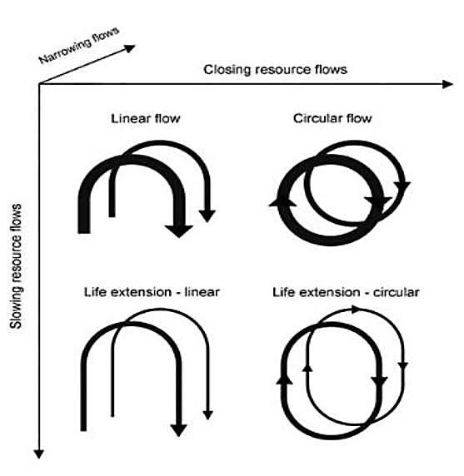According to the Ellen MacArthur Foundation (2017) a “circular city embeds the principles of a CE across all its functions, establishing an urban system that is regenerative, accessible and abundant by design”. The concept of Circular City has been defined “as a city in which, in particular, the built environment is designed in a modular and flexible manner; energy systems are resilient and renewable, consequently reducing costs and producing positive impacts on the environment; the urban mobility system is accessible, affordable and effective; and the production systems encourage the creation of local value loops” (Ellen MacArthur Foundation, 2015). As cities concentrate a high consumption of finite resources, they represent a strategic start for reducing waste with a “fully closed loop” thinking (Croci, 2018, Bocken et al, 2016).

**Figure 1: Categorization of linear and circular approaches for reducing resource use, Source: Bocken et al. (2016)**

The transition towards circular cities is only possible through a cultural paradigm shift leading to “innovation and adaptation in governments’ organization, business strategies, and educational structures (determining the supply of new products and services) as well as civil society (the “demand” side)” (Gravagnuolo, 2019).

**Theoretical Framework: Strategic Collective System Building Activities**

The successful implementation of circular cities requires a deep change in the socio-technological regime. The isolated correction of market-failures (e.g. direct R&D support and economic incentives) is not enough as the change of institutional and systemic barriers require a broader interaction between stakeholders.

The Circular Cities implementation has been pushed to the current political agendas by international organizations, national governments and academy but mainly implemented by municipalities (local) - that strategically give priority to activities that are under their direct responsibility (e.g. waste management that in the case of Amsterdam is done by the publicly owned company AEB (Collectors, 2020)). The private sector is slowly getting on board but the results of such partnerships have not seen the same impressive results as policies that complete its total cycle under the municipalities’ umbrella. By making use of the “Strategic Collective System Building” framework (Planko, 2016) this paper aims to contribute to the discussion on the strategic next steps to improve the private sector role in the transition of Amsterdam to become a circular city.

The selected framework refers to “processes and activities that firms can conduct in networks to collectively create a favorable environment for their innovative sustainability technology” (Planko, 2016) and its main goal is the creation or modification of broader institutional or organizational structures in a technological innovation system carried out by innovative actors (Planko, 2016).

**Case Study: Amsterdam Circular City**

*Systemic Aspects of the Circular City and its Advantages*

As of now, the current economic paradigm follows a model of take-make-waste. Though profitable, it is also unsustainable due to limited resources: only 9% of materials consumed are recycled (Circle Economy; Municipality Amsterdam, 2017). On the contrary, the objective of a CE is to eliminate waste from the system by closing loops of energy and material flows (Meini, Facchini, & Papa, 2019; Bocken, 2016). In 2015, the Netherlands adopted this strategy and set two gradual objectives: first, to reduce by 50% the use of primary raw materials by 2030, and second, to be 100% circular by 2050 (Circle Economy & City of Amsterdam, 2018; Mené, 2020).

The city of Amsterdam, aware of the benefits of a CE, reacted quickly to the government’s decision and developed a vision of the city as a living ecosystem. The circular model adapted to the city has the particularity to have a holistic approach with objectives in terms of competitiveness, environmental sustainability (reducing waste and greenhouse gas emissions) and social inclusion (creating circular jobs and reducing inequality). It calls for the participation, environmental responsibility and inclusion of all societal actors and gives particular attention to the development of new technologies.

*Amsterdam Circular City History*

The journey which is leading Amsterdam to be a circular city dates back to 2015. Several deals, publications and policies have been done in order to reach the desired goal. The latter, together with the role of the actors in the city played a crucial role in making Amsterdam circular. A sustainability agenda has already been published in March 2015, which was the milestone for further advancements in the next three years. Other important documents, which will be further detailed in the analysis of current policies, are the Waste Implementation Plan (published in June 2016) and the Circular Innovation programme 2016 - 2018 (published in November 2016). Together with the latter mentioned documents, various publications have been able to create a consistent and clear framework to reach the set goal.

Moreover, Amsterdam has already made a plan forward for 2020 - 2021 and 2020 - 2025. For instance, the 2020-2025’s strategy focuses on three specific value chains, namely, food and organic waste streams, consumer goods and built environment (Gemeente Amsterdam, 2019). The vision is the one of building a strong understanding of the circularity benefits for the city and its citizens. Nevertheless, a strong cooperation between actors is necessary.

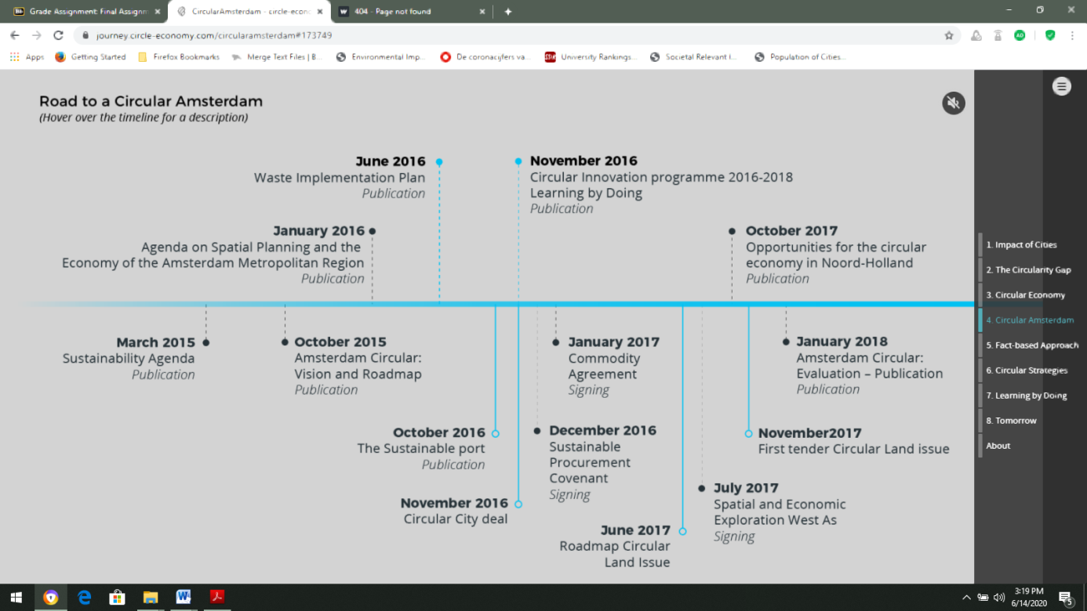

**Figure 2: Development of the circular project in Amsterdam, Source: Circle Economy & City of Amsterdam, 2018, Accessible:** [**https://journey.circle-economy.com/circularamsterdam#173749**](https://journey.circle-economy.com/circularamsterdam#173749)

*Amsterdam Circular City Actors*

The role of the various actors around the project of making Amsterdam a circular city is extremely important. This is due to the fact that great commitment and cooperation is needed in order to reach the set goals. Thus, several actors shall be recognized, namely, the municipality, citizens and private and public sector stakeholders, such as local businesses and nonprofit organizations (NGOs) (Campbell-Johnston, Cate, Elfering-Petrovic, Gupta, 2019).

Both private and public actors are necessary for different reasons. At a first glance a top down approach, implemented by the Municipality, seemed to be the one used in order to increase the circularity of Amsterdam. However, a few bottom up initiatives have shown the interest of the civil society (customers, users, local community…) to be part of the Circular transition (Circle Economy, 2019). A great example of that, is the creation of the Zuidoost Food Forest (under the Circular City Plan), done by residents of the K - District in order to increase biodiversity and make the area more climate proof (Gemeente Amsterdam, 2019). Such initiatives show not only how the population is aware of the need to make the city more circular, but also how citizens can be an active part of doing so. Thus, they are representing one of the main actors for the circularity of Amsterdam.

Nevertheless, the main fundamental actor in making Amsterdam a circular city is the Municipality itself. The Municipality has acted as a planner and implementer but also as an orchestrator of the active cooperation with private sector stakeholder and research institutes, such as universities or research and knowledge centres (Circle Economy, 2019). Such research has focused on product development for the value chains of Construction and Biomass & Food (Gemeente Amsterdam, 2019). The municipality played also an important role by spreading the outcomes of these researches, through public campaigns to impact consumer acceptance. The design of the Circular Economy Plans has been commissioned by the Municipality to the Circle Economy - a non-profit organisation that empowers a global community to accelerate the transition to the circular economy - (Circle Economy, 2019).

Regional, national and international governments also play a crucial role to enable the transition to a circular economy (Circle Economy, 2019). From a regional point of view, providing support to housing corporation, construction and urban plans for new districts is an important milestone. From a broader perspective, thus, national and international, the various legal frameworks and different guidelines to municipalities and businesses play a crucial role. This is due to the fact that such measures provide the basis for all the different actors to cooperate and actively work towards embedding the circularity principles.

For instance, private businesses cooperated with the Municipality in some particular circular projects (Circle Economy, 2019). In order to do so, the Municipality created instruments, as financial support, throughout loans or tax incentives to improve the business circularity of private firms (such as food vendors and producers, construction companies, wholesale suppliers and distributors, private waste collectors, manufacturing firms…). Cooperation, on the supply and demand side, was also promoted through the expansion of already available recycled and reusable materials markets, involving repair businesses, with the objective to close construction industry loops (Gemeente Amsterdam, 2019). Other private businesses shall be taken into consideration, such as financial or start-ups advisors and consultancies but also urban planning, developing and engineering firms (Circle Economy, 2019). While on one hand, the advisors can develop new investment strategies, bring innovation and develop new techniques to for instance, manage water and waste. On the other hand, urban planners can incorporate the strategies created and move towards a more sustainable framework. An example has been the one in the Haven-Stad area of Amsterdam. Here with the support of financial advisors, urban planner are working towards building new houses which will produce 75% less of Co2 emissions, mobility which would not pollute, rainproof districts and half of the resources to be reused and 65% of waste separation (Gemeente Amsterdam, 2017).

From the public point of view, NGOs and interest groups can collaborate with public service providers and the civil society (Circle Economy, 2019). This can be done starting from the NGOs which can bring their knowledge on for instance, relevant environmental content to make the civil society engage more in local initiatives and public service providers to explore alternative ways to cope with for instance, housing services (Gemeente Amsterdam, 2019). Moreover, also Knowledge Institutions (Circle Economy, 2019), such as universities play a role in assessing, for instance, how environmental friendly some products can be and investigate on the impact and the way materials are composed. Amsterdam relies widely on institutes such as the Dutch Institute for Building Biology and Ecology NIBE (Gemeente Amsterdam, 2019).

In order to complete a full transition, a multiple level actor integration is needed (Campbell-Johnston et Al., 2019) but it is urgent to upgrade the relationship between Businesses and the Municipality. Those need to pass from being isolated circular project partners to being fully integrated in the circular system (with circular business models, offering circular products and services with life-cycle extension and promoting material resources efficiency (Gemeente Amsterdam, 2019).

*Amsterdam Circular City Current Policies*

According to Amsterdam Circular – Evaluation and Action Perspectives, since 2015, the city has completed over 73 projects that contribute towards a CE. CE is the leading theme of the city’s Sustainability Agenda that originated Amsterdam Circular: Vision and Roadmap for City and Region. This last plan is the umbrella for:

• Learning by Doing (plan that focused on 26 projects about procurement and land development).

• Circular Innovation Programme (that developed 30 projects in collaboration with market parties and knowledge institutes).

• Waste Implementation Plan (that completed 5 projects).

• Other 12 projects developed separately by the municipality.

After identifying the most effective areas of intervention, the Municipality decided to prioritize five value chains that represented the largest (volume wise) material streams: Construction, Biomass & Food, Plastics, Manufacturing and Consumer goods, prioritizing the first two. Some of the key strategies for the Biomass chain were the development of a biorefinery hub, cascading organic residues and extracting phosphate from waste residues. For the Construction chain the plan included smart design implementation, dismantling and separation, reuse and recycling facilitated by developing a secondary market and material bank. For these projects, the municipality brought on board about 100 businesses.

The overall results have proven that the CE is both realistic and profitable. However, several barriers interfere with the systemic transition and especially with its appeal to have more private stakeholders on board.

*Amsterdam Circular City Barriers to Diffusion*

The municipality of Amsterdam qualifies the city as a ‘living lab’ (Circle Economy; Municipality Amsterdam, 2017). Through the programmes Learning by Doing, Circular Innovation Programme and Waste Implementation Plan, the city promotes the implementation and experimentation of innovative solutions to make the transition to a CE. Such plans have been the nest for projects such as the “De Ceuvel”, a symbol of the social transition to a circular lifestyle. Considered as a circular office park, it was built out of recycle materials (such as old boat houses) and uses innovative technologies to recycle the waste it produces and to be energy self-sufficient (De Ceuvel, 2019). “De Ceuvel” is an example of successful transition to circularity.

Nonetheless, De Ceuvel remains a small-scaled project. If the city of Amsterdam wishes to scale-up these projects and make a full transition from a linear to a CE, it will undoubtedly face challenges. As Campbell-Johnston points out, there can be barriers to this transition that can be hard, that is relying on technology and the market, and soft, meaning institutional/regulatory and cultural (2019). In the case of Amsterdam, what has been the source of critics is the fact that the city is limited in creating a closed loop because of focusing on end-of-pipe solutions.

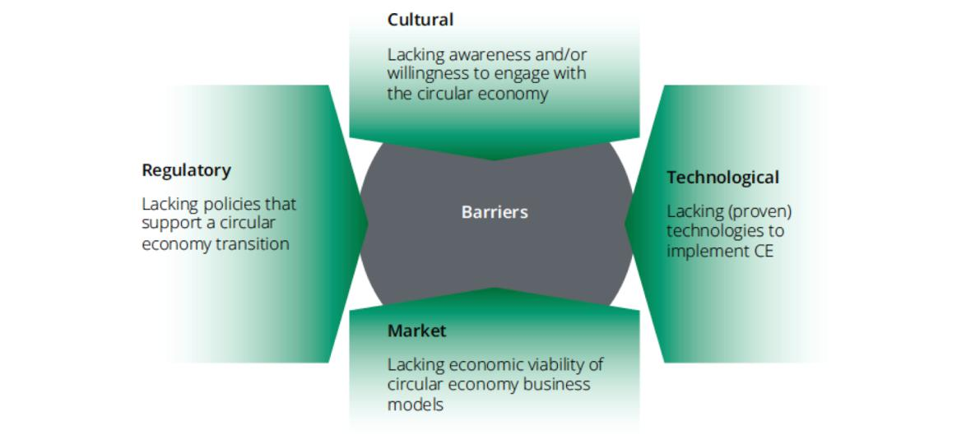**Figure 4: Barriers to the transition from a linear to a circular economy, Source: Kirchherr, et al., 2017**

As pointed out previously, the city’s efforts are concentrated on two value chains: construction and, biomass and food. In the case of construction, the municipality wishes to close the loop by reusing and recycling secondary materials and use non-finite resources. However, it has encountered challenges in terms of market, culture and regulation. First, the current linear market is an open market in which competition exists. Secondary materials have to compete with cheaper products that come from raw materials and/or form finite resources. Second, cultural barriers are crucial as existing practices are deeply rooted within the system and, trust and transparency between the partners and clients need to be enhanced. Third, institutional and regulatory barriers may be the most challenging as the actors from the municipality needs to be consistent and coherent in their strategy for the CE. Here, Campbell-Johnston shows that some departments of the municipality are not always open for change which impedes the transition. Though, technological barriers are not mentioned in the case of the construction sector as they are considered less important and easier to overcome than the three others.

Moreover, the city of Amsterdam is facing another, yet important, challenge to the transition to CE. The municipality is limited in its scope of action due to its powers being limited the city boundaries. The municipality does not have the capacity to use legislative and fiscal instruments to enhance the transition. Hence, it is crucial that the municipality takes action and lobbies in favour of CE at the national level. An initiative was launched to review Dutch legislation in order to support CE (Jonker & Montenegro Navarro, 2019). Nevertheless, the municipality’ capacities will remain limited and dependent on national legislation.

**Missing Policies - Private and Public Relations and Institutional Change for Wider Diffusion**

In order to complete a successful system transition, the city needs to proceed with strategic changes to have the private sector fully on board. By using the “Strategic Collective System Building” framework (Planko, 2016), this paper aims to make a contribution on the improvement of private stakeholders role in the transition of Amsterdam to become a full Circular City. For that purpose, each key area of the selected framework was analyzed.

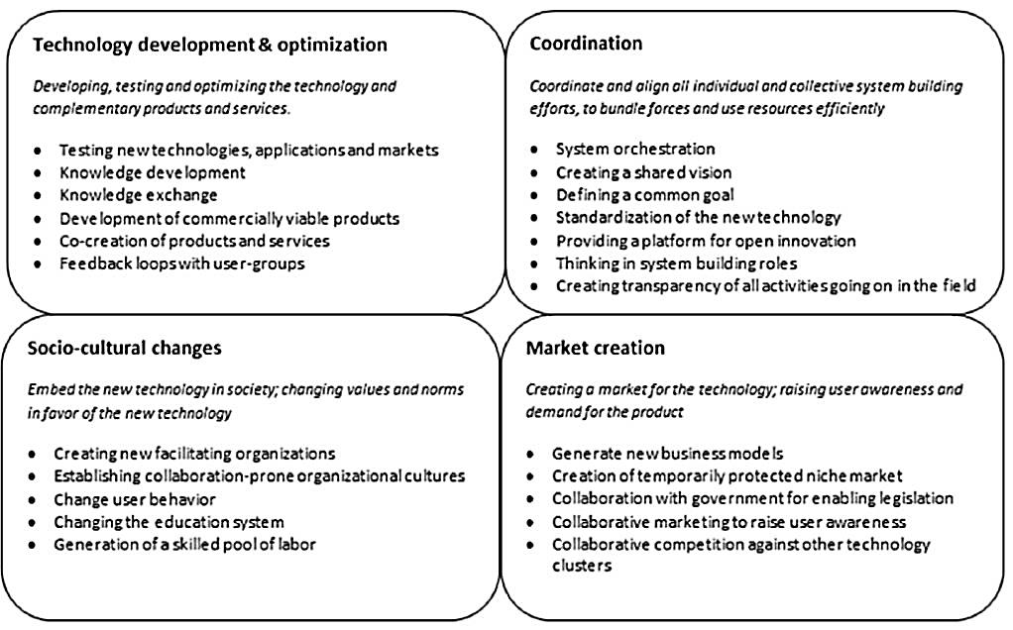**Figure 5: Overview of the strategy framework for system building and its system-building activities, Source: Planko, 2016**

*Technology development and optimization:* When looking at table 1, we understand that this section was the one where more projects were developed. However, those were mainly conducted by Research Institutes and not by companies. By having firms on board since this stage, there would be a time reduction between the R&D phase and the adoption of such technologies, improving the efficiency on the supply side and taking early into account the limitations that firms face when commercializing the new technologies.

*Coordination:* The Municipality has shown a strong leadership capacity both on the local implementation but also in the influence of National and International Agendas. However, as mentioned before the priority has focused on the top-down control of chains that are mainly controlled by the municipality itself. Even though, that is an effective strategy to achieve short-term results, the municipality needs to position itself more as stakeholder coordinator and less as an implementer.

*Socio-cultural changes:* In order to make the Circular City transition more attractive to firms, the municipality needs to focus on the change of ‘consumer acceptance’ (Aldersgate Group, 2012). By focusing on the consumer education and engagement (Lee et al., 2012), the municipality would reinforce the creation of ‘a new contract between businesses and their customers’ (Ellen MacArthur Foundation, 2013) and would increase the demand for the firms technology.

*Market creation:* Until now, this system transition has focused on reforming some parts of the existing market and not on fully creating a new one – resulting on maladjustment of supply and demand. To fully close the loop, the Municipality needs to support firms to become circular (e.g. by helping on the creation of new business models or protected niche markets) and not only by involving them on isolated circular projects (Jonker, 2017). In order to make it more attractive both on the demand and supply side, the municipality needs also to fight price disparity through the creation of price-control mechanisms (e.g. legislation).

**Policy Recommendations**

The concept of circularity is about to become a key element of urban organization. Cities evolve rapidly and are expected to host two thirds of the world’s population by 2050 (World Bank, 2020). As of now, cities consume 75% of natural resources, produce over 50% of of global waste and emit between 60 and 80% of greenhouse gases (Ellen MacArthur Foundation, 2020; OECD, 2019). Similar outcomes are expected for the city of Amsterdam; in 2017, Amsterdam reached over 855,000 inhabitants and is expected to reach 1 million by mid-2030. The pressure on key societal needs, such as mobility, nutrition and housing, is increasing. As shown previously, the city of Amsterdam is a worldwide leader in the implementation of a circular model. Nonetheless, it did not yet fully adopt this model. If the City of Amsterdam wishes to be fully circular by 2050, it needs to make a transition towards the model of circularity and abandon the current paradigm of the linear economy, take-make-waste.

Hence, the following policy recommendations to take the circular economy transition to a next level:

*Policy recommendation No 1: Reframe the strategy behind “Circular Economy Directions” to focus on process adaptation/damage prevention and sustainable technologies promotion, rather than end-of-pipe solutions.*

The main improvement on the strategy for the period of 2020-2025 (Circle Economy, 2019) was done on the amplification of the value chains that were considered to be part of the Circular Economy transition Plan (Construction, Biomass and food, Consumer goods). However, the “Directions” designed for each value-chain still focus on end-of-pipe solutions (e.g.: Construction: Scale-up circular dismantling and mono-stream collection, Support the use of renewable and secondary construction materials... Biomass and food: minimise food waste from retail, catering and households, Increase separate organized waste collection from households and businesses, Scale- high value transformation of residual biomass… Consumer goods: stimulate recycling of complex consumer goods, encourage the shared and long-term use of products…). End of pipe solutions are incremental solutions and they represent a medium to low impact on resource efficiency and low impact on emissions (Mulder, 2007). By diversifying the portfolio of solutions and including more sustainable technologies and process adaptation/damage prevention, the Municipality would treat the problem at its source and increase the impact of its actions.

*Policy recommendation No 2: Build mechanisms to shift the Municipality’s relationship with businesses from a suggestive character to a binding one.*

The reach of the Municipality on legislation and regulation is limited, as those instruments are under the national and international government domain. As a result of such barrier, the recommendations and the participation of businesses for the period of 2020-2025 (Circle Economy, 2019) focus on general recommendations as “Startups and Scale-ups: develop innovations and realistic solutions”, “Banks: provide financial support models to enable scale-up” or “Food vendors: purchase food products from local producers”. Even thoughthe Municipality **cannot** make such suggestions mandatory, there are other facilitation mechanisms that can be used in order to increase the interest of such actors on a circular economy transition. The increment of network platforms to allow the matching of supplier and vendors, the direct support for the structuration/restructuration of startups and scale-ups business models and the creation of shared financial support programmes in partnership with banks are some of the mechanisms that would transform the mentioned recommendations on concrete actions and take the incentives to businesses given by the Municipality to a next level of concretization.

**Conclusion**

As it was evidenced during the present analysis (and by the City evaluation reports), there is much room “for business as usual”. Both private sector and Municipality are still in an “innovator phase”, and it is the Municipality role to scale it up with the private sector in order to take the transition to the next phase. But the question is “how can circular projects be scaled up and become the new standard?”. In order to answer that, the City has presented a new Circular Plan for 2020-2025, which prioritizes the value chains of Construction, Biomass and Food, and Consumer Goods and focus on expanding procurement instruments and deployment of research, information provision and networks.

This paper has been answering the research question as to ‘How can the private sector play a bigger role on the transition of Amsterdam to become a circular city?’. From the results it is visible how the need of having more circularity and thus, sustainable cities represents a vital issue for the safety of our planet and of the worldwide population. The Amsterdam Case Study provided us with interesting insights of how the process towards a CE is a long one which needs cooperation between actors and great policy efforts. It has been highlighted that more cooperation and participation is needed from the private sector to reach the goal by 2050. Moreover, this example shall be considered of great importance as to other European and worldwide cities.

Lastly, the reader shall acknowledge possible limitations to the paper. First, we tried to reach via email some members of the Amsterdam Gemeente, which were related to the circle economy, however, we did not receive any answer. Nevertheless, we relied on official documents released by the Municipality itself in order to tackle this limitation. Another limitation which shall be acknowledge, is that the specificic framework of System Building Activities from Planko has been chosen. This research has shown that private participation to the transition to a circular economy was not sufficient and needed to be enhanced. This is a firm-centric framework and was designed to serve the purpose of enhancing firms activities to stimulate new technologies. Because of that, the present analysis do not focus on the activities to be done by other relevant stakeholders. For a broader analysis, it would be also recommended to combine this framework with a system-centric one, in order to achieve more holistic results.

**References**

Aldersgate Group. (2012). Resilience in the Round: Seizing the growth opportunities of acircular economy. London: Aldersgate Group.

Bastein, A., Verstraeten-Jochemsen, J., Rietveld, E., Hauck, M., Frijters, E., Klijn, O., & Driessen, B. (2016). Circular Amsterdam: A vision and action agenda for the city and metropolitan area. Amsterdam.

Bocken, N. P., de Pauw, I., Bakker, C., & van der Grinten, B. (2016). Product design and business model strategies for a circular economy. Journal of Industrial and Production Engineering, 33(5), 308-320.

Campbell-Johnston, K., Cate, J., Elfering-Petrovic, M., & Gupta, J. (2019). City Level Circular Transitions: Barriers and Limits in Amsterdam, Utrecht and The Hague. Journal of Cleaner Production, 235, 1232-1239.

Chatham House. (2012). Resources Futures. London: Chatham House Report. Retrieved from Chatham House: https://www.chathamhouse.org/publications/papers/view/187947

Circle Economy. (2016). Developing a Roadmap for the First Circular City. Amsterdam: Circle Economy.

Circle Economy. (2018). The Circularity Gap Report: An analysis of the circular state of the world economy. Amsterdam: Circle Economy. Retrieved from CGRi.

Circle Economy. (2019). Building blocks for the new strategy 2020-2025. Amsterdam: Circle Economy.

Circle Economy; City of Amsterdam. (2018). Amsterdam Circular: Evaluation and Action Perspectives. Amsterdam: City of Amsterdam.

Circle Economy; Copper8; Gemeente Amsterdam. (2018). Circular Amsterdam: Evaluatie en handelingsperspectieven. Retrieved from Cooper8: https://www.amsterdam.nl/wonen-leefomgeving/duurzaam-amsterdam/publicaties-duurzaam/amsterdam-circulair-1/.

Circle Economy; Municipality Amsterdam. (2017). Towards a Circular Economy in Amsterdam. Retrieved from Circle Economy: https://journey.circle-economy.com/circularamsterdam#156340

City of Amsterdam. (2015). Sustainable Amsterdam. Agenda for renewable energy, clean air, a circular economy and climate resilient city. Amsterdam: City of Amsterdam.

City of Amsterdam. (2020). Policy: Circular City. Retrieved from City of Amsterdam: https://www.amsterdam.nl/en/policy/policy-innovation/policy-circular-city/

COLLECTORS. (2020). Amsterdam. Retrieved from Collectors: Waste Collection System Assessed and Good Practices Identified: <https://www.collectors2020.eu/wcs->ppw/amsterdam-nl/

Croci, E. (2018). “Circular cities: setting the agenda”. International conference Circular Cities: promoting sustainable innovation in urban systems and service within the energy-food-water-climate nexus. Milan: Bocconi.

De Ceuvel. (2019). Sustainability. Retrieved from De Ceuvel: https://deceuvel.nl/en/about/sustainable-technology/

Ellen MacArthur Foundation . (2013). Towards the Circular Economy: Economic and Business Rationale for an Accelerated Transition. Cowes: Ellen MacArthur Foundation : Isle of Wight.

Ellen MacArthur Foundation . (2013). Towards the Circular Economy: Opportunities for the Consumer Goods Sector. Cowes: Ellen MacArthur Foundation : Isle of Wight.

Ellen MacArthur Foundation . (2015). Growth Within: A Circular Economy Vision for a Competitive Europe. Cowes: Ellen MacArthur Foundation.

Ellen MacArthur Foundation . (2017). Cities in the Circular Economy: An Initial Exploration. Cowes: Ellen MacArthur Foundation .

Ellen MacArthur Foundation. (2020). Circular economy in cities: how can we embed circular economy principles to build thriving, liveable, and resilient cities? Retrieved from Ellen MacArthur Foundation: https://www.ellenmacarthurfoundation.org/our-work/activities/circular-economy-in-cities

ENEL. (2019). Circular Cities: Cities of Tomorrow. Rome: ENEL.

Gravagnuolo, A., Angrisano, M., & Fusco Girard, L. (2019). Circular Economy Strategies in Eight Historic Port Cities: Criteria and Indicators Towards a Circular City Assessment Framework. Sustainability, 11(3512).

Hobson, K. (2015). Closing the Loop or Squaring the Circle? Locating Generative Spaces for the Circular Economy. Progress in Human Geography, 40.

Jonker, J., & Montenegro Navarro, N. (2019). Circular City Governance: An explorative research study into current barriers and governance practices in circular city transitions across Europe. European Investment Bank.

Jonker, J., Stegeman, H., & Faber, N. (n.d.). The Circular Economy - Developments, concepts, and research in search for corresponding business models. Radboud Universiteit Nijmegen.

Kirchherr, J., Hekkert, M., Bour, R., Huijbrechtse-Truijens, A., Kostense-Smit, E., & Muller, J. (2017). Breaking the Barriers to the Circular Economy. New York: Utrecht University.

Kirchherr, J., Reike, D., & Hekkert, M. (2017). Conceptualizing the Circular Economy: An Analysis of 114 Definitions. Resources, Conservation & Recycling, 127, 221-232.

Meini, L., Facchini, A., & Papa, C. (2019, January 22). Cities of Tomorrow: The Circular Cities. Retrieved from ISPI: Instituto per gli Studi di Politica Internazionale: https://www.ispionline.it/it/pubblicazione/cities-tomorrow-circular-cities-22057

Mené, N. (2020). Amsterddam embraces the Circular Economy. Retrieved from Sustainable Amsterdam: http://sustainableamsterdam.com/2018/02/amsterdam-embraces-the-circular-economy/

OECD. (2019). The Circular Economy in Cities and Regions. Retrieved from OECD: https://www.oecd.org/cfe/regional-policy/circular-economy-cities.htm

Planko, J., Cramer, J., Chappin, M., & Hekkert, M. (2016). Strategic collective system building to cmmercialize sustainability innvoations. Journal of Cleaner Production, 112, 2328-2341.

Ritzén, S., & Ölundh Sandström, G. (2017). Barriers to the Circular Economy - integration of perspectives and domains. Procedia, 64, 7-12.

Van Eijk. (2015). Barriers and Drivers towards a Circular Economy.

William, J. (2019). Circular Cities. Urban Studies, 56(13), 2746-2762.

Williams, J.(2019). Circular Cities: Challenges to Implementing Looping Actions. Sustainability, 11(423).

# Aquaponics Farming System: Addressing Urban Food Security and Sustainability in Singapore*, by Fraser Dryburgh, Ayse Koçak, Aira Paliukenaite, Bansi Popat*

Fraser Dryburgh, Ayse Koçak, Aira Paliukenaite, Bansi Popat

**Introduction**

Scarce land resources mean Singapore’s agricultural sector is in a Lilliputian state; approximately 90% of the nation’s total food consumption is produced in other countries (Tortajada & Zhang, 2016). As a result, Singaporeans are highly dependent on food imports. This makes the city-state particularly vulnerable to disruptions in supply chains (Montesclaros & Teng, 2018). In attempts to mitigate this ongoing problem, increasing the amount of food produced locally is a top priority for the country.

Currently, Singapore has a small food sector. However, calls for more domestic food production and utilising innovative farming technology have become stronger in recent years. The former Minister for National Development argued that Singapore’s domestic farmers “…must invest in technology and adopt efficient farming methods so that they can grow more with less land and fewer workers." (AVA, 2013). The Agri-Food and Veterinary Authority of Singapore (AVA) has created a food security roadmap to ensure the nation is not at risk of supply shortages in the future. A core tenet of this roadmap is boosting local food production (Tortajada & Zhang, 2016). The AVA is also actively encouraging firms to take onboard existing agricultural technologies from overseas (AVA, 2013). There is a political will for Singaporeans to explore innovative ways to produce food locally. Considering the limited land resources available to the country, this will not be an easy task (Tortajada & Zhang, 2016). The following paper explores the extent to which aquaponics can help address issues of food security and sustainability in Singapore.

Aquaponics is not a new technology. Developed in the late 20th century, it combines the culturing of plants and fish by recirculating a contained water system (Bartelme et al, 2018). Aquaponics technology is in line with the country’s goal to promote a sustainable agriculture system. It can help boost productivity, efficiently utilise land resources, and use technology that supports farming that can be scalable within the cramped city-state (Rut & Davies, 2018). Crucially, the technology is seen as a potential solution to improving food security and resilience (Goddek et al., 2015), which would help urban environments like Singapore.

The main research question of this paper is: “To what extent can aquaponics be a solution to urban food challenges in Singapore?”. Besides, three important sub-questions will also be asked. Firstly, how can aquaponics have a wider application and be a sustainable business solution? Secondly, what are the main ways of improving aquaponics (processes & actors)? Thirdly, what are the blocking mechanisms that slow down or hinder further development of this technology? The authors of this paper undertook research of primary sources to help inform the discussions and policy recommendations. This involved interviewing three experts in the field of food security and sustainability in Singapore, including Dr Paul Teng, Adjunct Senior Fellow at the Centre for Non-Traditional Security Studies at Nanyang Technological University; Jose Ma. Luis P. Montesclaros, Associate Fellow at the same institute; and Allan Lim, the Founder and Chairman at ComCrop - the first commercial rooftop farming company in Singapore.

In order to sufficiently address these questions, the paper provides a complex analysis of aquaponics, the policy implications surrounding the technology, and recommendations for policymakers in Singapore. Section two goes on to provide a more detailed explanation of the technology and the third part considers the conceptual framework applied in this paper. This framework offers a mechanism for analysing emerging sustainable technologies. Moving onto the fourth section, a discussion focusing on the main actors involved and the overall sustainable innovation system will be provided. This leads to policy recommendations in the penultimate section of this paper. Finally, a short conclusion summarises the overall message.

**Aquaponics: Understanding Technology**

Aquaponics is an integrated system of two technologies: recirculation of aquaculture (fish farming) and hydroponics (soilless cultivation of crops) (König et al, 2018). The working principle of the aquaponics system is quite simple and evident in Figure 1. Nutrient-rich effluents produced by the fish in a large tank are used as fertilisers for the plant beds. The roots of the plant and rhizobacteria feed on the nutrients from the water resulting in clean water favourable for fish to live in. Creating a sustainable model of a food production system where the waste product of one biological system (fish) serves as nutrients for another biological system (vegetable beds) (Diver, 2006). In addition, this polyculture of fish and plants increases diversity and generates a variety of products. Furthermore, this system conserves key resources as it uses less water than traditional agricultural methods, which can be reused. Lastly, local food generation addresses the issue of food security and contributes to the local economy (Diver, 2006).

*Figure 1: Aquaponics a sustainable system*

*Source: Adapted by authors based on Cornell University Blog*

**Ideal Conditions for Aquaponics System**

*Appropriate tank selection:* Selecting the appropriate tank and ensuring that it is clean are important considerations. The use of inert plastic or fibreglass tanks which are round with flat bottom is advisable. This is due to their greater durability and that they are easy to clean (FAO, 2015).

*Sufficient aeration and water circulation*: In order to ensure a healthy culture of animals and plants, it is vital to have a high level of dissolved oxygen and proper water flow. Hence, it is advisable to use water and air pumps, while also using photovoltaic power. This reduces electricity costs. FAO (2015) recommends the following key water quality parameters that should be monitored and controlled: the level of dissolved oxygen (5mg/litre), pH level (6-7), temperature (18-30 °C).

*Clean and balanced fish density in tanks:* For ease of maintenance, the fish stocking density needs to be 20kg/1000 litres, which is sufficient for plant growth. It also needs lower maintenance as opposed to highly dense areas that require more active maintenance. The nutrients needed for fish are injected in the water every day, however, the extra and uneaten food needs to be removed every 30 minutes to prevent rotting which can eat up the oxygen and can cause diseases for the fish. This prevents any disruptions in the balance of the system (FAO, 2015).

*Appropriate selection of plants and animals:* For the steady harvest of fish and plants, a batch cropping system is used. It is recommended that plants which have short grow-out periods such as salad greens are grown in between longer-term crops (e.g. aubergine). This method provides naturally shared conditions which are very useful for aquaponics to function (FAO, 2015).

The species of fish that are suitable for aquaponics culture are tilapia, trout, catfish, carp, largemouth bass, ornamental fish, and invertebrates. This is due to the reason that these fish are able to thrive in crowded conditions, resistant to disease, parasites, fluctuating oxygen levels, and pH fluctuations (Green & Vibrant, 2020). However, only tilapia and bluegill are suitable for commercial aquaponics. The plants suitable for aquaponics are mostly leafy such as basils, salad greens, kale, bok choi, head lettuce, tomatoes, and cucumbers (Nelson & Pade Aquaponics, 2020).

**Conceptualising Aquaponics: Technological Innovation System**

Technological Innovation System (TIS) – a heuristic analytical construct widely used for the analysis of emerging (sustainable) technologies. Due to its systemic approach that it goes beyond the boundaries of neo-classical guidance and its emphasis on market failures, TIS provides a comprehensive overview of various factors essential for sustainable innovation (Jacobsson & Bergek, 2011). The framework identifies seven areas for possible intervention and points out the blocking mechanisms that might hinder the further development of aquaponics technology and the formation of its TIS. Figure 2 briefly introduces the seven TIS functions and measurements used for capturing the activities. according to which the analysis of the following section is structured and presented.

|  |  |  |
| --- | --- | --- |
| **TIS function** | **Description of activities** | **Measurements** |
| Knowledge development and diffusion | Function pertains to the existing knowledge base and how it changes, develops and diffuses over time. There are different types of knowledge development – from R&D to learning from new applications and products to imitation. | Bibliometrics (orientation, citations, publications), number of R&D projects, and learning curves. |
| Influence on the direction of search | Combination of factors that incentivize firms and other organizations to enter a (newly developed) TIS. While on one side there are different competing mechanisms that include technologies, markets and business models, on the other different incentives to enter the innovation system are provided. | Beliefs in growth potential, visions and motivations, tax regimes. |
| Entrepreneurial experimentation | The importance of vibrant experimentation without which the TIS will stagnate. By exploring and exploiting new opportunities, experimenting with new technologies, markets and institutions, actors can reduce uncertainty and help TIS evolve. | A number of new entrants, and diversified incumbent companies; different types of application of a particular technology. |
| Market formation | Practices that protect new technologies and help them to grow and compete with embedded ones. Such practices include the creation of niche markets, the introduction of favourable tax regimes and/or minimal consumption quotes. | Market size and customer groups, examination of the role standards and actor’s strategies. |
| Legitimation | Social acceptance and compliance with relevant institutions; actions to counteract resistance to change. Lobbying activities to put the technology on the political agenda. | Perceptions of a new technology, the activities that are likely to increase legitimacy. |
| Resource mobilisation | Function combines human resources with financial capital, stresses the importance of complementary assets that include additional products and services, as well as network infrastructure needed for a TIS to evolve. | A number and quality of human resources, the rising volume of seed and venture capital, complementary assets. |
| Development of positive externalities | Development of positive externalities, otherwise known as knowledge diffusion through networks, addresses the importance of information/ knowledge exchange between networks. It has both pecuniary and non-pecuniary side-effects. | Attempts to capture pooled labour markets, acceptance, political power, specialized intermediaries, information and knowledge flow. |

*Figure 2: TIS Framework Developed by the authors based on Bergek et al., 2008 & Jacobsson & Bergek, 2011.*

**Discussion**

Importing around 90% of its food, Singapore relies heavily on suppliers overseas. Challenged by high urban density, rising population, and land scarcity, the country has been experimenting with sustainable urban and high-tech farming, besides diversifying its import sources, to ensure food security and increased self-sufficiency in its food supply. According to the Singapore Food Agency (SFA), only 13% of all the vegetables, 9% of all the fish, 24% of all the eggs consumed in the country are produced locally. Recognising land scarcity and that less than 1% of the country’s total landmass (about 1500 hectares) is dedicated to agricultural production, Singapore has been scaling up its efforts to capitalise on unused urban surfaces, like rooftops and sky gardens, to add on to productive spaces without increasing the acreage of agricultural land. The Government has set out a ‘30 by 30’ strategy where it aims to increase the country’s self-sufficiency in food production from its current level of 10% to 30% by the year 2030, by being ‘prudent and strategic’ with its use of limited space (Singaporean MFA, 2018). The strategy prioritises the production of leafy vegetables, fish, and eggs as these are not only the most consumed food in Singapore but also are considered to be the food that is more vulnerable to future supply shocks as they cannot be stored (Montesclaros interview, June 2020).

While Singapore tops the Global Food Security Index as the most food-secure country in the world, it faces unique challenges in natural resources and resilience against future food supply shows due to its heavy dependence on food imports, vulnerability to climate change and rising sea levels as a low-lying island, as well as ocean eutrophication (EIU, 2019). Increasing self-sufficiency in food supply will not only increase Singapore’s food security and resilience but also contribute to decreasing ‘food miles’ and the carbon footprint associated with importing food from overseas.

|  |  |  |
| --- | --- | --- |
| **Core strategies** | | **Supporting strategies** |
| Diversity sources if imports | | R&D |
| Invest abroad | Industry development | Food wastage reduction |
| Strengthen infrastructure |
| Strategies offsetting limitations in diversification | | Financial instruments |
| Local production | Stockpiling | Welfare / Affordability |
| **Enabling strategies** | | |
| Cross-government coordination | | |
| Emergency planning | | |
| Communication | | |
| Market monitoring | | |
| Fiscal, legal and regulatory framework | | |

Against this background, the aquaponics farming system offers “self-sustainable, cost-effective, and eco-friendly urban farming” that could meet Singapore’s unique challenges with the potential for commercialisation and further urban integration as a way of transforming the country’s urban food production (Kyaw & Ng, 2017). Despite its great potential, however, aquaponics is still in its nascent phase of development in Singapore and there is a need for positive public policy intervention in all of the seven functional aspects identified in the TIS framework introduced above, for this emerging technological field to unlock its full potential.

*Figure 3: Singapore Food Security Road Map Source: AVA, 2012*

**System Building**

Singapore's aquaponics sector is small. According to our interview with Allan Lim, aquaponics was introduced to the country in 2013/14. He owns the company which developed the first farm on a rooftop and provided fresh food to nearby hotels (The Straits Times, 2016). In more recent years, the Fairmont Hotel in Singapore has developed its own aquaponics system. By August this year, they aim to produce 1,200kg of vegetables and 350kg of fish monthly for themselves and a neighbouring hotel (Teo, 2019). For now, this is the extent of the aquaponics history in the city-state.

A 2020 article by Ai Nah suggests that “Singapore is well-positioned to be the next great place for urban agriculture, given our deep research and development expertise in engineering and manufacturing, pro-business environment and global connectivity.” The rich environment of innovation and technology in Singapore makes it a feasible marketplace for agri-tech opportunities (Ai Nah, 2020). “The presence of active agri-tech and fintech entities in Singapore offers much promise to attract new investment into the food sector” (Teng & Montesclaros, 2019). Since the launch of the ‘30 by 30’ strategy, there has been a boom in the agri-tech startups (Ai Kok, 2020). Additionally, the Government is supporting this strategy wholeheartedly by providing the right expertise and access to capital.

To bring more stakeholders and to uncover more promising agri-tech players, Singapore conducts competitions like Ag-Ignite which creates a pitching platform for several agri-tech enthusiasts. These sorts of events play an important role in bringing innovation, financing, and internationalization opportunities (Ai Nah, 2020). The Ministry of Trade, Enterprise Singapore (ESG) has also been providing full support to the ‘30 by 30’ strategy global investment in the food sector. The key investment wing of ESG is SEED capital which co-invests more than S$65m with seven other partners to encourage Singapore-based agri-tech startups. These venture capital firms not only provide finances but also mentorship, and serve as a playground to innovate by organising ‘hackathons’ and accelerator programs (Ai Kok, 2020).

In Singapore motivations and expectations regarding the aquaponics is mixed, thus posing a question whether backing up the technology is reasonable. The technology has a potential to be scaled up and become a part of the existing agri-food ecosystem (Kyaw & Ng, 2017), gradually contributing to the Government's ‘30 by 30’ strategy (Montesclaros & Teng, 2019). However, the debate on how aquaponics can make this happen needs further examination. On one hand, aquaponics can be applied on a small scale and offers a space-saving alternative. On the other hand, the question of whether an aquaponic system has something unique to offer to the market still remains to be under-explored (König et al., 2018; Teng et al., 2019). The system combines both aquaculture and hydroponics. Looking from a theoretical point of view, it seems to serve as a more efficient food production technology. In practice, however, further research is needed to inform about different aspects of this agri-food system. Questions of such research should include the following: What is the perfect balance of nutrients for plants to not get food-deprived? - an issue some researchers refer to as yellowing. What kinds of crops, besides herbs and fruits, can be produced from an aquaponic system? Is there any other fish, besides tilapia, that is relatively robust and more attractive to consumers than imported fish (Teng interview, May 2020)?

While currently there are only a few actors in the field which exclusively promote aquaponic technology in Singapore, the Government's new approach to self-sufficiency and plausible future crisis such as COVID-19 can act as a window of opportunity for further development of this technology (Teng interview, May 2020). In other words, aquaponics can benefit from a changing landscape of food security in Singapore. The Government’s recent efforts to further scale up local agricultural production within the next two years as well as strengthening food resilience, with the introduction of an additional S$30 million ‘express grant’ in the face of the coronavirus crisis, can be taken as a clear indication that the nation is more receptive than ever to cutting-edge, resource-efficient and climate resistance technologies and new modes of production in its agri-food industry (Choo, 2019). The grant aims to crowdsource innovative ideas and approaches in the agri-food industry for producing food sustainably. It would not only improve the local food production but also potentially create better jobs in the industry and help the SMEs (Singapore Government, 2020).

A multi-agency task force under the Ministry of Environment and Water Resources (MEWR) is set up to oversee the ramp-up of the activity, to address the hurdles faced in expanding the farms and ensuring its productivity and sustainability. The important factor here is the support from the demand of consumers. The higher the demand, the higher the productivity of farmers would be and it would allow the farmers to take benefits of economies of scale (Singapore Government, 2020). This is how the executives attempt to generate positive externalities by capturing pooled labour markets, fostering the acceptance of the technology and creating specialised intermediates to oversee them.

Aquaponics is a knowledge-intensive system. It requires expertise of the local context to meet the needs of consumers and be economically viable. The technical part of aquaponics can be easily understood. However, the implementation phase of technology has some challenges. Here, the mobilisation of human and financial resources is of high importance (König et al., 2018). With a few experimentational attempts to run aquaponic gardens, there is only one commercialised aquaponic farm in Singapore that has been recently introduced by Fairmont Singapore and Swissôtel The Stamford. The project is a part of the hotels’ sustainability strategy aiming at making it more self-sufficient by producing fresh ingredients for its restaurants and cafes and reducing the transportation costs, including time, money, and carbon emission. Apart from this, however, only a handful of other local actors work and experiment with the aquaponics technology. Financial resources are also not exclusively allocated to technology-specific projects for further experimentation, development and commercialisation of the technology (Teng interview, May 2020). Nevertheless, the nature of aquaponic technology allows it to benefit from existing infrastructure, as well as research focused on aquaculture and hydroponics. However, one should not forget that experimentation with local production of greens and fish that potentially competes with imported goods takes time and patience (Teng et al, 2019). In addition, mobilising human and financial resources for further development of aquaponic technology is valuable when production does not compete so much with existing technologies and provide additional value to the market (Montesclaros & Teng, 2018).

Given that the technology is not yet widely used in the country, legitimacy needs to be considered for any aquaponics sector to form (Bergek et al, 2008). In the context of Singapore, the legitimation of aquaponics has not yet taken place. However, in recent years there have been significant acts to boost the legitimacy of a new technology innovation system which involves boosting local production and investment in new technologies which aid in this effort (AVA, 2013). Recently, the MEWR and SFA announced that they would be ensuring that vacant sites and industrial spaces can be used as alternative farming locations. Additionally, both the Deputy Prime Minister and many members of the legislature have called for developing Singapore’s domestic food production even further. These all demonstrate efforts to legitimise an increase in the production of local food and the use of emerging technologies to meet this ambition (Liu, 2020), as well as overcoming resistance to change and to help put new technology onto the policy agenda (Planko et al, 2016).

The Singaporean Government has put in place generous R&D funding programs under the 2012 Food Security Road Map. An Inter-Ministry Committee was specifically set up for food security and its focus was to develop the supporting strategy described in Figure 3. The committee works closely with farmers to increase productivity by using the innovative technology given the limited farmland available. In order to boost productivity and encourage the farmers to adopt technology, the S$63m Agricultural Productivity Fund (APF) was launched in 2014. The AVA bridges the gap between the farmers and technology by establishing training plans for farmers, conducts R&D in partnership with the industries and research institutes to find innovative methods to increase productivity in local farms. Various publicity outreach programs, public education programs in the supermarkets, at Food Expos etc were launched to support the strategy for Singapore food security roadmap (Ai Kok, 2020).

**Actors Mapping**

Various actors and stakeholders play an important role in the development and diffusion of aquaponics systems in Singapore. In mapping the actors, our analysis employs the ‘Penta-helix’ model (see Figure 4), where actors from different sectors interact with each other and facilitate the further development and diffusion of the technology. While the government sets ambitious goals for food self-sufficiency and provides generous funds and incentives for sustainable local food production technologies, including aquaponics, it also ensures the harmonisation and coordination of policies needed to have an aquaponic-friendly regulatory framework. In other words, the government employs the roles of planner, sponsor, and regulator (Kemp, 2000).



*Figure 4: Actors mapping Developed by the authors*

In addition, the private sector introduces sustainable business models and applies aquaponics technology as a part of its sustainability agenda. Currently, two luxury hotels, Fairmount & Swissôtel, pave the way for commercialised and financially viable aquaponic farms becoming a reality, despite their shortcomings. Academia is another important pillar that engages in research and development activities and seeks to unleash the potential of aquaponic systems and identify how they can further contribute to local food production.

Research institutions and universities also play an important role in capacity development and bring a new generation of graduates trained in domestic food production and processing. Furthermore, civil society is very much linked to the acceptance of locally produced food in the case of aquaponics technology. Consumers choose to either adjust their consumption patterns and support local farmers or express resistance and give a priority to imported products, thus shaping the further development and diffusion of technology. Finally, there are social entrepreneurs, who play the role of intermediaries. Although ComCrop does not work with aquaponics systems anymore and produces vegetables only by using hydroponics, it serves as an intermediary linking actors and stakeholders from different sectors. Being the first enterprise that commercialised aquaponics in Singapore, it links not only the actors and stakeholders working with aquaculture, hydroponics and aquaponics (inter-networks) but also within the circles of these technologies (intra-network).

**Policy Recommendations**

In this section, we advocate for three sets of policy recommendations for Singaporean policymakers with a view to fostering further adoption and commercialisation of aquaponics technology. We argue that aquaponics farming provides a virtually untapped opportunity for Singapore and has the potential to contribute to the nation’s food security and self-sufficiency if it is employed under the right conditions and marketed smartly.

*Recommendation I: Encourage targeted R&D to identify best practices in aquaponics that is suited to Singapore’s ecosystem and the population’s consumption needs and preferences.*

As discussed above, aquaponics remains to be a farming technique that has been underexplored and underexploited in Singapore. As part of its ‘30 by 30’ initiative, the Government of Singapore has allocated S$144m to R&D efforts within the agrifood industry. These efforts focus on three main production lines, including urban agriculture, ‘future foods’, and aquaculture (Teng interview, May 2020). Despite generous funding for agrifood technology development there is not a targeted R&D effort towards identifying the best practices, including determining the right combination of microclimate, fish-vegetable combinations that adapt well to the country’s ecosystem and consumption needs and preferences. The Government’s ambitions towards increased self-sufficiency in agro-food production call for experimentation with ‘future foods’ with high nutritional value and alternative proteins, this niche area could be integrated with the aquaponics farming technique. As argued by Dr Teng in our interview, aquaponics farming will have the potential to gain an edge in Singapore’s already competitive and saturated agrifood market if it manages to offer products with higher nutritional value than what is already available in the market.

*Recommendation II: Provide subsidies and fiscal incentives to MSMEs engaged in aquaponics to facilitate their transition into commercial farming and encourage entrepreneurial experimentation.*

The Government provides ample subsidies to local farmers under the APF with a view to supporting them in their efforts “to expand production capability, boost yield and raise productivity” (SFA, n.d.). However, these subsidies are typically only available to farmers who already achieved the minimum production level set out by the Government (Montesclaros interview, June 2020) and granted to ‘progressive and growth-oriented’ strategic food farms producing commonly consumed items (SFA, n.d.). These conditions exclude smaller scale farms and start-ups who like to experiment with different farming techniques. Therefore, the Government needs to expand the scope of the APF to stimulate entrepreneurial experimentation and encourage new ventures in the agri-food sector, as well as providing transition funds to aquaponics farms as they expand their productive capacity as they commercialise their production.

*Recommendation III: Design dedicated marketing strategies and carry out extensive public information campaigns to foster market and consumer acceptance.*

One of the biggest challenges identified in this paper in regards to the further adoption of aquaponics farming technology and market expansion is market and consumer resistance. The high purchasing power of the population coupled with easy and relatively cheap access to premium agrifoods within the Republic acts as a significant blocking mechanism in front of the further expansion of the technology. Therefore, the Government, along with relevant stakeholders, should design dedicated marketing strategies highlighting high-quality and nutritional aspects of aquaponics products and their significance in regards to increasing the nation’s food resilience and carry out extensive PR campaigns to educate the population with a view to fostering market and consumer acceptance.

**Conclusion**

This paper analysed the implementation of aquaponics technology as a way to address urban food security challenges and sustainability issues in Singapore. By adopting the TIS framework as its analytical tool, the paper evaluated the applicability of aquaponics as a solution to future urban food challenges in Singapore and assessed challenges and opportunities for further adoption of the technology, across seven functions. In addition to making use of relevant literature and Government documents, three semi-structured interviews with experts from Singapore were carried out to help inform the discussions and develop policy recommendations.

After identifying gaps that require positive public policy intervention and relevant stakeholders needed for further technology adoption and commercialisation, and mapping out Singapore’s agrifood ecosystem and Penta-helix of actors involved, we presented three policy recommendations for Singaporean policymakers. Firstly, we highlighted that the Government needs to encourage targeted R&D to identify best practices in aquaponics that is suited to Singapore’s ecosystem and the population’s consumption needs & preferences. While Government spending has a generous R&D support scheme under various grant programmes, there is limited targeted research on aquaponics. Secondly, we advocated for the Government to provide subsidies and fiscal incentives to MSMEs engaged in aquaponics to facilitate their transition into commercial farming and encourage entrepreneurial experimentation. Lastly, we recommended the Government, along with the industry, to design dedicated marketing strategies and carry out extensive public information campaigns to foster market and consumer acceptance.

**References**

Agri-Food and Veterinary Authority of Singapore. (2013). ​*AVA’s Food Security Roadmap for Singapore.​*Retrieved on May 27, 2020, from [https://www.sfa.gov.sg/food-for-thought/article/detail/ava’s-food-security-roadmap-for-singapore](https://www.sfa.gov.sg/food-for-thought/article/detail/ava%E2%80%99s-food-security-roadmap-for-singapore)

Ai Kok, M. (2020). Singapore’s Emerging AgriTech Ecosystem. Retrieved from UNDP website: [https://sgtechcentre.undp.org/content/sgtechcentre/en/home/blogs/sg-agritech-eco](https://sgtechcentre.undp.org/content/sgtechcentre/en/home/blogs/sg-agritech-ecosystem.html) [system.html](https://sgtechcentre.undp.org/content/sgtechcentre/en/home/blogs/sg-agritech-ecosystem.html)

Ai Nah, K. (2020). Singapore – The Next Great Place for Urban Agriculture. Retrieved June 1, 2020, from Enterprise Singapore website: <https://www.enterprisesg.gov.sg/blog/agritech/singapore-the-next-great-place-for-urban-agriculture?utm_source=website&utm_medium=blog&utm_campaign=Indoor+Ag-Con+2019>

Bartelme, R. P., Oyserman, B. O., Blom, J. E., Sepulveda-Villet, O. J., & Newton, R. J. (2018). Stripping away the soil: plant growth-promoting microbiology opportunities inaquaponics. *Frontiers*​ *in microbiology.​*9( 8).

Bergek, A., Jacobsson, S., Carlsson, B., Lindmark, S., & Rickne, A. (2008). Analyzing the functional dynamics of technological innovation systems: A scheme of analysis. *Research Policy​*. 37(3). pp. 407–429.

Cornell University. (n.d.). Aquaponics Technology: Integrating Aquaculture and Hydroponics. Retrieved June 5, 2020, from https://blogs.cornell.edu/aquaponics/techincal/

Choo, S. (March 2019). Singapore’s farming revival: 'Tech is the only way to go. ​*Today Online.* Retrieved from <https://www.todayonline.com/singapore/super-fish-speedy-rice-singapores-farming-revival>

Diver, S. (2006). Aquaponics — Integration of Hydroponics with Aquaculture. *A*​ *Publication of* *ATTRA - National Sustainable Agriculture Information Service​*, 28.<https://doi.org/10.1146/annurev.genet.37.110801.143717>

Economist Intelligence Unit (EIU) (2019). ​*Global Food Security Index 2019 Report​*. Retrieved [from​​https://foodsecurityindex.eiu.com/](https://foodsecurityindex.eiu.com/)

Fairmont Singapore and Swissôtel The Stamford Debut Urban Aquaponics Farm. (2020, March 13). Fairmont Singapore. [https://www.fairmont-singapore.com/blog/fairmont-singapore-debuts-urban-aquap](https://www.fairmont-singapore.com/blog/fairmont-singapore-debuts-urban-aquaponics-farm/) [onics-farm/](https://www.fairmont-singapore.com/blog/fairmont-singapore-debuts-urban-aquaponics-farm/)

FAO. (2015). 7 rules-of-thumb to follow in aquaponics. Retrieved May 30, 2020, from <http://www.fao.org/zhc/detail-events/en/c/320156/>

Goddek, S., Delaide, B., Mankasingh, U., Ragnarsdottir, K. V., Jijakli, H., & Thorarinsdottir, R. (2015). Challenges of sustainable and commercial aquaponics. ​*Sustainability​*. 7(4).pp. 4199-4224.

Goddek, S., Joyce, A., Kotzen, B. Burnell, G.M. (Eds). (2019). *Aquaponics*​ *Food Production* *Systems Combined Aquaculture and Hydroponic Production Technologies for the Future​*.Springer International Publishing.

Jacobsson, S., & Bergek, A. (2011). Innovation system analyses and sustainability transitions: Contributions and suggestions for research. ​*Environmental Innovation and Societal* *Transitions​*. pp. 41–57.

Kemp, R. (2000). Technology and Environmental Policy—Innovation effects of past policies and suggestions for improvement, ​*OECD proceedings Innovation and the Environment​*, OECD, Paris, 35-61.

König, B., Janker, J., Reinhardt, T., Villarroel, M., & Junge, R. (2018). Analysis of aquaponics as an emerging technological innovation system. ​*Journal of Cleaner Production​*, 180, 232–243. https://doi.org/10.1016/j.jclepro.2018.01.037

Kyaw, T. Y., Ng, A.K. (2017). Smart Aquaponics System for Urban Farming. ​*Energy Procedia​*.143. pp. 442-347.

Lindholm-Dahlstrand, Å., Andersson, M. & Carlsson, B. Entrepreneurial experimentation: a key function in systems of innovation. ​*Small Bus Econ.​*53. pp. 591–610.

Liu, V. (2020) $30m for local farms to grow more, grow faster. Retrieved from https://www.straitstimes.com/singapore/30m-for-local-farms-to-grow-more-grow-fa ster

Ministry of Foreign Affairs of Singapore (2018). *Towards*​ *a Sustainable and Resilient* *Singapore: Singapore’s Voluntary National Review Report to the 2018 UN High-Level Political Forum on Sustainable Development​*. Retrieved from[https://sustainabledevelopment.un.org/content/documents/19439Singapores_Volu](https://sustainabledevelopment.un.org/content/documents/19439Singapores_Voluntary_National_Review_Report_v2.pdf) [ntary_National_Review_Report_v2.pdf](https://sustainabledevelopment.un.org/content/documents/19439Singapores_Voluntary_National_Review_Report_v2.pdf)

Montesclaros, J. M. L., & Teng, P. P. S. (2018). ​*Ensuring a Successful Singapore Urban Food* *Cluster​*. Retrieved from ​[​https://think-asia.org/handle/11540/8401](https://think-asia.org/handle/11540/8401)Montesclaros, J. M. L., & Teng, P. P. S. (2019, December 2). Supporting Singapore’s “30-by-30” Food Security Target: Finding the “Sweet Spot” in Property Taxation | *RSIS,*​ pp. 1-17.

Nelson & Pade Aquaponics. (2020). Recommended Plants And Fish In Aquaponics. Retrieved June 9, 2020, from <https://aquaponics.com/recommended-plants-and-fish-in-aquaponics/>

Proksch G., Ianchenko A., Kotzen B. (2019). Aquaponics in the Built Environment. In Goddek S., Joyce A., Kotzen B., Burnell G. (Eds).​*Aquaponics Food Production Systems​*. Springer International Publishing.

Rut, M., & Davies, A. R. (2018). Transitioning without confrontation? Shared food growing niches and sustainable food transitions in Singapore. ​*Geoforum​*, 96, pp. 278-288.

Singapore Food Agency (SFA) (n.d.). *Funding*​ *Schemes​*: Retrieved on 31 May 2020 from <https://www.sfa.gov.sg/food-farming/funding-schemes/agriculture-productivity-food>

Singapore Government. (2020). 30x30 Express: Ramping Up Local Production to Enhance Singapore’s Food Security. Retrieved from <https://www.mewr.gov.sg/news/30x30-express--ramping-up-local-production-to-enhance-singapores-food-security>

The Straits Times. (2016). Rooftop farm has crop of new ideas. Retrieved from https://www.straitstimes.com/singapore/rooftop-farm-has-crop-of-new-ideas

Tendall, D.M.., Joerin, J,.Kopainsky, B., Edwards, P., Shreck, A.,Le, Q.B., Kruetli, P., Grant, M., Six, J. (2015). Food system resilience: Defining the concept. ​*Global Food Security. ​*6. pp. 17-23.

Teng, P., Montesclaros, J. (25 March 2019). Singapore’s ’30 by 30’ Strategy: Can Food Self-Production Be Achieved?. *RSIS*​ *Commentary No.054​*. Retrieved from <https://www.rsis.edu.sg/wp-content/uploads/2019/03/CO19054.pdf>

Teng, P. P. S., Montesclaros, J. M. L., Hulme, R., & Powell, A. (2019). The Evolving Singapore Agrifood Ecosystem. *NTS*​ *Insight​*, *IN19*​*-03​*. pp. 1–14. Retrieved from [https://www.rsis.edu.sg/wp-content/uploads/2019/08/NTS-Insight-TengMontesclaro](https://www.rsis.edu.sg/wp-content/uploads/2019/08/NTS-Insight-TengMontesclarosHulmePowell-Aug2019.pdf) [sHulmePowell-Aug2019.pdf](https://www.rsis.edu.sg/wp-content/uploads/2019/08/NTS-Insight-TengMontesclarosHulmePowell-Aug2019.pdf)

Teo, M. (2019). Singapore hotel’s aquaponic rooftop farm to produce vegetables and fish. Retrieved from https://www.scmp.com/magazines/post-magazine/travel/article/3042574/singapore-hotels-aquaponic-rooftop-farm-produce

Tortajada, C., & Zhang, H. (2016). Food policy in Singapore.​*Food sciences​*. pp. 1-7.

**Annex I: Interview Questions**

1. How did the idea of aquaponics come to Singapore?
2. What are the challenges/blocking mechanisms that slow down or hinder further development of aquaponics in Singapore?

* Knowledge development and diffusion
* Market creation
* Entrepreneurial experimentation
* Resource mobilization (example, agriculture productivity farm by SFA)
* Legitimation
* Influence on the direction of search

1. What are the positive externalities that you believe could help with promotion and / or facilitate the adoption of aquaponics?
2. Specific policies for this technology/subsidies (is it organic food?) What are the policy barriers?
3. Can you think of any specific behavioural or consumption patterns that locals possess and that could help increase the demand side for aquaponics production?
4. Who are the main actors in the field of aquaponics in Singapore? Are there any stakeholders that are being left out or you believe could play a more important role in the development and application of this technology? Potential customers & Producers?
5. What are the complementary/competing agriculture technologies and what role do they play in the adoption / scaling-up of aquaponics in Singapore? Synergies with other technologies.
6. Whom do you see as a potential producer working with aquaponics, besides a couple of farms that are already experimenting with this technology?

# Bicycle-centered Cities: An analysis on Copenhagen and Utrecht’s Bicycle Policy*, by Elena Schmider, Max Jochem, Tim Haresma, Steff Nagel*

Elena Schmider, Max Jochem, Tim Haresma, Steff Nagel

**Introduction**

With an increasing population living in cities over the last decades, urban planning and mobility strategies have adapted to subsequent challenges. Car-centered mobility systems emerged and vehicle infrastructure such as parking spaces were subsidized, whilst cycling paths and pedestrianized zones were largely marginalized in local policy (Choi, 2014; European Cyclists Federation, 2018). Currently, the general public is becoming more aware of the environment effects of rising air pollution and congestion within urban areas (Reintjes, 2013). Transportation systems play a crucial role for cities’ sustainability transitions. This has been increasingly realized and has since led to the adoption of more environmentally friendly, sustainable transportation systems (Choi, 2014). As a consequence, cycling policies, which are created through the collaborative efforts of local governments, organizations, private sector institutions and civil society, evolved to become a priority issue in urban planning and sustainable development (Choi, 2014). Cycling-inclusive urban planning policies not only contribute in terms of decreasing congestion and air pollution, but also enhance quality of life in general terms (Choi, 2014). Furthermore, studies have found that cycling accessibility can positively impact urban economies and GDP (Reintjes, 2013).

Copenhagen and Utrecht are two cities with a long cycling tradition and bicycle-based urban mobility strategies. In the last few years, these cities have consistently been among the top 3 of the most bicycle-friendly cities in the world (Copenhagenize Index, 2019). This study aims to analyze the current cycling policies within these two cities according to their ability to address system failures that arose during the transition period in a consistent and coherent fashion. It also provides policy recommendations to enhance the current situation. Firstly, this paper looks at the history of cycling and cycling policy within Copenhagen and Utrecht; secondly, it describes the system and stakeholders governing cycling policies within the two cities; thirdly, the analysis draws attention to how system failures were mitigated through policy; and lastly, conclusions and policy recommendations are presented.

**Theoretical Framework**

In analyzing the history of the transition towards bicycle-centered mobility in Utrecht and Copenhagen, a Multilevel Perspective (MLP) can be invoked. This perspective is characterized as a social framework used to analyze sociotechnical transition and focuses on the co-structuring of three elements that influence systemic change: landscape factors; regimes; and niche-level factors (Geels and Kemp, 2007). More specifically, these refer to the interaction of sociotechnical systems, rules and formal or informal institutions, and social groups (Geels and Kemp, 2007).

The two case studies present an example of a system transition, rather than a system reproduction or transformation, because both involves a shift away from one sociotechnical regime (cars) and towards another (bicycles). This is stimulated by influences at the landscape, regime *and* niche levels, which is characteristic of transition-type change.

Copenhagen, Denmark, has a long tradition of cycling as a means of transportation. In the first half of the 20th century biking became the most common form of transportation in the city, a trend that was significantly influenced by the popularization of six-day bike races that peaked in popularity in the 1960’s (Elmgreens, 2020). Similar to other European cities, Copenhagen’s affiliation with bikes declined sharply in the 1950’s and 60’s when motorized transportation became more affordable and comprehensively available. This trend continued until the 1970’s when the share of bikes in the overall transportation landscape of Copenhagen dropped to 10% (Goodyear, 2012).

However, landscape-level dynamics in the form of the Oil Crisis of 1973 prompted the national government to consider energy security, which translated at municipal level into a renewed interest in encouraging bicycle usage. This prompted a gradual break away from the dominant regime technology of automobiles, which were widely and inexpensively accessible at the time. In the 1990s, government departments contracted the private sector to begin monitoring citizens’ transport behaviors so as to target regime-level dynamics by tailoring transport policy that favored bicycle usage to citizens’ needs. This was accompanied by supply-side factors such as adequate infrastructure policy, construction and maintenance to allow for the smooth uptake of bicycles. At the niche level, grassroots organizations such as the Danish Cycling Federation and the Cycling Embassy of Denmark helped to create new markets and extend the stakeholder network, thereby facilitating convergence between macro-, meso- and micro-level stakeholders and dynamics. The relationships between stakeholders at the three levels have since been embedded in consistent and expected roles, which have helped to secure the legitimacy of the new sociotechnical system. For example, government agencies set targets, develop and fund bicycle strategies; the private sector (eg. Copenhagenize Consulting) consistently monitors and evaluates bicycle-friendly cities; and non-governmental actors facilitate public participation and network formation.

Although the Dutch have maintained a similarly longstanding cycling culture, the transition process in Utrecht was slightly different to that of Copenhagen’s. This could be due to the difference in landscape pressures which prompted regime change: Dijk et al. (2020) notes that the Netherlands has been slow to promote renewable energy policies to facilitate energy security in comparison with Denmark and Norway. Indeed, concern for the rising number of car-bicycle accidents in the 1970s after a prolonged period of decreased bicycle usage is cited as the main landscape pressure pushing for regime change (Basu, n.d.).

Ensuing government intervention lead to a more bicycle-driven approach to transportation, with the ‘Masterplan Fiets’ (Bike Masterplan) in the 1990s being the biggest boast to municipal cycle policy (van Goeverden and Godefrooij, 2010). The Masterplan’s objective was to have a safer environment for cyclists, as the number of casualties remained significant up until the 1990s. Policy efforts focused on regime-level factors associated with safety such as changing motorist behavior, road layout and traffic systems. This entailed coordinated policy efforts at the national, provincial and municipal levels to stimulate demand and supply mechanisms for the transition to safer cycling environments. Further regime-level efforts extended to creating a hierarchical traffic order which prioritized bicycles above public transport and cars; and the suggestion of a car-free city center in 2020. At the niche level, multiple organizations were involved in creating demand for the transition towards bicycles through policy promotion, including health insurance providers, schools, transport companies, retailers and the media. A democratic city discussion was also held in 2015 to involve the general public in formulating an action plan to create a cyclist-friendly city, coinciding with the “window of opportunity” presented by the Tour De France in 2015 to make Utrecht a “world cycle city”. In the case of Utrecht, government roles are clearly defined, however there remains room to consolidate the roles of other non-governmental and private actors in facilitating the system transition.

The MLP can be further supplemented by the Policy Arrangements Approach (PAA), which focuses on the content and structure of policy domains that help to stabilize new sociotechnical regimes (Paredis, 2011). It links the mechanisms of sociotechnical change as exemplified in the MLP to everyday policy processes related to several key elements: actors and actors’ coalitions, resources, rules and discourse (Paredis, 2011). In the case of Copenhagen, policy processes for the transition towards bike-centered mobility emerged in the form of a coalition of actors from different sectors and levels of governance, their resources and capabilities, and common goals feeding into policy formulation, monitoring, evaluation and implementation. These practices became embedded in the policy domain, leading to further consolidation of the new regime. In the case of Utrecht, bike-centered mobility policy processes largely remain the responsibility of the public sector, with the main actors being the national and municipal governments. Other stakeholders such as health insurance providers, schools, private companies and the media were mostly involved in the implementation stage of the policy process.

**Cities**

In order to coherently analyze the two cities, the stakeholders that play an important part in both Copenhagen and Utrecht must be outlined; a map of current bicycle-centered policy objectives must be drawn; and future objectives must be identified.

**Copenhagen**

Stakeholder Analysis

Numerous actors are invested in the goal to make Copenhagen the world’s most bicycle-friendly city (The City of Copenhagen, 2011). In the field of bicycle transportation policy in Copenhagen, the city’s Roads and Parks Department (CRPD) can be identified as the main stakeholder (Centre for Public Impact, 2016). In principle it is the CRPD that sets targets for the construction of new bicycle infrastructure and is responsible for the planning and creation of viable strategies to fund and develop the city’s bicycle strategy, which is then developed by the Technical and Environmental Administration Traffic Department (The City of Copenhagen, 2011). Next to these local government actors, the DCF and the Cycling Embassy of Denmark (CED) - a network organization that is comprised of public and private stakeholders in the transportation sector (Cycling Embassy of Denmark, 2020) - are actively involved in the creation of the city’s bicycle strategy. In terms of evaluation of past policies, Copenhagen’s government has collaborated closely with Copenhagenize Consulting, a private consultancy that actively monitors the development of cycling in cities, and which created the Copenhagenize Ranking of cities across the globe based on their bicycle friendliness.

Political and Public Support

The local and national governments in Denmark have consistently supported and encouraged cycling (Centre for Public Impact, 2016). Due to consistent monitoring of citizens’ transport behavior since 1995, different stakeholders were able to formulate evidence-based policy goals in the two bicycle strategies which have been implemented to date. The inclusion of non-governmental actors at the formulation stage (DCF and CED) and the evaluation stage (Copenhagenize Consulting) of the policy cycle has actively led to a sound foundation for bicycle-centered policy (Centre for Public Impact, 2016).

Current State of Policy

Copenhagen has actively monitored the transport behavior of citizens since 1995 and released its first bicycle account in 1996. These accounts have since been published on a bi-annual basis and in 2002 were accompanied by Copenhagen’s first bicycle strategy. Whilst the 1996 bicycle report defined 10 indicators according to which the city’s bicycle friendliness was to be evaluated, the city’s 2000-2003 budget formally outlined the goal for a clear bicycle strategy by stating:

“An overall action plan for the improvement of cycling conditions shall be drawn up. The plan shall contain provisions for the extension of the cycle track network and proposals for new cycle routes and include proposals for the improvement of general passability, cyclist safety and comfort, including necessary maintenance.” (City of Copenhagen, Budget 2000-2003[1])

The bicycle strategies of 2002 and 2015 followed up on the indicators defined in 1996 and outlined a coherent and comprehensive set of targets to be achieved by the end of the proposed strategy. These were clearly built on the aims defined in the previous policy and have in many cases replaced the 2010 goals with more ambitious targets for 2025.

Goals of Bicycle Policy

Like its 2002 predecessor, Copenhagen’s current bicycle policy defines 9 areas of focus[2]:

1. *Cycle tracks and reinforced cycle lanes*
2. *Green cycle routes*
3. *Improved cycling conditions in the City Centre*
4. *Combing cycling and public transport*
5. *Bicycle parking*
6. *Improved signal intersections*
7. *Better cycle track maintenance*
8. *Better cycle track cleaning*
9. *Campaigns and information*

For each, clear strategies and indicators were defined, and bi-annual reports were published measuring their development. The state of development was taken into account for the defining of new policy goals and was streamlined with the city’s Climate Plan (Copenhagen Climate Plan, 2009) transport objective. The focus on bicycles is consistent across multiple fields of policy such as transport, health and climate (The City of Copenhagen, 2011).

**Utrecht**

Stakeholder analysis

Many stakeholders in the Netherlands are involved in shaping current bicycle policy, including “the national government, provinces and municipalities as well as non-governmental stakeholders (such as the Traffic and Transport Infrastructure department for promotion of the policy). Stakeholders such as health insurance providers, schools, transport companies, retailers and the media are also involved in promotion of the policy” (Basu, n.d.).

The national government has shaped bicycle policy in the Netherlands for the past 30 years, and as such, is arguably the most important stakeholder. The government sets national policy for all other stakeholders follows; however, it is not responsible for funding all bicycle projects, as this role is delegated to the municipalities. Provinces manage the cycling roads that connect cities together and create cycle routes throughout the Netherlands. Additionally, they fund larger projects within municipalities and create a space for cycling within the larger transportation system. Another strong actor is the municipality, which is the main unit of analysis of this paper. Municipalities have specified budget allocations for bicycle projects and implement goals related to creating bicycle-friendly cities (Dutch Cycling Embassy, 2016, p. 11).

Current State of Policy

Utrecht’s bicycle policy rapidly changed after the Tour de France began in the city in 2015; this is cited as a significant driver for making Utrecht the ‘world cycle city’ (wereldfietsstad) (Gemeente Utrecht, 2015, p. 8). The position of Utrecht on the Copenhagenize Index - third place in 2019 and second place in 2018 - arguably shows that their cycling strategy has been effective. Indeed, cycling is a top priority for a fast-growing city like Utrecht and plays a key part in an even broader Municipal strategy, ‘Utrecht Aantrekkelijk en Bereikbaar 2030’ (Utrecht: Attractive and Reachable 2030). This strategy states that with population growth and the city being located in the center of the Netherlands, an improvement in bicycle mobility is needed if the city is to prevent congestion and improve urban quality of life (Gemeente Utrecht, 2012). For example, one argument in favor of more bicycles in the inner city is that this facilitates a livelier atmosphere. This ties cycling directly to the local economy, encouraging people to use their bikes to go to work, and promoting bicycles as a healthy alternative to cars. Furthermore, the city proposed a hierarchical order in which traffic should be organized, placing the bike first, then public transport, and only then the car. This same order is applied at traffic lights and crossroads, where cyclists typically had to wait longer than cars, creating bicycle congestion and irritation due to slower cycling flows in the city (Gemeente Utrecht, 2015). This flow makes cycling a more attractive alternative to driving, as people know that travelling by bike allows them to reach their destinations more quickly, and gives them a healthier, greener lifestyle alternative. Furthermore, in 2020, the proposition was made to create car-free city center: there will be enough car parking spaces in a ring around the city to encourage people to take easily-accessible public transport or to rent a city bike to traverse around the city (Fietsberaad Crow, 2020).

Goals of Bicycle Policy

In the current version of Utrecht: Attractive and Reachable 2030, six goals were identified that aim to make bicycles the primary mode of transportation by 2030 (Gemeente Utrecht, 2015, pp. 4-5):

* *Bicycle routes and bicycle lanes*
* *Traffic lights and traffic flow*
* *Traffic operations and detours*
* *Traffic safety and bicycle behaviour*
* *Bicycle parking and enforcement*
* *Bicycle economy*

These six indicators broadly outline the overall 2030 strategy, and do not necessarily build on any other policy basis than transportation policies. The approach Utrecht is taking is broad, working within guidelines that are designed to help implement these goals, but these are by no means fully formulated (Gemeente Utrecht, 2015).

**Analysis**

The literature on system building activities to facilitate systemic change, exemplified by the underlying transition towards a more bicycle-centered mobility, emphasizes that significant socio-cultural changes and legislative adjustments are needed (Planko et al., 2016). It identifies two main justifications for policy interventions: market failures and system failures (Jacobssen and Bergek, 2011). The latter arose from the innovation system literature and applies a more systemic, outside-in perspective (Planko et al., 2016). Klein and Woolthuis (2005) identified four broad system failures related to structural components: infrastructural failures (e.g. roads and technology), institutional failures (e.g. laws and values), interaction failures related to networks, and capabilities failures. In order to address the failures that hamper systemic change, targeted and tailored policy interventions and system building activities related to several sub-functions and processes of a system are needed. Here, the technological innovation system literature refers to seven sub-functions (Jacobssen and Bergek, 2011): as not all can be applied in this case, this paper’s analysis will focus specifically on the processes of resource mobilization, market formation and legitimation.

Policies to promote the resource mobilization sub-process focus on mitigating actor weaknesses related to how and when actors deploy their resources and whether their resources are adequate (Jacobsen and Bergek, 2011). Examples of this in the two case studies include how a multitude of actors are involved in the policy process, each contributing a role according to their appropriate resources. In Utrecht, the public sector dominates the policy formulation and funding processes, whilst the plural and private sectors are responsible for implementation and the dissemination of knowledge. In Copenhagen, a similar approach is adopted, whereby the private sector and public sectors are involved in monitoring and evaluation and policy formulation, whilst the plural sector act as intermediaries in disseminating information to the general public and representing public interests in the bicycle-centered mobility policy agenda. Such a multi-stakeholder approach promotes a more efficient and effective mobilization of resources towards the transition than any one sector’s efforts likely could; hence, systems failures related to actor weaknesses and interaction failures are mitigated by active stakeholder alignment efforts of the local government. However, some resources remain untapped; for example, Denmark is home to the Federation of Danish Motorists whose purpose is to protect the rights of motorists on the road (FDM, n.d.), and could make for an important stakeholder in the transition network. Although their purpose is undoubtedly linked to the transition from car-centered to bike-centered mobility in Copenhagen, the Federation’s potential resources (such as their unique membership and audience) is not integrated in the policy making process. In Utrecht, the policy formulation process could also benefit from untapped resources outside of the public sector, as is exemplified by the case of Copenhagen’s integration of the private sector into monitoring and evaluation practices.

According to Planko et al. (2016), market formation is characterized by the creation of niche markets through a process of regulatory and legislative changes, as well as adaptation of business models and improved consumer awareness and behavior. These processes are generally undermined by institutional failures such as lack of regulatory and legislative frameworks, uncertainty of funding, and lack of standards and coordination (Jacobsen and Bergek, 2011). In traditional economic theory, markets also emerge due to mutual (but not necessarily simultaneous) causality between technology-push and demand-pull mechanisms (Choi, 2017). Many of the policy instruments and policy goals related to bicycle-centered mobility in Copenhagen and Utrecht focus on improving demand-side factors for the easy uptake of bicycles in both cities. These are mostly related to enhanced infrastructure; however, also extend to engaging stakeholders to educate the general public about transition efforts for bicycle-centered mobility. Planko et.al (2016) argues that this is important for ameliorating consumers’ selective perception and lock-in behaviors. In the case of Utrecht, consumer awareness efforts are supplemented by further demand-side mechanisms such as a traffic hierarchy that prioritizes bikes on the road above cars. In Copenhagen, bicycle policy is consistently monitored and tailored to citizens’ needs, and grassroots organizations provide platforms for engaging the general public’s interests. Both of these cases represent the creation of hard (regulatory) and soft (social) institutional frameworks that allow for the bicycle market to flourish. These could be complemented by further supply-side policy efforts.

Finally, the social acceptance of and compliance with such hard and soft institutions for bicycle-centered mobility in Utrecht and Copenhagen reflects the legitimacy of the bicycle regime. This could be destabilized by incomplete networks or the absence of networks altogether (Jacobsen and Bergek, 2011); however, the municipal authorities’ efforts to align a multiplicity of stakeholders from the public, private and plural sectors towards their cause created strong networks that worked to facilitate the transition. The local governments’ system building approaches were successful in facilitating the societal transition to and legitimacy of bicycle-centered mobility in both cases.

**Policy proposals**

Based on the above provided analysis, we are now proposing three different policies aiming to further improve the current situation and foster the speed of the transition in both cities. These approaches can be simultaneously used in other cities as well. Yet, dependent on the stage of development and structural circumstances, the efficaciousness can vary.

*Increased parking space prices*

To dissuade people bringing their cars into the city centre, a simple and effective measurement that could be taken, is raising the parking ticket prices. This is a short-term action that can be easily undertaken by the local authorities. Examples from other cities have shown positive changes by decreased traffic and therefore less polluted city centres as a result. Increased prices can generally be seen as a first step in the process of creating a more bike-friendly city that also allows for better vehicle flow, especially in areas that were originally not designed for cars, like historical city centres. By decreasing the amount of spaces available and by offering only parking spots to residents of the area in further steps, the incentives to park outside the city and use public transportation to get into the city centre are increased.

*Commuter card*

In order to facilitate the growth of sustainable means of transportation we suggest the creation of a Commuter Card. This card, designed in a similar fashion to the Dutch OV-Chipkaart, should enable commuters to utilise public transportation, be it in form of trains, trams or busses, to commute from their homes to the cities and working places in a more cost-efficient and relaxing way. Within the cities, owner of these commuter cars should then free access to bicycle parking and rent city-bikes cheaply. By offering an entry point for commuters into the local and sustainable transport system, the overall number of cars in the cities could be reduced while the bicycle share of inner-city transportation will be increased.

These Commuter cards could be funded through a public-private partnership, for example between municipalities and employing companies, in which the state could cover part of the cost while the employers would be encouraged to cover the remaining share of the cost. In order to make this system attractive to local employers, certifications for companies that encourage sustainable transportation and therefore appeal corporate social responsibility will be handed out.

*Digital platform*

The third and last recommendation does not only provide solutions, how transition can be managed more efficiently. It further adds a policy goal to the currently existing bicycle strategies which has been addressed neither in Copenhagen nor in Utrecht, the circularity of the bicycle market and economy.

Both, Copenhagen and Utrecht have many students and internationals resulting in a brisk change within the cities and therefore with constant procurement and demand for bicycles, especially second-hand bikes. These bikes are mostly sold on the informal market at platforms like Facebook and eBay, resulting in a huge uncertainty about the quality and durability of these bikes.

To remove these uncertainties, extend the lifecycle of bicycles and reduce waste, we propose the creation of a digital platform, hosted by local authorities. This platform connects users, such as students and new residents, with suppliers, such as other students and bike shops, as well as repair stores carrying out maintenance and reparations to increase the quality of the products.

**Conclusion**

This paper has analyzed the policy processes of the transition towards a bicycle-centered mobility in two of the most bike-friendly cities in the world, Copenhagen and Utrecht. Both cities have a long cycling tradition; however, they have used two different approaches to manage the transition. While in Utrecht, change was driven mainly by governmental actors and State institutions, both at local and national level, a broader set of actors, including societal organizations, collaborated in policymaking in Copenhagen. A coherent set of policy goals has been generated in both cities by the elaboration of major strategies to make cities more bicycle friendly. In Copenhagen, these goals are connected to well suited and consistent policy instruments. These instruments and the progress in achieving the outlined goals is consistently tracked with a set of indicators in bi-annual reports. Comparably in Utrecht, goals and strategies formulated in the ‘Masterplan fiets’ serve as broader guidelines and lack of consistent policy instruments and measures to achieve them. Although Copenhagen and Utrecht are amongst the most bicycle-friendly cities in the world, there is still room for improvement to further foster and speed up the transition towards bike-centered mobility. Therefore, we formulated three policy recommendations providing additional measures complementary to and consistent with the already existing policy instruments.

**References**

Basu, D. (n.d.). The rise of cycling in the urban areas of The Netherlands. Retrieved from [https://www.centreforpublicimpact.org/case-study/focusing-bicycles-transport-urban- netherlands/](https://www.centreforpublicimpact.org/case-study/focusing-bicycles-transport-urban-%20netherlands/)

Centre for Public Impact. (2016). *Cycle infrastructure in Copenhagen.* Boston: Boston Consulting Group.

Choi, H. (2018). Technology-push and demand-pull factors in emerging sectors: evidence from the electric vehicle market. *Industry and Innovation, 25*(7), 655-674.

Choi, Y. (2014). Cycling policies for the Sustainable City: The Case of the City of Seoul. Master thesis in Sustainable Development at Uppsala University No. 177, 54 pp.,

Copenhagenize Index. (2019). *The 2019 Index.* Retrieved from Copenhagenize Index: <https://copenhagenizeindex.eu/the-index>.

Copenhagen Climate Plan. (2009). *Copenhagen Climate Plan - Carbon Neutral by 2025.* Copenhagen: Climate Capital Copenhagen.

Cycling Embassy of Denmark. (2020, 05 24). *Presentation of the Members*. Retrieved from Cycling Embassy of Denmark: http://www.cycling-embassy.dk/presentation-of-the- members/

Dijk, M.; Iversen, E.; Klitkou, A.; Kemp, R.; Bolwig, S.; Borup, M.; Møllgaard, P. (2020). Forks in the Road to E-Mobility: An Evaluation of Instrument Interaction in National Policy Mixes in Northwest Europe. Energies, 13, 475.

Dutch Cycling Embassy. (2016). *Opportunities for Dutch cycling enterprises in Germany: How can the Netherlands assist in promoting cycling in Germany?* Retrieved from <https://dutchcycling.nl/downloads/HendrikeHellman.pdf>

Elmgreens, H. (2020, 05 24). *Seksdagesløb.* Retrieved from The Great Danish Encyclopedia: <https://denstoredanske.lex.dk/seksdagesl%C3%B8b>

European Cyclists Federation. (2018). *Why are cyclists essential for livable and sustainable cities?* Retrieved from European Cyclists Federation: <https://ecf.com/news-and-events/news/why-are-bicycles-essential-liveable-and-sustainable-cities#_ftnref3>.

Fietsberaad Crow. (2020, May 6). College van Rijksadviseurs: Zo voorkom je dat de fiets de nieuwe auto wordt - Fietsberaad. Retrieved from https://www.fietsberaad.nl/Kennisbank/%E2%80%98Voorkomen-dat-de-fiets-de-nieuwe- auto-wordt%E2%80%99

Geels, F.W., and R. Kemp (2007) ‘Dynamics in socio-technical systems: Typology of change processes and contrasting case studies', Technology in Society, 29(4) 441-455.

Gemeente Utrecht. (2012). *Utrecht: Aantrekkelijk en Bereikbaar*. Retrieved from https://omgevingsvisie.utrecht.nl/fileadmin/uploads/documenten/zz- omgevingsvisie/thematisch-beleid/verkeer-mobiliteit/2012-01-ambitiedocument-utrecht- aantrekkelijk-en-bereikbaar.pdf

Gemeente Utrecht. (2015). *Actieplan Utrecht fietst! 2015-2020*. Retrieved from [https://www.utrecht.nl/fileadmin/uploads/documenten/wonen-en- leven/verkeer/fiets/actieplan-utrecht-fietst-interactief.pdf](https://www.utrecht.nl/fileadmin/uploads/documenten/wonen-en-%20leven/verkeer/fiets/actieplan-utrecht-fietst-interactief.pdf)

Goodyear, S. (2012). Why the Streets of Copenhagen and Amsterdam Look So Different From Ours. *Atlantic Cities*.

Jacobsson, S., Bergek, A. (2011). Innovation system analyses and sustainability transitions:

Contributions and suggestions for research, Environmental Innovation and Societal Transitions 1: 41–57.

Kern, F., Howlett, M. (2009). Implementing transition management as policy reforms: A case study of the Dutch energy sector. Policy Sciences, 42, 391–408.

Paredis, E. (2011) Transition management as a form of policy innovation. A case study of Plan C. A process in sustainable materials management in Flanders, Centre for Sustainable Development – Ghent University, Flemish Policy Research Centre on Sustainable Development.

Planko, J., Cramer, J.M., Chappin, M.M., Hekkert, M.P. (2016). Strategic collective system building to commercialize sustainability innovations. Journal of Cleaner Production, 112, 2328–2341.

Reintjes, J. (2013). The benefits of cycling: Contribution to sustainable city development. *A report for UN Habitat Governing Council 2013*, 1-32.

The City of Copenhagen. (2011). *GOOD, BETTER, BEST - THE CITY OF COPENHAGEN’S BICYCLE STRATEGY 2011-2025.* Copenhagen: The City of Copenhagen Technical and Environmental Administration Traffic Department.

van Goeverden, K., & Godefrooij, T. (2010). *Ontwikkeling van het fietsbeleid en –gebruik in Nederland*. Retrieved from https://www.cvs-congres.nl/cvspdfdocs/cvs10_062.pdf

Woolthuis, R. K., Lankhuizen, M., & Gilsing, V. (2005). A system failure framework for innovation policy design. *Technovation*, *25*(6), 609-619.

# Brave New Volt: Sustainable Energy Transition analysis of German Solar Power Energy Sector*, by Sarah El-Boujdaini, Pamela Navarrete, Richard Herts, Luciana Paredes*

Sarah El-Boujdaini, Pamela Navarrete, Richard Herts, Luciana Paredes

**Introduction**

*“Energy is central to nearly every major challenge and opportunity the world faces today.*

*Be it for jobs, security, climate change, food production, or increasing incomes,*

*access to energy for all is essential”*

*(United Nations, 2018).*

According to the United Nations, energy is the main tool that drives the world and is an important catalyzer of economic growth and social development; but it is also the main environmental pain. For many years, non-renewable energies have been the main source of power. In 1968, oil, gas, coal, and uranium (nuclear energy) accounted for 94% of the world’s energy consumption and fifty years later they still play an important role in many countries around the world. Actually, in 2018, they represented 89% of the consumption worldwide but non-renewables reserves are decreasing (Ritchie & Roser, 2015). So far, considering current production and consumption, coal reserves are estimated to last around 132 years more, oil reserves around 50 years, and gas reserves 51 years (BP, 2019).

How can we maintain sustainable growth if one of our main inputs is non-sustainable? Moreover, fossil fuels have short-term and long-term impacts in the environment, being the primary source of carbon dioxide emissions (CO2), air and ocean pollution, and environmental destruction while extracting and processing. So, with no doubt, a change to a more sustainable and environmentally friendly energy source is needed, and some countries have already begun this important transition. Between the major renewable energy sources, we can find solar, wind, hydro, and biopower; solar being the fastest growing in the last five years (Power Technology, 2020) due to a decrease in prices and political will (The Guardian, 2017).

One of the countries that have started to reduce its reliance on fossil fuels is Germany, using clean and renewable energy to generate power. Germany was the first European country with more renewable energy consumption in 2018 and the 6th in the world ranking, after China, USA, Brazil, Canada, and India; and regarding solar power, it is also the first in Europe and the 4th worldwide (BP, 2019).

The transition to greener energy sources in Germany started in 1991 and despite being one of the countries with fewer hours of sunshine, it is nowadays among the main producers of solar power. How could Germany achieve this important task? In this work, we will identify the main factors, policies, and opportunities that allow the rapid growth in Germany’s solar power capacity; as well as new policy recommendations that could foster this transition.

**Theoretical framework**

For addressing our question and to understand and analyse the transition of Germany into a more renewable energetic matrix we will use the policy mix perspective developed by Dijk et al., under the motivation that policies do not work in isolation. Particularly in the German case, a bunch of different instruments from the supply and the demand side were key aspects on the transition. So we will assess the policy instruments that were implemented since 1991 and how they interact with each other in order to allow the successful result (Dijk et al., 2020).

Furthermore, for the actor analysis in Chapter 5, a combination of different frameworks and theories have been used. Transition to a more sustainable energy system in Germany requires a socio-technical system transition. Therefore, the concept of the technological systems approach (TSA), which emphasizes the “networks of agents interacting in a specific technology area under a particular institutional infrastructure to generate, diffuse and utilize technology” (Carlsson and Stankiewicz, 1991; Carlsson, 1997), will be used.

Moreover, the Actor-network theory (ANT) (Greenhalgh and Stones, 2010) has been used to map and explain relationships and interactions between actors and technologies, since ANT states that a network is made of people and technologies. In addition, the multi-level perspective (MLP) is also taken into account because of the socio-technical regime (Geels and Kemp, 2007), which allows us to map more sorts of actors such as users and policymakers (Geels and Kemp, 2007; Geels, 2004).

**The Photovoltaic Module Technology**

The idea of solar panels (or also Photovoltaics) was born from the ability of certain materials to produce electricity out of sunlight - “photovoltaic effect”, which was discovered in the far 1839. It followed with numerous research activities, and in 1954 the first commercially used solar panel was developed in the USA.

Today almost 3% (450 TWh) of global energy production (17.000 TWh) is produced using solar panels and this number grows annually (+100 TWh/year) (Our World in Data, 2020). The growth, reliability, and profitability of this technology mainly comes from its relatively cheap and non-complicated production. The main element in the solar panels is silicon, which is the second-most abundant element on Earth after oxygen and can be extracted from clay, silica sand, and rocks. The transformation of rough silicon into crystalline silicon used in panels is also an easy and well-known technology that does not require complicated infrastructure (Osanyinpeju, 2018).

One of the gaps in solar panels is their physical efficiency level - most of them are not exceeding the level of 25% efficiency. This means that from 100% of energy input (sunlight) each solar panel converts only 25% into energy. To compare, the average coal energy efficiency is around 50%. But from an economic perspective, where “efficiency” is defined by ERoEI (Energy Returned on Energy Invested), solar energy efficiency is 4:1. This means that for each invested unit of resources into solar panels, 4 units coming as revenues and energy output of this panel. Although it shows the efficiency of solar energy, this is the lowest ERoEI of all energy sources, where coal is in a leading position with a score of 80:1 (Raugei et al, 2017). In order to increase the efficiency of solar energy, multiple R&D activities are conducted around the world. The most promising one is the recent discovery from Australia, where the physical efficiency of a solar panel reached 40%. This value may largely increase the ERoEI of solar energy in the future (Da Silva, 2016).

Being an efficient and sustainable source of power, the solar energy sector has rapidly expanded since 2000. Around 26% of the world’s solar panels are located in Europe, where France, Germany, and the United Kingdom are among the top 10 world producers of solar energy. Today, the turnover in the solar Photovoltaic (PV) industry in Europe amounted to 14,5 billion Euros (Longman, 2017).

One of the leading countries in the world and in Europe in the area of solar energy is Germany. This paper will examine Germany’s case closer to investigate the local context of PV technology. Germany is a good example to investigate due to the amount of data and literature.

The first movement towards PV industry development started from the number of investments in 1991. By 2004 Germany reached the threshold of productivity of 1 GW and since then the cumulative capacity was growing faster each year (Wirth, 2020). One of the important policy-factors that affected this growth was the Renewable Energy Sources Act (Germ. - *EEG).* This act encouraged businesses to support renewable energy transition and channel investments. A variety of mechanisms was used, like production tax credits, renewable portfolio standards, and improved auctions. The EEG played a crucial role in the transition, decreasing the price per kW from 5000 Euro in 2006, to 1300 Euros in 2015. For a consumer, the price for kWh is 3.6 Eurocents (BMWi, 2015).

Today almost 10% of Germany’s energy production is provided by PV technology. The overall number of 1.58 million of solar panels jointly produces over 41 GW. In 2016, the amount of money invested in further development of PV systems was 1.58 billion Euros, and by 2020 the net value of the PV market in Germany reached 176 billion Euros (Wirth, 2020).

Solar energy as part of a renewable energy source is regulated by the list of institutions that govern and oversee the energy-production sector of Germany. Germany is a federal republic, therefore in each of 16 federal lands (Germ. - *Bundesland*), the local government is responsible for its PV infrastructure, as well as for local transition policies. Still, major decisions are made by the federal government. The Federal Network Agency for Electricity, Gas, Telecommunications, Posts, and Railway (BNetzA) is mostly responsible for the regulation of the PV industry, prevents monopolies, and ensures effective cooperation between the producers, the state and the consumers. The Federal Ministry of Economics & Technologies (BMWi) and the Federal Ministry for the Environment, Nature Conservation and Nuclear Safety (BMU) are the main governing bodies on a federal level. The BMWi is responsible for Germany’s energy infrastructure: the supply, efficiency, and grids. The BMU is responsible for renewable sources of energy production, environmental protection, and nuclear safety (TERI-KAS, 2017).

During the implementation of PV technology in Germany and establishing a reliable source of energy, a number of policies were implemented on different levels. The next section will take a closer look at the policy actions which supported Germany’s energy transition.

**Policy Analysis**

Government policies had, without any doubt, a key role in the diffusion and creation of more efficient PV technologies in Germany. Different policy instruments, put in place since the 90s, helped Germany to catch-up world leaders in PV global market share, taking the country’s consumption to the top 5 of the world today. Several authors have highlighted the importance of the comprehensive German policy mix put in place, leveraging on different incentives to promote the diffusion of PV technologies, and exploiting efficiently preconditioned and synergetic linkages along the different stages of the policy mix as we can appreciate in Table 1. Among the main policy instruments, we can find:

*1,000 roofs program*

PV solar panels were a niche market by the start of the 90’s decade. It was not only a more costly alternative for power generation in comparison to traditional energy sources but also a technology with a high degree of novelty that needed to be proven effective before thinking of a higher adoption, especially from households. Therefore, the German government established in 1991 the *1,000 roofs* program for promoting the installation of new PV capacities, with a strong investment subsidy of 70%. The program was proven effective to provide a market of experience with PV installations, develop knowledge for new housing projects to meet the requirements for PV generation and to stimulate the solar power usage on the consumer front. The program was so successful that during the five years of implementation (1991 – 1995) they doubled the target of roof installations in Germany, reaching a 4MWp installed capacity (Chowdhury et al., 2014).

*The Act on Supplying Electricity from Renewables – Stromeinspeisungsgesetz (StrEG)*

The StrEG, enacted in 1990, was the first official law in Germany to provide support for the development of renewable energies. The StrEG was a framework to enable the purchase of electricity generated through different renewable energies such as solar, wind, hydro, landfill, and sewage gas, among others. It also set the foundations of Feed-in-tariffs (FIT) remunerations that would be later a key component of the success of the German policy mix. The StrEG was targeted to powerplants with an installed capacity lower than 5MWp and with public ownership of electric utilities lower than 75% (to promote the engagement of new actors and make the initiative more inclusive). It helped to create a market by securing a share for renewable energies of 5% from the utilities’ requirements (Töpfer & Gawel, 2013).

*Energy Feed-in Law*

The law was enforced in 1991 is a second stage of the regulatory framework for promoting renewable energies after the StrEG. One of the key aspects of this law was to secure the access of PV solar installations to the electricity grid, paving the way towards a formal market of renewable energies and for incentive mechanisms such as feed-in tariffs (FIT). The FIT policy guaranteed a yearly fixed rate for producers of renewable energies that would be paid by the utilities in relation to the average revenue they perceived per unit of traditional energy. The FIT varied among the different sources of renewable energy and was established at 90% for the solar-powered electricity. Under this mechanism, operators of PV power plants would receive a secured price of 90% of the retail energy price for a period of 20 years, incentivizing the investment in more PV units. However, this mechanism had two main flaws. The first, due to the fluctuation of electricity retail prices as the base for calculating the FIT, financial institutions were discouraged from investing in long-term projects with such levels of volatility. On the other hand, it made grid operators prefer renewables with lower FIT percentages (such as hydro and biomass), leading PV energy to remain an unviable option for the mass market (Chowdhury et al., 2014; Töpfer & Gawel, 2013).

Erneuerbare-Energien-Gesetz (EEG)

The EEG was enacted during the second trimester of the new millennium as the successor of the StrEG and the feed-in law that were into force during the past decade. Different from the previous FIT scheme, the EEG provided a fixed revenue to the owners of renewable power plants per energy unit produced based on production costs and inclusive of a significant margin of profit for a period of 20 years. The EEG introduced priority purchase obligation and remuneration by the closest grid operators and allowed all the energy produced to be sold in the open market, transferring the cost of the FIT scheme to the consumers. The difference between the market price at a given time and the fixed FIT rate allocated to the PV producers were charged to the consumer under the concept of “EEG levy” (TERI-KAS, 2017). A key characteristic of this revised FIT mechanism was an annual 5% degradation in the fixed rates offered to stimulate power plant operators to lower the costs and adopt more efficient technologies (Töpfer & Gawel, 2013).

The EEG Act also included a new “100,000 roofs” program that provided interest-free loans to all new PV installations up to capacity enhancement of 300MWp with an extremely competitive 10-year repayment scheme that included 2 years free of redemption (Chowdhury et al., 2014). The program had an ambitious budget of 695 million euros and was so successful that the funds were exhausted earlier than expected by June 2003 and, according to a later official report of the first EEG amendment in 2014, the 300 MWp goal was achieved as well. As a consequence, the program was not extended, and the German government decided to focus on the FIT program as the only support policy for PV (and other renewables) adoption by offering additional premiums to producers (Töpfer & Gawel, 2013).

Since the introduction of the EEG Act in 2000, there have been several amendments to this policy that have been revised more frequently than expected due to the dynamics of the industry and the rapid adoption of new technologies. These modifications introduced changes to the FIT scheme (recently replaced by an auction system for installations over 750 kW), set up goals for renewable energies share in electricity and established a “deployment corridor” that specifies how much renewables capacity should be installed per year to achieve the renewable targets (TERI-KAS, 2017).

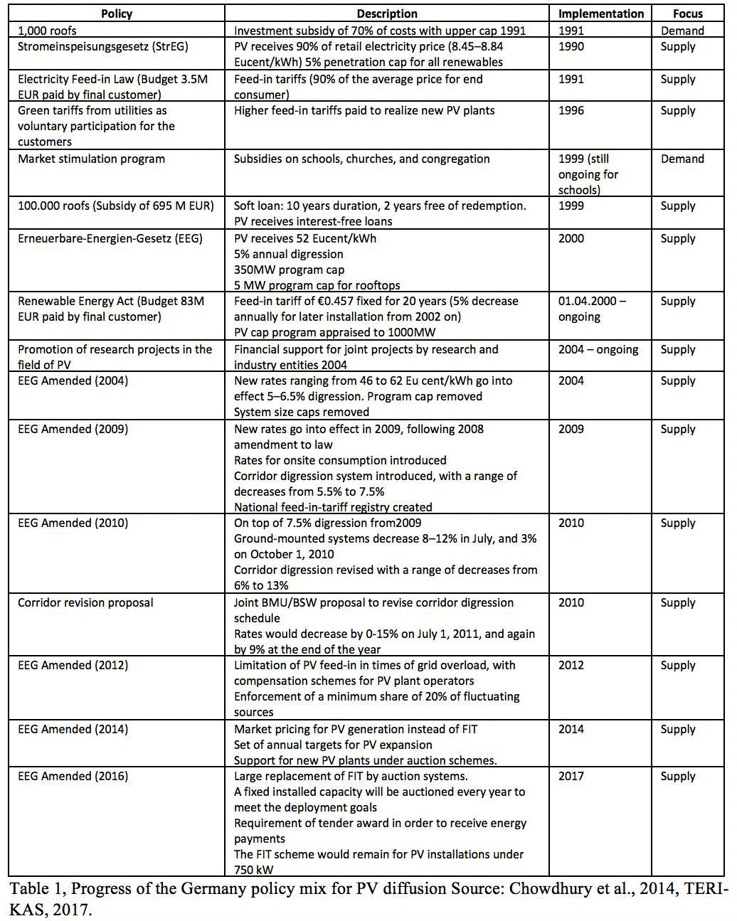

**Actors**

This chapter lists, maps and explains the relevant actors in Germany of the solar power energy sector and their interactions using the frameworks as mentioned in Chapter 2; the TSA, ANT and MLP.

This chapter starts by showing two tables; table 2 shows the relevant actors identified.

Table 3 shows whether the actors can be categorized in the micro-, meso- or macro-level.

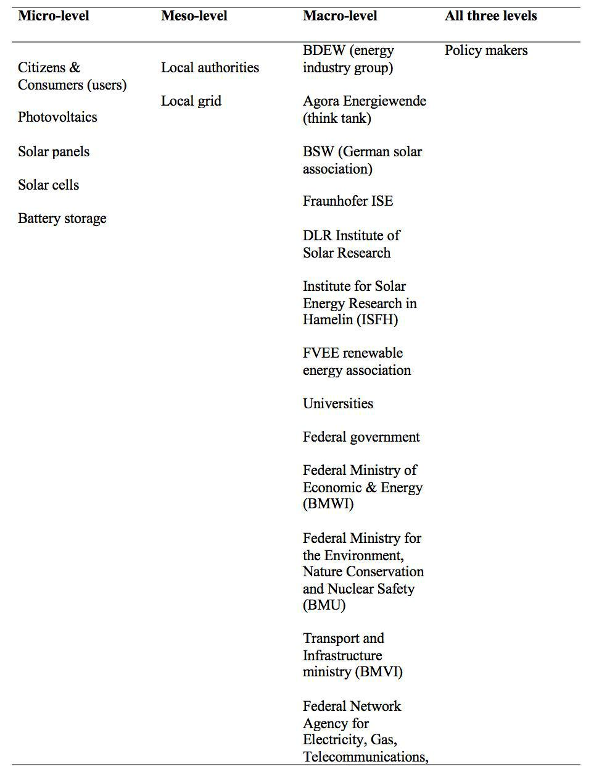

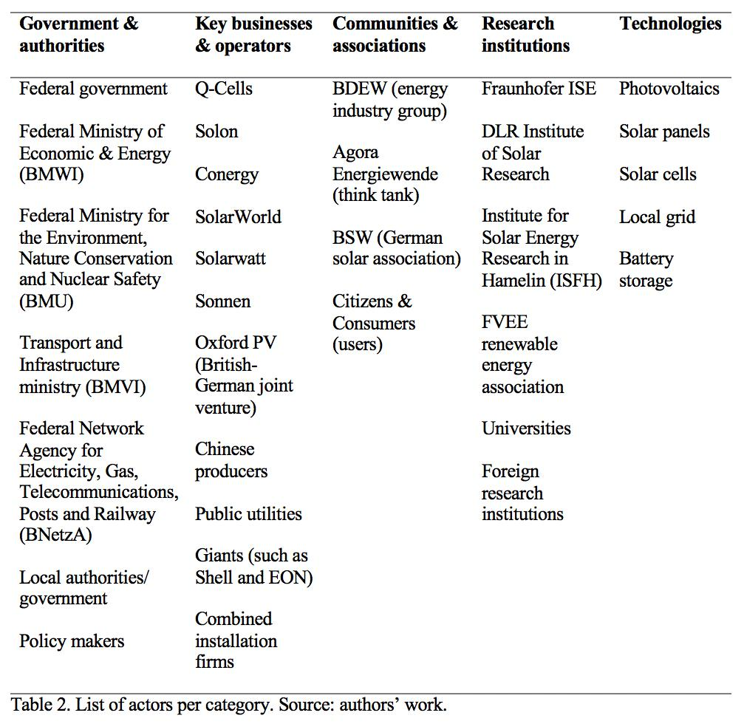

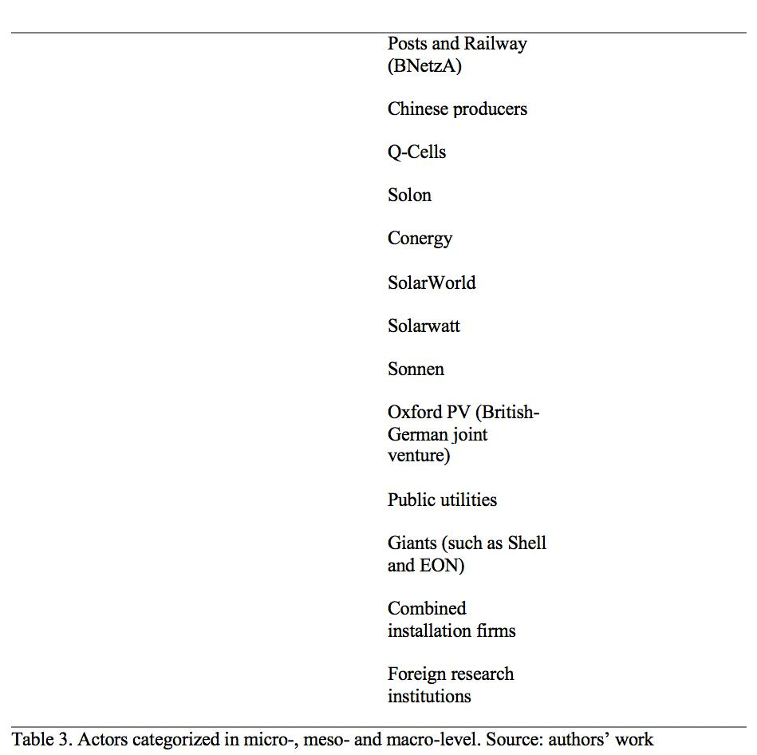

Since actor-networks are dynamic and considered inherently unstable, a stabilized factor is needed to align the actors (Greenhalgh and Stones, 2010). Hence, the global strategy of achieving the energy transition where solar power functions as a major technology can function as a factor that aligns the actors mentioned in table 1 since they all play a part in the energy transition using solar power.

*Citizens, consumers, users*

To successfully manage energy transition, the acceptance and support of German citizens are needed (Kalkbrenner and Roosen, 2016). If they accept and support the PVs for solar energy, the consumer will adopt the PV technology and therefore become a user. The national transition energy is decentralised in Germany, therefore civil society for transformations towards an environmentally friendly energy system in countries is important (Kalbrenner and Roosen, 2016). Furthermore, according to the research of Kalkbrenner and Roosen (2016), the factors that play the most important role in the willingness to participate in adopting renewable energy are social norms and trust, followed by environmental concern and higher income. This shows that social aspects are important for the energy transition, so a socio-technical transition is needed.

PV consumer demand has risen since prices of solar panels have fallen and a product range has broadened. Recent numbers show that in 2018 up to 1 million German households extract their energy from solar power (Karry, 2018). However, a recent developed is taking place regarding electricity storage. Germany has 120,000 households that installed solar units combined with battery storage, for electricity production and storage (Webb, 2019). Hence, battery storage and local grid systems combined with PVs have become important technologies that need to be further developed and diffused (Hockends, 2019; Webb, 2019; Cooke, 2019). These technologies are growing in popularity since numbers show that the amount of solar energy storage installations doubled since 2015 amongst German households (Karry, 2018), and more than 40 businesses in Germany are currently involved in this combined unit sector (Cooke, 2019).

*Key relationships and interaction between actors*

As explained in chapter 3, the role of the German federal government, which includes the BNetzA, BMWi, and BMU, is to regulate and facilitate the environment for the solar power market, in which businesses & operators, communities & associations, research institutions and technologies act and interact, and where the regional authorities – the Bundesländer – are responsible for the local energy transition policy and the PV infrastructure (TERI-KAS, 2017).

Businesses and Operators are firms and producers, electricity utilities, and the innovators of solar power technology. Firms, producers, and utilities are suppliers of solar energy and solar panels for electricity (Fraunhofer ISE, 2020).

The federal ministries and local authorities have the power to promote and incentivize the transition from non-renewable energy to renewable energy coming from solar power with e.g. PVs, and also storing this energy, by making investment decisions and providing benefits for PV users and producers (Fraunhofer ISE, 2020, p. 77). Hence, the interaction between the federal institutions, their policymakers, and the businesses are important.

The federal government changed the dynamics of the energy market by introducing the Energy Feed-in Law - 1991. Public utilities began to purchase renewable energy from solar, among other renewables. However, this solar power stayed unviable (TERI-KAS, 2017). Hence, the EEG introduced in 2000, brought some change. The EEG brought a fixed tariff over a 20 years period for every renewable energy generated. The government was also able to offer low-interest loans for PV installations below 300 MWp (TERI-KAS, 2017). With this, the government made citizens potential users of solar power, since they are able to generate their own electricity with PVs. With this the government took the role of an active promoter and citizens became consumers and active users. This is a way of facilitating a socio-technical transition.

The government providing a low-interest loan also provides the opportunity for solar power businesses and PV producers to grow and it stimulates the diffusion of solar power technology.

Looking at local authorities, it shows that public utilities can be owned by municipalities (TERI-KAS, 2017). Hence, municipalities can use this advantage to achieve renewable energy goals since they have a say in regional renewable electricity. Meaning that they can actively promote the energy transition among potential users. Making the relationship between municipalities, public utilities, and users significant for the socio-technical transition.

Research institutes and universities are funded by federal ministries (Braun, 2019). They depend on this funding for R&D, Germany also depends on R&D for the energy transition. Therefore, this relationship can be seen as interdependent.

R&D of research institutions is also important for businesses & operators and vice versa since businesses & operators are able to commercialize the R&D of research institutions (Braun, 2019). They both cause new technologies into the energy market that contributes to the energy transition.

The German Renewable Energy Act in 2000, boosted solar power energy. Between 2008 and 2013 investors wanted to capture the benefits of this large-scale technology, causing rapid growth of solar energy producers and service companies (Wehrmann, 2020). This made Germany one of the world leaders in that time in the field of solar power. One of the three largest solar panel producers in the world was a German company called SolarWorld. However, Germany had a tough time competing with China since China offered solar panels at a cheaper rate. It even caused the fall of SolarWorld, this was caused by investors changing investments from Germany to China to maximize returns since China produces at a much cheaper rate (Wehrmann, 2020).

Another interesting interaction is between large firms and German companies specialised in combined units; PVs and battery storage. Giants such as Shell have bought Sonnen, which was the leading supplier of home storage batteries. Power company EON – another German leading renewable company - and Solarwatt are cooperating. Furthermore, EnBW, which is one of the four large German utility companies, purchased Senec, also a supplier of battery storage (Cooke, 2019). This all shows that large firms are getting a hint of the growing German market of battery storage.

Besides the relationship between the actors, the interaction level is determined. Table 4 shows at what level the actors mostly interact with each other.

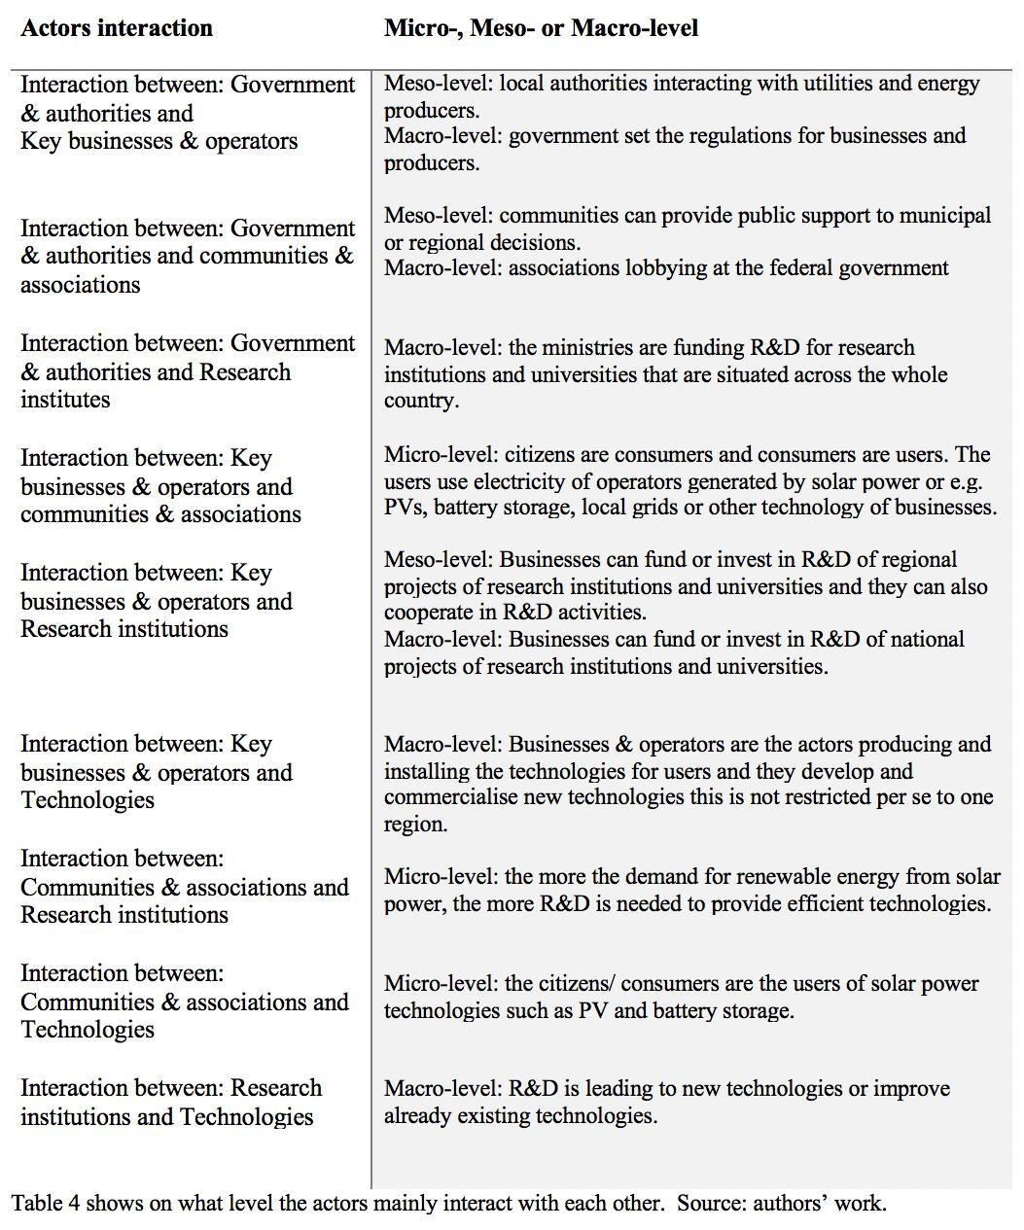

**Policy Recommendations**

The German solar power sector is already well developed but had its ups and downs (Wehrmann, 2020). Past years have shown that Germany also faces challenges in the solar power sector due to foreign players, such as China (Thompson, 2015). Germany has also shown that R&D activities, cooperation and knowledge flows between German firms, research institutions, universities and foreign technologies can be enhanced, as well as the development of infrastructure. Hence, the recommendations below are mainly focused on improving these aspects.

*Recommendation 1: Matchmaking with research institutions*

As it was indicated in Chapter 1 of this paper, there are recent improvements in enhancing the output of solar panels. Still, most of those R&D activities are made outside Germany, for example in Australia. In the case of Australia, the lab that made this breakthrough is struggling with financing and looking for investments (da Silva, 2016).

It is crucial to engage in cooperation or partnerships with research institutions overseas that are making progress in solar energy efficiency. The Australian case is an example, but there are many other companies looking for foreign investment to conduct their research, like Sub-Saharan Africa and companies in China (Tsagas, 2019). Therefore, it is recommended to invest or provide grant funding to related projects or institutions.

That kind of cooperation and partnership agreements will not only increase knowledge flows from other countries into Germany but will also develop a network of reliable partners.

*Recommendation 2: Subsidize R&D cooperation for battery storage and local grids.*

From what is explained in Chapter 5 regarding citizens, consumers, users, and large firms purchasing smaller firms specialised in battery storage, shows that supporting the R&D infrastructure for solar energy battery storage could be a leading path for Germany.

Germany once had a booming solar panel production market to provide solar panels to consumers to contribute to the diffusion of PVs. However, foreign competition has led to a significant decrease in solar panel production in Germany. Leading to a decline in domestic investments and domestic purchase by consumers.

Nevertheless, the issue of generating too much solar energy by PVs of households is leading to new opportunities for Germany, namely the development of battery storage technology. Germany can enhance this technology by providing the right R&D environment for firms, research institutions, and universities.

Therefore, the recommendation is to provide subsidies for R&D when firms and research institutions or universities cooperate to develop the technology of battery storage or local grid projects. This provides an incentive to cooperate and stimulate open innovation. Thereby, from the firms’ side, cooperation with research institutions and/ or universities will provide more knowledge, and from the research institutions’ and universities’ perspective, cooperation with firms can help to commercialise new innovations (Kuhlmann and Ordóñez-Matamoros, 2017).

*Recommendation 3: Capacity*

Germany has an ambitious goal of increasing the share of renewable energy to 65% by 2030 and to phase out coal power by 2038. Thus, additional installed capacity for PV power will be required (International Energy Agency, 2020) and solar parks and solar roofs systems should increase in a large scale. Although current levels of support through the FIT program will be needed in the short term (Weiss, 2014) to foster the implementation of both technologies, the government should start thinking in promoting also subsidy-free business models in the medium and long term, to reduce the energy prices that are nearly among the highest around the world.

*Recommendation 4: Developing promotion economic incentives for higher efficiency and related services*

During the last decade, several key German manufacturers of PV panels have been displaced out of their national market due to cheaper alternative panels produced in China. Companies such as SolarWorld, Solon and Q-cells filled for insolvency and warned that the German PV industry would be close to collapse due to unfair dumping practices by Chinese manufacturers whom, at the same time, have managed to find ways around the antidumping tariffs imposed by the EU through opening subsidiaries in neighbouring countries (Clean Energy Wire, 2017). However, the German PV industry – once at the cutting-edge of PV technology - could resurge with the right incentives if production or purchase subsidy schemes that reward development of more efficient PV panels are enforced. This way, the German industry could be incentivized to position in a more efficient niche market that brings higher environmental returns and is more attractive to corporate buyers. Incentives for related services, such as maintenance and development of storage capacity could be feasible alternatives as well for providing German PV players a second opportunity.

**Conclusion**

Using a combination of different frameworks and theories allowed us to analyse Germany’s solar power energy sector. We have found that Germany has a well-developed solar energy market compared to other countries. However, to achieve their ambitious goals the R&D sector needs further development and the solar power energy technology needs to grow more efficiently in order to diffuse this technology to achieve a sustainable energy transition. Hence, chapter has outlined four recommendations that can bring Germany a step closer to their ambitious goals regarding the sustainable energy transition, where solar power plays a major role.

**References**

BMWi. (2015). Making a success of the energy transition: on the road to a secure, clean and affordable energy supply (PDF). *Federal Ministry for Economic Affairs and Energy* *(BMWi)*.

BP. (2019). Statistical Review of World Energy. Retrieved from: https://www.bp.com/en/global/corporate/energy-economics/statistical-review-of-world-energy/downloads.html

BP. (2020). *Energy economics: Oil*. BP Global. Retrieved from: https://www.bp.com/en/global/corporate/energy-economics/statistical-review-of-world-energy/oil.html

Braun, J. (2019). Energy R&D Made in Germany. *HCSS Geo Economics.* Retrieved from: <https://hcss.nl/sites/default/files/files/reports/HCSS_Report_Energy%20Made%20in> %20Germany.pdf

Carlsson B, and Stankiewicz R. (1991). On the nature, function and composition of technological systems. *J Evol Econ,* 1. Pp. 93–118.

Carlsson B. Technological systems and industrial dynamics. Boston/Dordrecht/London:

Kluwer Academic Publishers; 1997.

Chowdhury, S., Sumita, U., Islam, A., & Bedja, I. (2014). Importance of policy for energy system transformation: Diffusion of PV technology in Japan and Germany. *Energy* *Policy*, *68*, 285–293. https://doi.org/10.1016/j.enpol.2014.01.023

Clean Energy Wire. (2017, May 11). Last major German solar cell maker surrenders to Chinese competition. *Clean Energy Wire*. Retrieved from: https://www.cleanenergywire.org/news/last-major-german-solar-cell-maker-surrenders-chinese-competition

Cooke, K. (2019). Sun shines on Germany’s solar sector. Climate news network. Retrieved from: <https://climatenewsnetwork.net/sun-shines-on-germanys-solar-sector/>

Da Silva, W. (2016). Milestone in solar cell efficiency by UNSW engineers. UNSW. Retrieved

from: https://newsroom.unsw.edu.au/news/science-tech/milestone-solar-cell-efficiency-unsw-engineers

Diepenmaat, H., Kemp, R., & Velter, M. (2020). Why Sustainable Development Requires Societal Innovation and Cannot Be Achieved without This. Sustainability, 12(3), 1270. https://doi.org/10.3390/su12031270

Dijk, M., Iversen, E., Klitkou, A., Kemp, R., Bolwig, S., Borup, M., & Møllgaard, P. (2020). Forks in the Road to E-Mobility: An Evaluation of Instrument Interaction in National Policy Mixes in Northwest Europe. Energies, 13, 475. https://doi.org/10.3390/en13020475

Fraunhofer ISE. (2020). Recent Facts about Photovoltaics in Germany. *Fraunhofer IS*. Retrieved from: <https://www.ise.fraunhofer.de/content/dam/ise/en/documents/publications/studies/rece> nt-facts-about-photovoltaics-in-germany.pdf

Geels FW. (2004). From sectoral systems of innovation to socio-technical systems: insights about dynamics and change from sociology and institutional theory. *Res Policy,* *33(6/7).* Pp. 897–920.

Geels, FW. and Kemp, R. (2007). Dynamics in socio-technical systems: Typology of change processes and contrasting case studies. *Technology in Society, 29.* Pp. 441-455.

Greenhalgh, T. and Stones, R. (2010). Theorising Big It Programmes in Healthcare: Strong Structuration Theory Meets Actor-Network Theory. *Social Science & Medicine*, 70. Pp. 1285-1294

Hockends, P. (2019). In Germany, Solar-Powered Homes Are Really Catching on. *Wired*. Retrieved from: https://www.wired.com/story/in-germany-solar-powered-homes-are-catching-on/#:~:text=The%20Parises%20are%20one%20of,the%20market%20five%20years% 20ago.

International Energy Agency. (2020). Germany 2020—Energy Policy Review. 229.

Kalkbrenner, B. and Roosen, J. (2016). Citizens’ willingness to participate in local renewable energy projects: The role of community and trust in Germany. *Energy Research &*

*Social* *Science*, 13. Pp. 60-70. Retrieved from: <https://doi.org/10.1016/j.erss.2015.12.006>

Karry (2018). Trend Report #1: Solar Energy, Devices and Gadgets in Germany. *Expansion* *eco.* Retrieved from: https://expansion.eco/solar-brands-in-germany/

Kuhlmann, S. and Ordóñez-Matamoros, G. (2017). Introduction: governance of innovation in emerging countries: understanding failures and exploring options. Cheltenham, UK: Edward Elgar Publishing. Handbook on Innovation Governance for Emerging Economies: Towards Better Models. Pp. 1-34. DOI: 10.4337/9781783471911

Longman, N. (2017). Top 10 solar-producing countries. *Energy digital*. Retrieved from: https://www.energydigital.com/renewable-energy/top-10-solar-producing-countries

Osanyinpeju, K., Aderinlewo, A., Olayide, A., Ajisegiri, E. (2018). Performance Evaluation of Mono-Crystalline Photovoltaic Panels in Funaab, Alabata, Ogun State, Nigeria Weather Condition. *International Journal of Innovations in Engineering Research and* *Technology.* 5 (2). pp. 8–20.

Our World in Data. (2020). Global renewable energy consumption, World, 1800 to 2018. Retrieved from: https://ourworldindata.org/renewable-energy

Power Technology. (2020). What are the most used renewable energy sources in the world? *Retrieved from:* https://www.power-technology.com/features/featurethe-worlds-most-used-renewable-power-sources-4160168/

Raugei, M. et al. (2017). Energy Return on Energy Invested (ERoEI) for photovoltaic solar systems in regions of moderate insolation: A comprehensive response. Energy Policy, 102, pp. 377-384.

Ritchie, H., & Roser, M. (2015). Energy. *Our World in Data*. https://ourworldindata.org/energy

TERI-KAS. (2017). Politics and Governance of Clean Energy: An Indo-German Comparative Study for Large Scale Diffusion of Renewable Energy in India. The Energy and Resources Institute. Report 2016 IA 02.

The Guardian. (2017). *Time to shine: Solar power is fastest-growing source of new energy*. https://www.theguardian.com/environment/2017/oct/04/solar-power-renewables-international-energy-agency

Thompson, S. (2015). How Germany Became a Solar Superpower. Triple Pundit. Retrieved

from: https://www.triplepundit.com/story/2015/how-germany-became-solar-superpower/32736

Töpfer, C., & Gawel, E. (2013). *The Photovoltaic Support Scheme in Germany: An* *Environmental Criteria Assessment of the EEG Feed-In Tariffs*. Logos Verlag BerlinGmbH.

Tsagas, I. (2019). Financing African projects remains a struggle. *PV Magazine*. Retrieved

from: https://www.pv-magazine.com/2019/11/25/financing-african-projects-remains-a- struggle/

United Nations. (2018). Goal 7: Affordable and Clean Energy - SDG Tracker. Our World in Data. https://sdg-tracker.org/energy

Webb, L. (2019). Which Countries Are Leading The Way With Solar Power? *Nes Global Talent.* Retrieved from:https://www.nesgt.com/blog/2019/06/which-countries-are-leading-the-way-with-solar-power

Wehrmann, B. (2020) Solar power in Germany – output business & perspectives. Clean Energy

Wire. Retrieved from: https://www.cleanenergywire.org/factsheets/solar-power-germany-output-business-perspectives

Wettengel, J. (2019) Tenant electricity expansion lags behind expectation – econ min. Clean

Energy Wire. Retrieved from: https://www.cleanenergywire.org/news/tenant-electricity-expansion-lags-behind-expectations-econ-min

Wirth, H. (2020). Recent facts about photovoltaics in Germany. Fraunhofer ISE.

Weiss, J. (2014). Solar energy support in Germany. Retrieved from: https://www.seia.org/sites/default/files/resources/1053germany-closer-look.pdf

World Coal Association. (2015). *Where is coal found?* World Coal Association. https://www.worldcoal.org/coal/where-coal-found

# For a Wider Adoption of Smart Grids: The Case of Norway, *by Christian Nota, Marie Gillet, Hamza Sayan*

Christian Nota, Marie Gillet, Hamza Sayan

**Introduction**

The Paris Agreement aims to reinforce countries’ capabilities to tackle adverse effects of climate change (UNFCCC, n.d.). Norway has assertive climate goals and aims to reduce its GHG emissions at least by 40% of its 1990 emissions until 2030 and be a low-emission society by 2050 (Ministry of Climate and Environment, 2017). An energy transition is needed to limit GHG emissions, where the transition from fossil fuels to low-carbon solutions may have an important role. This can be achieved through technological progress in the area of renewable energy (Gielen et al., 2019). However, cost and availability of renewable energy like hydro, wind and solar power is the main problem, since this kind of energy is not always available due to daily and seasonal effects that cause intermittent power generation. At this point, Smart Grids can be a promising solution (Hossain et al., 2016).

Smart Grids are a key component of the strategies aimed at moving towards sustainable development and a future where the energy produced and consumed is sustainable. They are key drivers to shifting towards sustainable cities (SDG 11), as they are facilitators of integration of renewable energy sources and the electrification of transports (Masera et al., 2018). This paper analyses the development, diffusion and use of Smart Grids in the context of Norway, one of the leading countries in the use of renewable energy. Indeed, “RES (Renewable Energy Sources) account for close to 100% of Norway’s electricity generation” (Y. Wang et al., 2019). However, given the country’s commitment to fulfilling the European Renewables Directive, 67% of the total energy use should be based on renewable energy by the end of this year, which requires an increase in the consumption of renewable energy so as to substitute the use of fossil-fuels in the power system (ETP SmartGrids, 2016). For the purpose of this paper, the term ‘Smart Grid’ is defined as “an electricity network that can cost efficiently integrate the behaviour and actions of all users connected to it – generators, consumers and those that do both – in order to ensure economically efficient, sustainable power system with low losses and high levels of quality and security of supply and safety” (EU Commission Task Force for Smart Grids, 2010).

This paper aims to formulate a policy framework for the government of Norway, institutions and bodies in charge of the research and implementation of smart grids in the country, as well as for producers and end-users of said technology to help the wider diffusion of our chosen eco-innovation: Smart Grids. In order to do so, the paper will be divided in 5 sections. Section 1 provides a detailed explanation of the theoretical framework that will be used to analyse the case of Norway, namely Technological Innovation Systems (TIS). Section 2 presents an overview of what Smart Grids are, how they work and how they differ from traditional electrical grids in terms of social and environmental sustainability advantages. Section 3 explores the case of Norway by mapping the relevant actors, describing the history of system building activities for Smart Grids, current policies around said technology, current levels of development of Smart Grids, and challenges the country still faces for a wider diffusion of this technology. Based on conclusions reached by the former sections, Section 4 provides a series of recommendations regarding the degree of supply chain change, organisational change, social innovation and wider institutional changes that are still needed for wider diffusion of Smart Grids at the country level. Section 5 will conclude the paper by summarising our findings and recommendations and outlining potential limitations of our analysis.

**Theoretical Framework**

The theoretical framework used to examine the case of Smart Grids in Norway will be the Technological Innovation System (TIS). It takes “a systems approach for understanding the development, diffusion and use of new technologies”(Edsand, 2019). Indeed, we define a TIS focusing on a technology as a “network of agents interacting in the economic/industrial area under a particular institutional infrastructure and involved in the generation, diffusion, and utilisation of technology” (Carlsson & Stankiewicz, 1991), and this network can operate at the national, regional and sectoral levels. According to Jacobsson & Bergek (2011), a TIS is comprised of seven sub-processes:

1. Knowledge development and diffusion

2. Entrepreneurial experimentation

3. Influence on the direction of research

4. Resource mobilisation

5. Market formation

6. Legitimation

7. Development of positive externalities

Using the TIS framework will provide us with a scheme of analysis for the case of Norway, so as to identify what the Smart Grid Innovation system is achieving and what are the barriers it currently faces (Figure 1). We will first define the focus of our TIS as the specific technology that is Smart Grids. We will then map all relevant players in the diffusion of Smart Grids at the country level and the functions of each player in enabling their research, development and diffusion. Finally, we will analyse how the functional pattern of this system is shaped through present inducement and blocking mechanisms (Bergek et al., 2008) and thus identify key policy issues that Norway has to overcome in order to enable a wider diffusion of Smart Grids.

The main benefit of using the TIS framework in this report is, that “it focuses on what is actually achieved in the system, rather than on the structure of the system” (Bergek et al., 2008). It will also enable us to identify potential system failures or weaknesses, and is most suited for this paper, which seeks to understand the potential and constraints of Smart Grids in Norway. Indeed, the wider diffusion of this eco-innovation will require the collaboration of a multitude of suppliers and service providers who will be able to install, integrate and maintain larger-scale Smart grids across the whole country.

SECTION 2: SMART GRIDS - A BACKGROUND

WHAT ARE SMART GRIDS AND HOW DO THEY WORK?

To define a Smart Grid, it is first necessary to understand what an electrical grid is: an electrical power system network, which is composed of a generating plant, transmission lines, substations and more which deliver electricity from the power plant to homes and businesses (Kehinde, n.d.). A Smart Grid is a modernization of the traditional electrical grid, a radical enhancement of how electricity is created and delivered. What makes the grid “Smart” is that the electrical grid has been computerized, moving from a one-way to a two-way communication network between the consumer and power supplier (Davis, 2017).

HOW DO SMART GRIDS COMPARE TO TRADITIONAL ELECTRICAL GRIDS?

Traditional electricity grids are mainly characterised by the traditional energy meter, which “measures the amount of consumed energy by a building, and stores the consumption data such that it can be read later for the purpose of billing” (Ghazi Khamees Ali & Abdul Lateef Abdul Ridha, 2014). Besides being unable to make users aware of their high energy consumption, using traditional energy meters comes with a number of disadvantages: their low accuracy levels give faulty readings, they are exposed to electricity thefts, additional financial resources have to be used to employ workers to read values of consumed energy, they cannot limit the amount of consumed energy by the consumer or control the operation of building appliances, do not support remote connection and disconnection, and are not built for enabling end-users to provide their excess electricity to the utility grid (Ghazi Khamees Ali & Abdul Lateef Abdul Ridha, 2014).

Smart Grids offer a few advantages for solving energy problems and enabling the transition towards sustainable development and smart cities when compared to the traditional grid. Javadi & Javadi (2010) outline five main benefits to using Smart Grids in comparison to traditional electrical grids. Firstly, the energy provision of Smart Grids is more reliable: it has few and brief outages, along with self-healing power systems, which use digital information, automated control and autonomous systems (Javadi & Javadi, 2010). Second, the constant monitoring process ascertains insecure situations, as “high cyber security is built into all systems and operations” (Javadi & Javadi, 2010). A third benefit is that Smart Grids lead to reduced energy consumption, controlling demand during peak hours, minimising losses and helping users manage their energy behaviour. Moreover, Smart Grids decrease the generation of electricity from non-environmentally-friendly sources, which also stimulates the replacement of oil-powered vehicles with electric vehicles (Javadi & Javadi, 2010).A final benefit is that operation costs related to electricity are reduced, as “customers have pricing choices and access to energy information [and] entrepreneurs accelerate technology introduction into the generation, distribution, storage and coordination of energy” (Javadi & Javadi, 2010).

Another advantage of implementing Smart Grids over traditional utility grids is a “better support for bidirectional energy flow, where implementing smart grids contributes to acquiring a better understanding of the value of renewable resources of energy […] because using these resources instead of the traditional resources helps in providing the energy from the consumers to the utility grids” (Ghazi Khamees Ali & Abdul Lateef Abdul Ridha, 2014).

POTENTIAL BARRIERS TO DIFFUSION

We identify two main categories of barriers to the implementation and diffusion of Smart Grids: non-technical challenges and changes in the power system value chain. First, non-technical challenges such as public concerns should not be ignored, as public acceptance or non-acceptance of related technologies have a strong influence on the diffusion of Smart Grids (and emerging technologies in general). Within this category of challenges is included the potential issue of privacy, whereby “detailed information about electricity use could be used by insurers, market analysts, or even criminals to track the daily routine of consumers; 35% of consumers would not allow the utility to control thermostats in their homes at any price (in Europe)” (Giordano et al., 2011). Concerns related to privacy also affect utilities, which are held accountable for secure data transfer and management, and the costs associated with managing large amounts of data.

The second main barrier to the diffusion of Smart Grids is that it requires major changes in the power system value chain (see Figure 2). Indeed, the traditional system can be seen as a ‘one-way-street’, in which “power is generated in large centralised plants, transmitted to regional utilities at high voltage, then transformed into medium and low voltage power, and finally delivered to the customer” (Nair, 2017). In order for Smart Grids to be effectively adopted and diffused, the electricity value chain has to evolve to a ‘two-way’ communicating smart system that is controlled by new communication and information facilities, and in which incumbent companies are forced to renew their business models so as to stay competitive (Nair, 2017).

SECTION 3: SMART GRIDS - THE CASE OF NORWAY

Norway has been chosen as a case study since it is one of the leading countries with regards to its renewable energy share. Nowadays, 98-99% of the total electricity share comes from hydropower (Fosso et al., 2014) although the country still has not achieved the European Renewables Directive, which aimed for reaching 67% of electricity usage from renewable energy by 2020.

ACTORS INVOLVED

To effectively develop a sustainable socio-technical transition, a system-building approach is needed: it is necessary to create a network in which all actors interact and cooperate. In the Smart Grid evolution, sixteen categories of actors have to be involved (Gangale et al., 2017):

1) Government

2) Consumers, civil society

3) Generation companies

4) Utilities

5) Transmission system operators (TSO): Statnett

6) Distribution system operators (DSO)

7) Retail companies

8) ICT and telecom services: Telenor, Telia, etc.

9) Technology manufacturers: Smartym Pro, Alphonic Network Solutions Pvt.

10) Industry associations

11) Companies providing engineering services

12) Universities: Norwegian University of Science and Technology (NTNU)

13) Research centres: Norwegian Smart Grid Centre, Norwegian Smart Grid Laboratory, CINELDI

14) Consultancies: 21 Enfo

15) Public institutions

16) Emerging stakeholders

Since legislation plays a crucial role in Smart Grid development, local governments have to be involved so as to implement coordinated policies and sharing responsibility. Norwegian municipalities are extremely influential actors, as they have large investments in the power sector: they own 90% of Norway’s electric production capacity (Norwegian Ministry of Petroleum and Energy, 2019). Individual, commercial and residential consumers must be considered differently, as they use energy diversely and should obtain different types of advantages from their energy management. Civil society representatives in the network are central, since they represent consumers, the environment and privacy-focused organizations. Moreover, since technology optimization is still in its experimentation phase, the incorporation of research institutions and universities is vital. The former is needed for the availabilities of niches where the technology can be further developed away from uncertainties present in the market. Universities are necessary for having the human capital needed to work correctly on those R&D Smart Grid projects. In terms of business and policy analysis, consulting companies also have to be aligned with other stakeholders in order to get a clear overview of costs and benefits involved in energetic projects.

Actors that are particularly pro-Smart Grid diffusion are new stakeholders that can make profit with a change of electrical regime, such as hardware providers, IoT-related companies, electric vehicle firms, and Smart grid consulting companies. Counter-actors that have been identified are low-income people, in particular those who have more important priorities than their energy management and consumption and are more concerned with reducing their bills by using less fuel or choosing the cheapest alternative (which currently is still fossil fuels) (Silvast et al., 2018). We also identify current (fossil fuel-sourced) energy suppliers as counter-actors, who are resistant to a sustainable transition in energy provision and consumption. This is because their current business models generate high profits, and their interaction at institutional and governmental levels makes them resilient to a change in the existing socio-technical regime.

CURRENT STATUS OF NORWAY

The Norwegian Smart Grid laboratory was opened in 2016 to integrate real-time simulations and physical power system assets. One of its main features is the flexibility in its setup, which allows a range of use cases to be tested, from smart homes/micro-grids to Alternative Currents or multi-terminal Direct Current transmission systems (Global Smart Grid Federation, 2017).

Moreover, Norway is the nation with the largest market share for electric vehicles (55.6%) (Manthey, 2020), which enhances its potential for the implementation of vehicle-to-grid (V2G) technology. Consumers are able to charge electric vehicles and constantly monitor their energetic consumption, leading to a better management of energy efficiency, in particular during peak hours.

CURRENT POLICIES AROUND SMART GRIDS IN NORWAY

NORWEGIAN SMART GRID CENTRE (NSGC)

The starting point of Norwegian Smart Grid policies was the establishment of the Norwegian Smart Grid Centre (NSGC) in 2010, a national strategy implemented by the Norwegian Ministry of Petroleum and Energy for defining the future of energy R&D in Norway (Fosso et al., 2014). NSGC is a strategic partnership which involves all actors which gravitate around Smart Grid initiatives. This project aims to strengthen the following functions of the TIS:

1) Knowledge development and diffusion

2) Resource mobilisation

3) Entrepreneurial experimentation

It currently has 46 members, including universities, research institutions, manufacturers, and power, ICT and consulting companies (Global Smart Grid Federation, 2017). The centre has three roles:

1) Setting primary issues and managing coordination and mobilisation activities related to the European Commission’s Horizon 2020 Programme and the Norwegian Centres for environment-friendly energy research;

2) Disseminating information and findings from demonstration projects;

3) Trendspotting and technology monitoring (International Energy Agency, 2015)

One of the weaknesses of the NSGC is related to the fact that the multi-stakeholder alignment process can be complicated and costly due to the large number of actors involved, with different interest and perspective on the development of the technology.

The NSGC has also developed the Demo Norway project for the creation of niches where knowledge and Smart Grid technologies can develop isolated from market uncertainties, while creating a new market itself, with the aim to achieve the “market formation” function of the TIS. On this laboratory platform, the functioning of this technology can be tested repeatedly before its introduction to the market. It is composed of eight demo sites with more than 10’000 network customers using Smart meters (Global Smart Grid Federation, 2017).

ENERGI21

Regarding energy research, the national R&D strategy (Energi21) was enacted in 2007 by the Norwegian Ministry of Petroleum and Energy (International Energy Agency, 2015). This policy focuses mainly on the following functions of the TIS:

1) Knowledge diffusion and development

2) Entrepreneurial experimentation

3) Resource mobilization

The execution of this strategy is done by an independent advisory board chosen by the previously mentioned ministry (Figure 3). "The primary function of the Energi21 initiative is to provide strategic input and recommendations to the authorities on R&D activities that target the development of climate-friendly, stationary energy technology" (International Energy Agency, 2015).

This policy largely contributed to the enhancement in public funding of energy R&D in the 2009 to 2011 period (International Energy Agency, 2015). The collaboration of a range of stakeholders from the business sector, academia and other influential actors is at the base of the policy itself. To be more precise, the shared vision for the multi-stakeholder alignment in the strategy is "a climate-friendly energy nation-and an international supplier of energy, power, technology and knowledge" (International Energy Agency, 2015).

R&D investments have been focused in six key areas, namely solar power, raising energy efficiency, hydropower, flexible energy systems, offshore wind power, and carbon capture and storage. The policy is focused on stationary energy, excluding electric vehicles from its interest, and this is one of its main weaknesses. It however does not consider the impact that total electrification of the transport sector (which is most likely to happen in the next decades) will have on the sector, in particular on power requirements (charging stations), frequency stability and general supply.

DRIVING FORCES FOR SMART GRIDS IN NORWAY

It is necessary to identify which are the driving forces to Smart Grid diffusion in Norway so as to then be able to identify remaining challenges for a wider implementation of this technology. Driving forces can be separated into three levels: megatrends, external driving forces and grid related driving forces (Hermansen, 2019), and are closely interrelated, as we can see in Figure 4 below.

Let us use the example of prosumers, end users that both use and produce energy and are therefore a source of distributed generation (CINELDI, 2019), as a driving force (in the generation group) for Smart Grid development. The underlying megatrend for this driving force is climate change, which has an influence on politics, regulation and standardisation, and societal trends and values in order to encourage production from renewable forces and spreading environmental awareness to make people want to contribute (Tonje Skoglund Hermansen, 2019). Climate change also influences technological development, which provides windows of opportunity for new business models and stakeholders, “calls for new planning methods for grid development and new aspects to be included in grid operation [which] influences on security of supply” (Tonje Skoglund Hermansen, 2019). More distributed generation also impacts on the economy, as the need for electricity from the grid will be reduced, but also gives rise to potential safety challenges around the control of small-scale generation of energy during blackouts. These internal driving forces and challenges then emphasize the need for changes in regulations, and reveal potential external threats, for example new channels for hackers to get into the control system of the grid (CINELDI, 2019). All these interactions between different levels of driving forces are shown in Figure 5 above.

REMAINING CHALLENGES

Norway’s TIS does not seem to be prone to any system failures due to collaboration issues between relevant actors, which are effectively coordinated through the Norwegian Smart Grid Centre national strategy. Despite the advanced level of development of Smart Grids in the country, two main challenges remain and constitute a challenge to the wider diffusion of this eco-innovation, which mainly relate to the degree of supply chain change that is required when shifting from traditional grids to Smart Grids (as mentioned in Section 2):

1) Weak grids: supply terminals are weaker than the standardised electromagnetic compatibility (EMC) reference, which gives means that the security of supply of electricity is not guaranteed everywhere (Ballo, 2015)

2) Low voltage system relative to the European average (230 Volt compared to 400 Volt in the majority of the region)

The first challenge is highly related to Norway’s geography, winter conditions and varied topography, which makes it difficult for the government and energy providers to meet all of their consumers’ needs (Bach Andersen et al., 2019). Indeed, the country’s cold winters mean that households heavily rely on stable electricity provision for heating, and will not tolerate black-outs and unreliable energy production. The issues that a low voltage system may cause in households are poor appliance performance, intermittent stopping of lights or dim lighting, due to appliances not receiving the proper amount of power they need, so they become overheated and stop functioning properly (Urvashi G., 2017).

A scenario that may give rise to the two previously mentioned challenges may be partly resulting from the ICT competence and organisational aspect driving force, in the cyber security driving force group (Figure 4). Indeed, DSOs focus their recruitment procedure on specialised competences, so their employees are either working on electric power or ICT. Since these two disciplines are organised in different departments, there is a lack of understanding of their interdependence, meaning that departments develop solutions that do not work together despite being separately good (Hermansen et al., 2019). Since the systems cannot work together, power interruptions last longer, so there is a lower security of supply and therefore also a negative impact on the economy (since interruption costs are increased).

SECTION 4: POLICY RECOMMENDATIONS

In order to overcome the previously mentioned challenges, we propose a few recommendations that will address and improve the following functions of the Smart Grid TIS: knowledge development and diffusion, influence on the direction of research, resource mobilisation and indirectly legitimation as research will provide more sources of argumentation to push for a full transition to Smart Grids.

First, Norway must ensure a continuous investment in R&D for Smart Grids and its associated technologies. Continued R&D of new energy storage technologies “should focus on improving round-trip efficiency and reducing capital costs […] and improving the performance of the most market-ready or highest-valued storage systems” (Zame et al., 2018) so as to ensure the continued improvement of Smart Grids system in Norway and limit the risks of any technical barriers to diffusion in the future. We also recommend the NSGC to invest in the researching ways to circumvent the issues of weak grids and low voltage systems, which constitute a great threat to the security of electricity supply. This is especially important due to the “expected future increase in number of electric vehicles due to Norway’s generous subsidy policy means that it is highly important to invest in maintaining and upgrading the electrical grid so as to be able to deal with increased demand of energy” (Ballo, 2015).

In addition to recommending investment in previously mentioned areas for research, we also recognize the need for a secure supply of electricity that needs to be tackled in more concrete ways. The Norwegian government already financially penalizes companies if a long-lasting black-out occurs, and has introduced Smart Meters in all households since January 2019 in order to deal with uncertainty in the security of supply of energy, but more needs to be done (Ballo, 2015), as this challenge still remains. In order to tackle this issue, and in order to cope with future pressures on the Norwegian Smart Grid, we recommend a three-step approach (the first two of which have already been achieved):

1) Intelligent planning

2) Intelligent monitoring

3) Active management and control (Einfalt et al., 2012)

The first step refers to planning an adequate infrastructure for electrical low voltage and ensuring the security of supply of energy at all levels. Since this is already functional in less remote areas of the country, we recommend Norway to conduct research for intelligently planning the necessary infrastructure for a secure supply of energy in most remote and difficult conditions. The second step refers to collecting data from Smart Meters, which have already been installed country-wide, so as to understand where exactly issues occur and find in which areas it will be necessary to improve and support grid operation. As for the last step, we recommend for energy providers and institutions related to the NSGC to conduct “active management and control [of energy supply] using communication infrastructures restricted in bandwidth and availability [which will] result in new and cost-effective active low voltage network control solution approach enabling higher densities of distributed energy resources, e.g. heat pumps, e-mobility, generators, etc.” (Einfalt et al., 2012).

One last recommendation we could make in order to curtail issues related to the weakness of the Norwegian Smart Grid would be to research and implement a virtual-impedance-based control scheme for voltage-source converters and current-source converters, which are used in renewable energy systems (X. Wang et al., 2015). The main benefit of implementing this scheme is that it acts as an active damper, so a way to control and stabilize the power running through the electrical grid (X. Wang et al., 2015). Applying such a scheme would result in a stable, resistant, and thus stronger Smart Grid that would resist to Norway’s difficult topography and seasonal challenges.

SECTION 5: DISCUSSION & CONCLUSIONS

We have provided through this paper a complete analysis of the development and diffusion of Smart Grids in Norway, using the Technological Innovation System (TIS) as a reference framework. The main aim of this report was to identify the remaining barriers to the wider implementation of this eco-innovation, and provide policy recommendations to overcome said barriers. We have determined that Norway was advanced and effective when looking at the seven sub-processes of TIS, and in implementing niches with the Demo Norway programme and Norwegian Smart Grid Laboratory, for example. Because of this, and of the effective collaboration between all relevant actors present in the TIS, the remaining barriers to the diffusion of Smart Grids are mainly technical and relate to the secure and stable supply of energy.

The recommendations we have provided in order to cope with said challenges include investment in R&D, a three-step approach to ensuring adequate infrastructure, and a virtual-impedance-based control scheme. We, however recognize that there are several limitations in our approach, in that our recommendations mainly address the supply-side of Smart Grids, and do not necessarily consider the consumer side and the unpredictability of their behaviour in terms of energy management. This relates to the idea that the real-world economy is different from the theory, as consumers are not always rational actors, and therefore their behaviour is difficult to predict.

**References**

Bach Andersen, P., Hashemi Toghroljerdi, S., Meier Sorensen, T., Eske Christensen, B., Christian Morell Lodberg Høj, J., & Zecchino, A. (2019). The Parker Project—Final Report (1.1). Energy Technology Development and Demonstration Program (EUDP). https://parker-project.com/wp-content/uploads/2019/03/Parker_Final-report_v1.1_2019.pdf

Ballo, I. F. (2015). Imagining energy futures: Sociotechnical imaginaries of the future Smart Grid in Norway. Energy Research & Social Science, 9, 9–20. https://doi.org/10.1016/j.erss.2015.08.015

Bergek, A., Jacobsson, S., Carlsson, B., Lindmark, S., & Rickne, A. (2008). Analyzing the functional dynamics of technological innovation systems: A scheme of analysis. Research Policy, 37(3), 407–429. https://doi.org/10.1016/j.respol.2007.12.003

Carlsson, B., & Stankiewicz, R. (1991). On the nature, function and composition of technological systems. Journal of Evolutionary Economics, 1(2), 93–118. https://doi.org/10.1007/BF01224915

CINELDI. (2019). Annual report 2019. https://www.sintef.no/globalassets/project/cineldi/annual-2019/cineldi_annual_report_2019_rev_lr.pdf

Davis, N. (2017, May 18). The Smart Grid: What’s ‘the grid’ and how is it ‘smart?’ Power Electronics. https://www.powerelectronicsnews.com/the-smart-grid-whats-the-grid-and-how-is-it-smart/

Demo Norway. (2014). Demo Norway for Smart Grids. https://smartgrids.no/wp-content/uploads/sites/4/2014/04/Case-book_contribution_Demo-Norway-for-smart-grids_AS.pdf

Develco Products. (2017, February 10). Implementing an energy smart grid system in Norway. State of Green. https://stateofgreen.com/en/partners/develco-costumized-products-for-companies-supplying-costumers-with-iot/news/implementing-an-energy-smart-grid-system-in-norway/

Edsand, H.-E. (2019). Technological innovation system and the wider context: A framework for developing countries. Technology in Society, 58, 101150. https://doi.org/10.1016/j.techsoc.2019.101150

Einfalt, A., Lugmaier, A., Kupzog, F., & Brunner, H. (2012). Control strategies for smart low voltage grids—The project DG DemoNet—Smart LV Grid. CIRED 2012 Workshop: Integration of Renewables into the Distribution Grid, 1–4. https://doi.org/10.1049/cp.2012.0824

ETP SmartGrids. (2016, May). National and Regional Smart Grids initiatives in Europe: Cooperation opportunities among Europe’s active platforms. ETIP SNET. https://www.etip-snet.eu/etip_publ/etp-smart-grids-national-regional-smart-grids-initiatives-europe/

EU Commission Task Force for Smart Grids. (2010). Expert Group 1: Functionalities of smart grids and smart meters. http://www.ieadsm.org/wp/files/Tasks/Task%2017%20-%20Integration%20of%20Demand%20Side%20Management,%20Energy%20Efficiency,%20Distributed%20Generation%20and%20Renewable%20Energy%20Sources/Background%20material/Eg1%20document%20v_24sep2010%20conf.pdf

Fosso, O., Molinas, M., Sand, K., & Coldevin, G. (2014, May 18). Moving towards the Smart Grid: The Norwegian Case. https://doi.org/10.1109/IPEC.2014.6869838

Gangale, F., Vasiljevska, J., Covrig, F., Mengolini, A., & Fulli, G. (2017). Smart grid projects outlook 2017: Facts, figures and trends in Europe. doi:10.2760/15583

Ghazi Khamees Ali, M., & Abdul Lateef Abdul Ridha, O. (2014). A Comprehensive Study of Smart Grids. International Journal of Computer Applications, 93(14), 15–21. https://doi.org/10.5120/16282-6041

Gielen, D., Boshell, F., Saygin, D., Bazilian, M. D., Wagner, N., & Gorini, R. (2019). The role of renewable energy in the global energy transformation. Energy Strategy Reviews, 24, 38–50. https://doi.org/10.1016/j.esr.2019.01.006

Giordano, V., Gangale, F., Fulli, G., & Institute for Energy (European Commission). (2011). Smart Grid projects in Europe: Lessons learned and current developments. Publications Office. http://dx.publications.europa.eu/10.2790/32946

Global Smart Grid Federation. (2017, January). Member of the Month: The Norwegian Smartgrid Centre. http://www.globalsmartgridfederation.org/old-website-on-13march2018/2017/01/20/member-of-the-month-the-norwegian-smartgrid-centre/

Hermansen, Tonje S, Vefsnmo, H., & Kjølle, G. (2019). DRIVING FORCES FOR INTELLIGENT DISTRIBUTION SYSTEM INNOVATION – RESULTS FROM A FORESIGHT PROCESS. 5.

Hermansen, Tonje Skoglund. (2019, December 3). Finding Smart Grid driving forces and how they affect Smart Grid development. #SINTEFblog. https://blog.sintef.com/uncategorized-en/finding-smart-grid-driving-forces-smart-grid-development/

Hossain, M. S., Madlool, N. A., Rahim, N. A., Selvaraj, J., Pandey, A. K., & Khan, A. F. (2016). Role of smart grid in renewable energy: An overview. Renewable and Sustainable Energy Reviews, 60, 1168–1184. https://doi.org/10.1016/j.rser.2015.09.098

International Energy Agency. (2015). Will a smarter grid lead to smarter end users – or vice versa: Smart grid applications at end-user points. The Research Council of Norway. http://www.ieadsm.org/wp/files/Report_EGRD_workshop_on_smart_grid_and_endusers.pdf

Jacobsson, S., & Bergek, A. (2011). Innovation system analyses and sustainability transitions: Contributions and suggestions for research. Environmental Innovation and Societal Transitions, 1(1), 41–57. https://doi.org/10.1016/j.eist.2011.04.006

Javadi, S., & Javadi, S. (2010). Steps to smart grid realization. https://www.researchgate.net/publication/228355435_Steps_to_smart_grid_realization

Kehinde, E. (n.d.). Electrical Grid. StudentEnergy. https://www.studentenergy.org/topics/electrical-grid

Krishnamurti, T., Schwartz, D., Davis, A., Fischhoff, B., de Bruin, W. B., Lave, L., & Wang, J. (2012). Preparing for smart grid technologies: A behavioral decision research approach to understanding consumer expectations about smart meters. Energy Policy, 41, 790–797. https://doi.org/10.1016/j.enpol.2011.11.047

Lallanilla, M. (2013, December 12). What is a Smart Grid? Livescience.Com. https://www.livescience.com/41920-smart-grid.html

Manthey, N. (2020, April 3). Norway: Electric cars take 55.9% market share in March. Electrive.Com. https://www.electrive.com/2020/04/03/norway-electric-cars-take-55-9-market-share-in-march/

Masera, M., Bompard, E. F., Profumo, F., & Hadjsaid, N. (2018). Smart (Electricity) Grids for Smart Cities: Assessing Roles and Societal Impacts. Proceedings of the IEEE, 106(4), 613–625. https://doi.org/10.1109/JPROC.2018.2812212

Ministry of Climate and Environment. (2017, June 16). Norway’s Climate Strategy for 2030: A transformational approach within a European cooperation framework—Meld. St. 41 (2016–2017)

[Stortingsmelding]. Government.No; regjeringen.no. https://www.regjeringen.no/en/dokumenter/meld.-st.-41-20162017/id2557401/

Nair, N. (2017). Smart Grid Policy Implementation Barriers. 70.

Norwegian Energy Regulatory Authority. (2016, May 23). Smart metering (AMS)—NVE. https://www.nve.no/norwegian-energy-regulatory-authority/retail-market/smart-metering-ams/

Norwegian Ministry of Petroleum and Energy. (2019). Ownership in the energy sector. Energifakta Norge. https://energifaktanorge.no/en/om-energisektoren/eierskap-i-kraftsektoren/

Silvast, A., Williams, R., Sampsa, H., Rommetveit, K., & Raab, C. (2018). Who ‘Uses’ Smart Grids? The Evolving Nature of User Representations in Layered Infrastructures. Sustainability, 10, 3738. https://doi.org/10.3390/su10103738

SINTEF. (n.d.). Smart meters. SINTEF. http://www.sintef.no/en/advanced-metering-and-control-systems/

United Nations Framework Convention on Climate Change (UNFCCC). (n.d.). The Paris Agreement |

UNFCCC. https://unfccc.int/process-and-meetings/the-paris-agreement/the-paris-agreement

Urvashi G., P. (2017, October 26). Common reasons for low voltage in residential areas. Ideas by Mr Right. https://www.mrright.in/ideas/home-improvement/common-reasons-low-voltage-residential-areas/

Wagner, L. (2014). Chapter 27—Overview of Energy Storage Technologies. In T. M. Letcher (Ed.), Future Energy (Second Edition) (pp. 613–631). Elsevier. https://doi.org/10.1016/B978-0-08-099424-6.00027-2

Wang, X., Li, Y. W., Blaabjerg, F., & Loh, P. C. (2015). Virtual-Impedance-Based Control for Voltage-Source and Current-Source Converters. IEEE Transactions on Power Electronics, 30(12), 7019–7037. https://doi.org/10.1109/TPEL.2014.2382565

Wang, Y., Martini, L., & Bajpai, S. (2019). Smart Grids Innovation Challenge Country Report 2019: Strategies, Trends and Activities on Jointly Identified Research Topics (START) (Smart Grids Innovation Challenge, pp. 102–106). Mission Innovation Smart Grids. https://smartgrids.no/wp-content/uploads/sites/4/2019/08/2019_MI_IC1_Country_Report.pdf

Zame, K. K., Brehm, C. A., Nitica, A. T., Richard, C. L., & Schweitzer III, G. D. (2018). Smart grid and energy storage: Policy recommendations. Renewable and Sustainable Energy Reviews, 82, 1646–1654. https://doi.org/10.1016/j.rser.2017.07.011

# The Case Study of Uruguay’s Energy Transition*, by Ana López, Anna Muizniece & Agustina Pérez*

Ana López, Anna Muizniece & Agustina Pérez

**Introduction**

Social and economic developments place pressures on ecosystems, subsequently influencing both the environment and the economy, according to the Driving Forces - Pressures - States - Impacts - Responses (DPSIR) system analysis model, which thereafter proposes responses to environmental and economic challenges take shape in the form of regulation and eco-innovation (Kemp et al., 2019). Eco-innovation requires the identification of “opportunity, capability and positive expectation about economic gains and reduced environmental impacts” (Kemp et al., 2019, pg. 396). It also includes the introduction or adoption of products or practices that reduce environmental impacts across the entire life cycle, as a means to promote green growth and environmental sustainability (Kemp et al., 2019). Both market failures and system failures provide rationale for eco-innovation policy intervention, with the former referring to the inadequacies of the neoclassical approach and the latter addressing weaknesses of institutions, markets and technology infrastructure and competences (Kemp, 2011). Acknowledging economic, social and environmental factors, eco-innovation invites promising potential to effectively address substantial societal challenges, including climate vulnerability, energy scarcity, resource efficiency and ultimately, nurture the long-term goals of sustainable development (Kemp, 2011).

In 2005, the national Uruguayan government began the process of constructing a long-term national energy plan, beginning with an analysis of the country’s primary energy mix between 2000 and 2005, which identified three major weaknesses, including minimal diversification of national energy sources, high reliance on fossil fuels and imported energy sources and substantial climate vulnerability (Sierra, 2016). In 2008, the national government approved the *National Energy Policy 2005-2030* (NEP), which was endorsed by all Congressional political parties in 2010, markinga unified commitment to renewable energies for sustainable development. Addressing energy supply and demand, in congruence with institutional and social aspects, the policy aims to reduce energy costs and dependence on fossil fuels, improve energy efficiency, attain a more diversified energy mix through the promotion of endogenous renewable energy resources and ultimately achieve energy sovereignty. The policy outlines strategic short, medium and long term goals for 2015, 2020 and 2030, respectively (Sierra, 2016; IRENA, 2015).

**Theoretical framework**

The aim of this paper is to understand the role of the state and the policy characteristics of the Transition Management (TM) process and functions as a form of policy innovation that enabled Uruguay to reconfigure its energy matrix in less than ten years. Currently generating 97% of electricity from multiple clean renewable sources including wind power, biomass and solar photovoltaic (PV) (Uruguay XXI, 2019). Following Paredis (2011), TM is defined as "one type of transition governance processes – which, in general, are meant as forms of innovation in governance that purposefully try to steer a socio-technical system towards a more sustainable direction, by influencing the speed and the direction of the developments going on in and around that system" (Paredis, 2011,p. 10). The socio-technical systems - or regimes - are defined as clusters including a wide range of elements encompassing technology, infrastructures, culture, market regulation and other characteristics that are maintained and reproduced by the incumbent actors (Geels and Kemps, 2007).

This analytical lens puts forward the political nature of TM and builds on two complementary frameworks: multi-level perspective (MLP) and Policy Arrangement Approach (PAA) (Paredis, 2011). The former focuses on enabling context for regime shifts to occur, distinguishing between three different types: reproduction, transformation and transition (Geels and Kemps, 2007). According to the authors, system innovations occur as a product of the interaction and combination of landscape (macro) pressures that create a "window of opportunity" and technological niche developments (micro). The latter emphasizes the political aspects of TM concentrating on both the organizational and substantial aspects of policies. Four dimensions are put forward: actors and actor coalitions, resources, rules of the game and discourse (Paredis, 2011).

**Transition Management**

According to Zabaloy and Guzowsk (2018), energy is a driver of economic growth and is therefore a crucial component for sustainable development. Firstly, from an economic perspective, it has physical and monetary impacts, especially for energy importing countries that are tied to its volatile prices and climate variations. Secondly, from a social perspective, access to electricity is a necessary condition to assert basic human rights, such as heating and cooking from secured and clean sources. Lastly, from an environmental perspective, "the energy sector is the main responsible [source] for anthropogenic emissions of Greenhouse Gases (GHG), in particular it represents two-thirds of global anthropogenic emissions (OECD/IEA, 2015)" (Zabaloy and Guzowski, 2018, p.3). This illustrates the intricacy of the sector, adding socio-cultural, geopolitical and economic dimensions to technological complexity, consequently emphasizing the need for public interventions and explicit energy transition policies (Zabaloy and Guzowski, 2018).

The NEP was introduced as an innovative policy aiming to promote and steer the energy sector towards a more sustainable development (Stern, 2015). Its success is a product of the combination of available natural resources, strong institutional and macroeconomic context, the development of an appropriate regulatory framework and successful public-private partnerships. The speed of the transition was influenced by technological advancements (especially regarding clean technologies), access to financial investment and a conducive public policy (Energía F.G.V., 2016). To understand how these factors interacted and the political mechanisms that lead to the positive outcome, this paper discusses the NEP implementation from an MLP and PAA approach.

**Multi-level perspective**

*Landscape pressures*

At an international scale, growing pressures are pushing an urgent transition towards a more sustainable system. The international community’s efforts in advocating the Environmental Agenda emphasizes the relevance of the energy sector as a key component in the transition to a greener economy since population growth and economic growth are directly related to energy demand and therefore to carbon emissions. It became thus imperative to rethink the energy systems, especially in countries from the global South, where a major increase in energy demand is expected (Energía F.G.V., 2016). "Worldwide there are diverse private initiatives, public policies and social movements involving transformations from conventional forms of energy to cleaner ones based on renewable sources” (Kamp 2008, Strachan et al. 2006 in Ardanche et al., 2017, p. 1). Upper-middle and high income countries, who are currently accountable for 86% of CO2 emissions (Ritchie, 2018) are mainly driven by climate change mitigation purposes (Recalde, 2016).

At a regional level, Latin America is no exception of these movements, but other motives and methods also prevail. Governments are embarking on energy transitions towards New and Renewable Energy Sources (NRES) in order to reduce their environmental impact, but also to address other pressing challenges intrinsic to developing economies such as increasing energy security and reducing external dependence (Recalde, 2016). Furthermore, current levels of economic development hamper the social engagement and legitimization of energy transition policies. Grassroots movements prioritize other societal issues rather than climate change, despite the fact that paradoxically, vulnerable populations in Latin America are very exposed to climate change hazards (Energía F.G.V., 2016).

At a national level, Uruguay has a strong tradition of state owned enterprises (SOEs) for the provision of basic services. "[T]hese considerations were key elements to prevent the privatization of many SOEs in the 1990s through direct democracy instruments" (Aboal et al., 2019, p. 12), which in the context of ramping privatization sponsored by the Washington Consensus across Latin America, prevented pressures that would undermine the leveraging power of the government. However, other factors at a national level pressured the existing regime. The combination of an insufficient domestic electricity capacity due to hydropower depletion and Argentina’s weakened energy system, failed to meet the need of Uruguay’s growing demand for energy imports, highlighting the importance of an energy security strategy based on energy sovereignty (Ardanche et al., 2017; Sabatier, 1993, Jimeno, 2014). What is more, in 2004 for the first time in the history of the country, a left-wing party coalition won the national elections, putting forward new actors and new priorities. These pressures destabilized the socio-technical system, highlighting and worsening issues of the existing energy regime and therefore creating a “window of opportunity”, that allowed for technological niche developments to breakthrough, diffuse and reshape the weakening regime.

*Technological Niche development*

The energy matrix transition is an outcome of the interplay between different processes that can be divided in three different stages (Geels and Kemp, 2007). Firstly, for over several decades, researchers and scientists have focused on developing technology to improve the generation and use of renewable sources of energy. At an international level, major breakthroughs regarding costs and operationalization, particularly of wind power and solar energy combined with a local knowledge accumulation in academia (e.g. Wind Maps created by FIng - UdelaR) allowed for radical innovations to emerge (Ardanche et al., 2017).

Secondly, "UdelaR created in 2003 a space for the interaction of diverse actors: academia, NGOs, productive sector, government, [and] labor unions" (Ardanche et al., 2017), which strengthened links and provided resources to further develop small market niches. In 2005, with the change in government and the direct appointment of researchers and scientists at the head of energy public firms, the new technologies developed further and started to diffuse in a changing regime scheme. The technical niches were composed by the adoption of foreign technologies and complemented by the possibility of domestic production (due to progress in lower production costs) and integration of other technological niches (e.g. Software industry in Uruguay and the development of SimSEE). Moreover, these changes provided the necessary funds for R&D in energy and a socio-cultural change to prioritize a transition in the national energy matrix and therefore the development of the long term vision embedded in the NEP, framing energy access as a human right (Ardanche et al., 2017).

Finally, in 2008 and particularly after 2010 with the full development of the NEP, the diffusion of the renewable sources of energy proliferated and a new structure for the matrix was established. With the influx of private capital through foreign investment (incentivized with 20-year contracts at a fixed price), the required infrastructure is developed, as the new socio-technical system is set in place and stabilized. There is a "professionalization" of the frontrunner and even complementary policies of communication and education programs are developed (Ardanche et al., 2017). The two main sources of renewable energy became wind power and co-generation of biofuels (Bersalli, 2018).

Therefore, the pressure of the landscape weakened the incumbent regime, allowing for new innovation to thrive and a new socio-technical system to be set in motion. All levels were involved in the transition and the incumbent actors had to reorient their intentions and actions in order to prevail in the energy sector. Responding to macro pressures and with the available and generated innovative technologies, the top down strategy to steer the transition management towards a renewable energy matrix, in the quest of a more sustainable path to development could be considered successful, despite newly arising challenges.

**Policy Arrangements of the National Energy Policy 2005-2030**

In order to understand the political dimension of Uruguay’s energy transition this section explores the policy arrangements which contributed to the acceptance and implementation of NEP*.* In doing so, it will present the changes at the regime level in terms of actors and actor coalitions, resources, rules of the game and discourses, which enabled for the stabilization of a focus in renewable energies generation (Paredis, 2011).

*Actors and actor coalitions*

The energy transition triggered by the NEP was consolidated on the basis of a network of heterogeneous actors which through negotiation enabled the development of renewable energy sources. The relevant actors can be divided into four main communities: entrepreneurial, academic, public sector and societal groups (Dutrénit et al., 2018). Overall, the implementation of the NEP followed a top-down approach, through which the government, by influencing market conditions, was able to steer stakeholders towards systemic efficiency. Some actors, in particular members of the academic community and public officials, had developed trust relationships through dialogue involved in the early stages of wind power projects (Goñi et al., 2015). In this case, the exchange of knowledge among these two communities promoted a synergic alliance among university researchers and government actors for the development of technical capacity needed for renewable energy policy. Furthermore, the election of a new government with closer ties to academia led to the integration of the visions of different communities (i.e. academic and public sector), which was later instrumental for the further integration of the private sector (Ardanche et al., 2017).

Nonetheless, linkages between new actors led to new spaces of dialogue which allowed for the identification of strengths and weaknesses in the development of renewable energies, specifically wind energy (Ardanche et al., 2017). Actors, such as the entrepreneurial community and the private sector, emerged as a consequence of this dialogue process. An example of an entrepreneurial actor was the Eolic Energy Uruguayan Association (AUDEE), which investigated different financial instruments as well as national and international cooperation in wind power projects, and represented the private sector’s and government energy agencies’ (DNE and Energy, and Water Services Regulatory Unit (URSEA) interests. AUDEE played a key role in integrating entrepreneurs, financial investors and promoters of the eolic market (Ardanche et al., 2017).

The synergic alliance between academia and government, in combination with the multi-party support for the NEP was key in establishing a well-design institutional framework underpinning the long-term collective vision required for a successful transition. The regulatory framework established a clear direction by providing clarity on the choice of technology that was being supported, and a regulatory umbrella for two major axis of action: demand and supply (Aboal et al., 2019; Energía F.G.V., 2016). The supply axis had the objective of diversifying the energy matrix (both in terms of sources and suppliers) through an increase in the use of local renewable sources of energy, by promoting both transfer of technology and development of Uruguayan knowledge capacities (Ardanche et al., 2017; Aboal, 2019). The demand axis of the NEP aimed at establishing financing mechanisms which had the ability to promote technical and procedural modifications at the industrial and household level, in order to improve efficiency in energy use (Energía F.G.V., 2016).

*Resources and Instruments*

Nevertheless, the key factor for the involvement of private investors in the renewable energy business was the development of win-win solutions. The supply-side design of NEP was supported by the practical exercise of stakeholder and price check through public tenders in a clear learning by doing process (Ardanche et al., 2017). The use of auctions as a main instrument for the promotion of renewable electricity in which UTE awarded power purchase agreements (PPAs) to successful bidders is an example. A first exploratory public tender aimed at 20 MW of wind energy, biomass and small hydropower contracted with UTE, respectively. The response was poor as the uncertainty associated with returns to investment was still high. The second public tender aimed at 150 MW and received offers up to 920 MW. This time stakeholders were provided with a wind map updated by FIng. Moreover, the combination of auctions with feed-in-tariffs, especially used to promote solar energy, acted as a main attraction for the private sector given the favorable investment conditions brought about by UTE’s obligation to purchase all energy produced at a fixed price for 20 years, regardless of whether the energy was being absorbed by the grid. Hence, tender changes represented a positive result out of government intervention, which attracted the participation of private sector actors in the energy sector (IRENA, 2015; Ardanche et al., 2017*).* In fact, the introduction of feed-in-tariffs is a positive example of how the Uruguayan government, through an interactive learning process with bidders, realized about the need for a synergetic policy mix (i.e. the combination of auctions with feed-in-tariffs) (Dijk et al., 2020).

Another policy instrument was net metering for small wind power, solar, biomass and mini hydro systems. This allowed for the storing of unused energy in a smart grid in exchange for credits for later consumption (IRENA, 2015). Moreover, the Uruguayan government introduced a framework of fiscal incentives to promote investment on renewable energy resources. Tax exemptions associated with renewable electricity generation started at 90% and decreased gradually over ten years. In addition, wind power and solar equipment were both exempted from VAT. Finally, in order to minimize environmental impact, all types of power plants over 10 MW required a prior environmental authorisation and operational permit. This also applied to biomass power plants using residues, regardless of their size, and the required environmental authorisation which included a decommissioning plan (ibid.).

Although synergic alliances among key actors enabled a strong institutional framework which directed and partly enabled the supply-side of the NEP to bring in the private sector into the transition, Uruguay’s previous financial energy arrangements also contributed to the success of the national plan in this regard. The absence of electricity subsidies in the previous fossil fuels and hydropower based regimes enhanced the competitiveness of new energy sources in the electricity market. Hence, the successful support of autochthonous renewable sources of energy was also partly a result of a transition towards a more open electricity production system which enabled the penetration of new actors willing to explore mechanisms for renewable energy deployment (Jimeno, 2014).

*Rules of the game*

Furthermore, the government coupled the abovementioned supply-side policy interventions with projects aiming to improve the technological groundings and capacities of the country with reference to the development and deployment of renewable energy sources (Jimeno, 2014). Initiatives supporting international policy learning were key interventions in breaking lock-ins which sunk costs associated to training and infrastructure for the previous fossil fuel and hydro power-based regimes (Mytelka et al., 2012). Collaboration between the Uruguayan-German Chamber of Commerce and the Spanish Agency for International Development, for instance, enhanced horizontal dialogue allowing domestic actors to observe, consult and learn from international practices. A second example of international policy learning was the joint venture project named *Peralta* formed by the German company EAB New Energy, its Brazilian GCEE subsidiary EPI Energía, and the Uruguayan company SEG Ingeniería, which contributed to enhance domestic developers technical knowledge and capabilities (Jimeno, 2014).

With regards to the demand side of the NEP, the goal was to satisfy the national demand upholding efficient and sustainable consumption. In this area, the Uruguayan government focused on promoting renewable energy heating through a mandate for solar hot water, a domestic and subsidy program for domestic solar water heaters and fiscal incentives, the Solar Plan in 2012 aimed at increasing the use of solar water heating in households. The plan provided optional financing for the public mortgage bank (BHU), with payments included in electricity bills. UTE also started offering electricity bill discounts for the first 2000 users as an incentive (IRENA, 2015). Overall, despite the consistency of these policies with regards to achieving a more efficient use of energy, the gap between producers’ expectations and consumer’s behavior, led the NEP to attain worse than expected results from the demand-side of the program. This highlights the dependence of, for instance, the Solar Plan in 2012, on previous government intervention trying to understand consumer behavior, requiring a synergic or reinforcing relationship between both policies (Dijk et al., 2020)

*Discourse*

Overall, although there is change to follow an endogenous and sustainable energy model, and this is partly affected by the Environmental Agenda pressures at the landscape level, the goal of NEP promoting an efficient use of energy is not fully achieved because the government fails to account for energy consumer’s behavior. Intervention aiming at spreading this message through educational campaigns and awareness initiatives would have enhanced a full change in the country’s energy discourse (Jimeno, 2014).

Regarding the social dimension of the project, NEP was viewed as an instrument for social integration. In this sense, the government was responsible for providing inclusive and affordable access to different energy types in order to meet the population’s needs. In this context, the NEP failed to account for social groups given their minimal participation. The fact that there was no organized social community representing users or local populations in neighborhoods near wind parks is believed to have led to information asymmetries which acted as barriers to local empowerment and fueled the opposition to the installation of wind parks. The main sources behind the lack of social acceptance of wind parks were their visual and environmental impact. While public hearings were part of the installation process of wind parks, many local organizations stated that this had a more informative rather than binding character (Ardanche *et al*., 2017). In any case, public demonstrations by citizens residing in the vicinity of wind parks reflected the lack of social legitimation of the NEP. Social opposition was also manifested from the workers union in the public energy enterprise, protesting increased energy costs for citizens, due to NEP’s business model and expected high returns to private investment as a result of UTE’s obligation to purchase all eolic energy produced (Ardanche *et* *al*., 2017). The lack of social support was even more evident in the 2019 marches', organized by over 60 civil societyorganizations, that gathered up to thousands of protesters against the implementation of a second UPM pulp mill plant in Uruguay. Reflecting that the government's and the companies effort to improve their public support has failed to induce behavioral changes, despite national and international recognitions of environmental friendly bio-industrial processes (Civicus, 2019; UPM Media, 2020).

**Conclusion and Policy Recommendations**

The success of the NEP can be, therefore, attributed to the building upon existing capacities which had been accumulated in the academic sector in the first stages of the transition, and the further development of new capacities through international policy learning initiatives during the implementation of the national energy plan. In turn, the quality of these learning processes rested upon circles of trust; firstly developed between the academic community and the State, and later incorporating the private sector. Moreover, the long-term political support of the NEP was crucial in establishing a strong institutional framework which could attract private investment by turning energy into an attractive, low risk and high return sector (Ardanche et al., 2017;Energía F.G.V., 2016).

In conclusion, the Uruguayan energy transition can be considered a policy renewal given that it represents an example in which the introduction of a new discourse advocating for renewable energy, especially wind power, and the new institutional arrangement of the NEP replaced the institutional arrangements of the previous socio-technical regime (Paredis, 2011). Two policy recommendations are outlined below to facilitate the continued success of the country’s renewable energy transition under the NEP. The first recommendation emphasizes the importance of social acceptance in response to the presence of social resistance to new energy technologies, while the second focuses on future challenges of continued transition across various sectors, highlighting the need for endogenous capacity development.

*Social acceptance*

While social resistance did not impede the success of the energy transition, the oppositions “can be seen as significant weaknesses in the social acceptance of the process and sources of potential conflicts which contrasts with the consensus between academia and politics” (Ardanche et al., 2018, p. 355). Social acceptance refers to three dimensions: socio-political, community and market acceptance. Market acceptance addresses consumer, investor and intra-firm acceptance. Socio-political acceptance relates to the broadest form of societal acceptance, wherein public opinion generally adopts a favorable outlook on renewable energy technologies. Consequently, government policies tend to overlook the possibility of social resistance in respect to community acceptance. Community acceptance refers to procedural justice, distributional justice and trust among local stakeholders, addressing aspects of fairness within decision making processes, shared costs and benefits, as well as community trust in the information and intentions of external actors(Wüstenhagen et al., 2007, p. 2685; Ardanche et al., 2018).

It is recommended that the government adopts a more participatory and inclusive approach to the governance of the ongoing transition process, understanding local communities as major stakeholders, as the country works towards the NEP’s 2030 objectives. The recommended approach would increase all three components of community acceptance among citizens and local communities, while simultaneously decreasing costs, limiting any potential delays in implementation and ultimately supporting the democratic legitimacy of the pathway towards sustainable development (Lennon et al., 2019).

*Capacity development*

Policy replacement allowed for the successful energy regime transition, which encompassed “a broad set of changes in existing patterns of production and consumption, in the knowledge and skills required, the organizational forms, and the business and governance practices, as well as other social habits, practices and norms” (Mytelka et al., 2012, pg. 1753). Regime changes require the creation of “capacity for making choices about options and configuration, skills for installation, and knowledge for product development, load management, defining appropriate policies, and adapting policies to changing circumstances” and moreover, regime transitions call for changes in lifestyle and user practices (Mytelka et al., 2012, pg. 1752).

Within the innovation systems approach, capacity refers to “the ability of individuals, organizations, societies, and communities to make choices, perform functions, solve problems and set and achieve objectives” (Mytelka et al., 2012, pg. 1754). The concept of capacity development, which refers to the “endogenous learning process through which these abilities are obtained, strengthened, adapted, maintained, or changed over time,” replaces that of capacity building, which assumes insufficient local capacities in developing economies (Mytelka et al., 2012, pg. 1754). Capacity development extends beyond the simple transfer of technical knowledge from the Global North to the Global South to foster the catch up process of developing economies. Rather, the effective adoption and diffusion of technologies relies on innovation practices and technological learning. These actions can include the adaptation of technologies to the country environment, adjustments to new product mixes and sources of input, upgrades to design, development of research capabilities, as well as skills development and training (Mytelka et al., 2012).

Reliant on foreign renewable energy technologies and international learning, the introduction and deployment of renewable energy technologies generated several technical challenges for the energy sector. In the instance of wind power, wind turbines were imported from Denmark, Germany and Spain, with wind turbine design and manufacturing largely beyond national capacity (Ardanche et al, 2017). Moreover, lacking expertise and technical knowledge within the wind energy sector in relation to the electricity sector brought about several obstacles regarding infrastructure capacity to receive and transport imported wind turbines, wind farm installation logistics and electricity grid management, causing delays in wind energy dispatch (Jimeno, 2014). While these obstacles were managed in due course, their occurrence highlights the need for endogenous expertise and technical knowledge to address future challenges and activities concerning the use, maintenance, repair and replacement of renewable energy technologies and their complementary mechanisms, demand management and energy efficiency in the electricity sector. It is recommended that continued capacity development is promoted within the electricity sector, as well as the heating and transport sectors, as the country continues to integrate renewable energies to reach the targets outlined in the NEP.

**References**

Aboal, Diego y García Goñi, Manuel y Pereyra, Martin y Rubalcaba, Luis y Zunino, Gonzalo (2019) El futuro verde de la electricidad: los casos de Uruguay y la Unión Europea. [ Documentos de Trabajo de la Facultad de Ciencias Económicas y Empresariales; nº 01, 2019, ISSN: 2255-5471 ]

Ardanche, M., Bianco, M., Cohanoff, C., Contreras, S., Goñi, M., Simón, L., & Sutz, J. (2017). The power of wind: An analysis of a Uruguayan dialogue regarding an energy policy. *Science and Public Policy*, 45(3), 351-360. Retrieved from https://doi-org.ezproxy.ub.unimaas.nl/10.1093/scipol/scx041

Bersalli, Germán Ariel; Hallack, Michelle; Guzowski, Carina; Losekann, Luciano; Zabaloy, María Florencia; La efectividad de las políticas de promoción de fuentes renovables de energía: Experiencias en América del Sur;

Organización Latinoamericana de Energía; enerLAC; 2; 1; 26-10-2018; 158-174 URI: http://hdl.handle.net/11336/92286

Civicus. (2019, December 20). Protests Against Pulp Mill Met With Excessive Force in Uruguay. Retrieved from: https://monitor.civicus.org/updates/2019/12/20/protests-against-pulp-mill-met-excessive-force-uruguay/

Dijk, M.; Iversen, E.; Klitkou, A.; Kemp, R.;Bolwig, S.; Borup, M.; Møllgaard, P. (2020). Forks in the Road to E-Mobility: An Evaluation of Instrument Interaction in National Policy Mixes in Northwest Europe. *Energies*, 13, 475.

Dutrénit, G., Natera, J.M., PuchetAnyul,M., et al. (2018). Dialogue Processes on STI Policy-Making in Latin America and the Caribbean: Dimensions and Conditions. Science and Public Policy, 45,p. 293–308.

Geels, F.W., and R. Kemp (2007) ‘Dynamics in socio-technical systems: Typology of change processes and contrasting case studies', Technology in Society, 29(4) 441-455.

Goñi, M., Bianco, M. and Puchet, M. (2015). Elementos para Caracterizar los Procesos de Diálogo en Políticas de CTI. Working paper 7. Retrieved from:https://www.lalics.org/wordpress/wp-content/uploads/DT2-CaracterizacionDialogos_26mayo.pdf

International Renewable Energy Agency (IRENA). (2015). Renewable Energy Policy Brief: Uruguay. *International Renewable Energy Agency (IRENA)*. Retrieved fromhttps://www.irena.org/-/media/Files/IRENA/Agency/Publication/2015/IRENA_RE_Latin_America_Policies/IRENA_RE_Latin_America_Policies_2015_Country_Uruguay.pdf?la=en&hash=A76CA561F1B9FE54B25756097F5A55D20ED8EB33

Jimeno,M.(2014). Explaining Divergent Energy Paths: Electricity Policy in Argentina and Uruguay. Retrieved from: https://refubium.fu-berlin.de/bitstream/handle/fub188/11716/PhD_Dissertation_Moixra_Jimeno_2015.pdf?sequence=1

Kemp, R. (2011). Ten themes for eco-innovation policies in Europe. *Surveys and Perspectives Integrating* *Environment and Society (S.A.P.I.EN.S.)*, *4*(2): 1-20. Retrieved fromhttps://journals.openedition.org/sapiens/1169

Kemp, R., Arundel, A., Rammer, C., Miedzinski, M., Tapia, C., Barbieri, N., Tűrkeli, S., Bassi, A.M., Mazzanti, M., Chapman, D., Diaz López, F. & McDowall, W. (2019). Measuring Eco-Innovation for a Green Economy. *WirtschaftspolitischeBlätter*, *66*(4): 391-404.

Lennon, B., Dunphy, N.P. &Sanvicente, E. (2019). Community acceptability and the energy transition: a citizens’ perspective. *Energy, Sustainability and Society9*(35). https://doi.org/10.1186/s13705-019-0218-z

Mytelka, L., Aguayo, F., Boyle, G., Breukers, S., de Scheemaker, G., Abdel Gelil, I., Kemp, R., Monkelbaan, J., Rossini, C., Watson, J. &Wolson, R. (2012). Chapter 25 - Policies for Capacity Development. In Global Energy Assessment - Toward a Sustainable Future (pp. 1745-1802). Cambridge: Cambridge University Press.

Nunes, V., and Cataldo, J. (2005). Prospectiva Tecnológica 2015 en el Área Energía: Nuevo Análisis en la Situación Actual de Crisis Energética. Retrieved from: https://iie.fing.edu.uy/eventos/epim/epim2005/trabajos/p41.pdf

Paredis, E. (2011) Transition management as a form of policy innovation. A case study of Plan C. A process in sustainable materials management in Flanders, Centre for Sustainable Development – Ghent University, Flemish Policy Research Centre on Sustainable Development.

Recalde, M.Y. (2016). The different paths for renewable energies in Latin American Countries: the relevance of the enabling frameworks and the design of instruments. Wiley Interdisciplinary Reviews: Energy and Environment, 5(3), 305-326.

Ritchie, H. (2018). Global inequalities in CO₂ emissions. Our World in Data.

Sierra, W. (2016, June 20). Uruguay: Revolution Rather than Energy Transition? Heinrich Böll Stiftung. Retrieved from https://us.boell.org/2016/06/20/uruguay-revolution-rather-energy-transition

Stern, N. (2015). Uruguay makes dramatic shift to nearly 95% electricity from clean energy. The Guardian.

UPM Media. (2020). UPM Bioforce Beyond Fossils. Retrieved from: https://www.upmpulp.com/media/

Uruguay XXI. (2019). Uruguay, líder en energías renovables. http://uruguayxxi.gub.uy/es/noticias/articulo/uruguay-lider-en-energias-renovables/#:~:text=URUGUAY%2C%20L%C3%8DDER%20EN%20ENERG%C3%8DAS%20RENOVABLES& text=En%202018%20el%2038%25%20de,-casi%20la%20mitad-%20hidroel%C3%A9ctrica

Wüstenhagen, R., Wolsink, M. &Bürer M.J. (2007). Social acceptance of renewable energy innovation: an introduction to the concept. *Energy Policy*, *35*(5), 2683–2691. https://doi.org/10.1016/j.enpol.2006.12.001

Zabaloy, M. F., & Guzowski, C. (2018). La política de transición energética de combustibles fósiles a energías renovables: el caso de argentina, Brasil y Uruguay en el periodo 1970-2016.

# Zero Energy Houses: The case of Norway*, by Inês Ruas, Anastasia Velonaki, Alena Pridiri*

Inês Ruas, Anastasia Velonaki, Alena Pridiri

**Introduction**

For a long time, buildings have been identified as an important man-made structure posing serious impacts on local and global environments, accounting for 20-40% of energy consumption in developed countries (Chau, Tse, & Chung, 2010).

Contributing to the attention the building sector gets is also the Greenhouse Gas (GHG) emission reaching values of nearly 40% of the total energy consumption and actually increasing at a higher rate than in the industrial and transportation sectors. (Berardi, 2013) To tackle this, the European Union plans to reduce GHG emissions by 80% by 2050, when comparing to the levels of 1990 (Andresen, 2017).

Therefore, it is expected that the building sector represents a crucial role in achieving a substantial energy and emissions reduction in the future in order to reach global energy and environmental targets (OECD/ IEA, 2013).

As it’s known, buildings also consume a big amount of raw materials and generate a meaningful amount of waste during their process of construction as well as demolition (Chau, Tse, & Chung, 2010). This importance for shifting into more sustainable building is also confirmed by their contribution to the general economy, since the overall economic value of construction represents 10% of the world GDP (Berardi, 2013).

The buildings sector uses a large variety of technologies and these are used in the building envelope and in its components. They can be used in space heating and cooling systems, lighting, devices and consumer products. Many measures can be applied and already act as cost effective, and others need a modest government support and incentives to become cost effective. Moreover, there are many areas that together with synergies and integrated systems approach can result in a great energy-saving potential (OECD/ IEA, 2013).

Along this paper we will be focusing specifically in Zero Energy Buildings (ZEB) even though there can be other options within the building sector. Therefore, a ZEB is “an energy-efficient building where, on a source energy basis, the actual annual delivered energy is less than or equal to the on-site renewable exported energy” (Peterson, Torcellini, & Grant, 2015). These buildings produce sufficient energy to satisfy its own annual energy consumption fulfilment, being able to reduce the use of non-renewable energy in the building sector. This is possible thanks to energy efficiency measures and renewable energy systems that produce enough energy to meet remaining energy needs (Peterson, Torcellini, & Grant, 2015).

Several countries have either adopted ZEBs or are considering to establish ZEBs as their future building energy targets. Furthermore, a number of case studies already exist worldwide indicating the potential ZEBs can have, contributing to alleviate the reduction of energy resources and the decline of our environment (Li, Yang, & Lam, 2013).

Moving towards ZEBs brings some long-term advantages such as lowering the environmental impacts, reducing operating and maintenance costs, improved resiliency to power outages and natural disasters, and enhanced energy security (Peterson, Torcellini, & Grant, 2015).

A ZEB concerns two approaches: diminishing the demand for energy use in buildings through energy-efficiency measure and using renewable energy and other technologies to fulfil the remaining energy needs (Li, Yang, & Lam, 2013).

It is also important to refer that ZEBs also bring social co-benefits, such as improved health or higher comfort levels, that then will translate in higher well-being (OECD/ IEA, 2013). However, it is also known that the involvement in ZEB’s will increase the perception of their benefits (Berardi, 2013).

We will be directing our attention to the case of Norway since it is a frontrunner country in this eco-innovation. According to the Norwegian ZEB Centre a “Net ZEB is used to refer to buildings that are connected to the energy utility infrastructure, and the wording ‘Net’ underlines the fact that there is a balance between energy taken from and supplied back to the energy grid over time”. In this centre, from 2009 to 2017, they had nine ZEB designed, constructed and operating. Through all these phases data was collected and analysed (Andresena, Wiikb, Fufa, & Gustavsen, 2019).

This paper provides a description of the actors involved in ZEBs in Norway, the existing policies this country has running for this innovation and also policies that could be missing and hampering the impact of this technology.

**Theoretical framework for use**

We consider that this eco-innovation should use a Strategic Collective System Building framework that combines views from the technology innovation system and the strategic management frameworks. With this framework it’s possible to develop a supportive innovation system while increasing the possibilities of successful commercialization and also stimulate the diffusion of ZEBs (Planko, Cramer, Chappin, & Hekkert, 2016).

The strategic collective system building has four crucial areas (Planko, Cramer, Chappin, & Hekkert, 2016):

Technology development and optimization (expand the technologies in the ZEB, while finding new complementary products and services for it)

Socio-cultural changes (adjust society’s values and norms respecting this technology in order to successfully embed ZEB in society)

Market creation (initiate a market for this technology by increasing user awareness and consequently demand for ZEB)

Coordination (organize and align all actors and their efforts, in order to join forces and use their resources accurately)

This strategic collective system building framework can be used to establish goals, split functions and responsibilities and assign roles (Planko, Cramer, Chappin, & Hekkert, 2016).

In a ZEB most of the separated technologies already existed by themselves, but here they were put together in order to make building less harmful for the environment. In this sense it was not as radical innovation as the Strategic Niche Management implies.

Moreover, the Strong Structuration Theory is also not adequate. Even though it recognizes the social-technical complexity and sees the need for a joint conceptual and methodological discipline this does not fit the ZEB context.

**Systemic aspects of the innovation (actor system description)**

Norway has early realized that setting regulations solely cannot solve all core ZEB issues, like formulating energy efficiency, renewable energy, and grid integration (Zhang, Zhou, Hinge, & Feng, 2015). Therefore, the country established the Norwegian Research Centre on Zero Emission Buildings (ZEB Centre) in 2009 to overcome the structural challenges that could create barriers to the ZEB diffusion. One of the objectives of the Centre is to develop achievable standards for the construction of ZEB that could facilitate for the formulation of a feasible to comply with regulatory framework (Fufa, S. M., Dahl, S. R., Sørnes, K., Inman, M., & Inger, A., 2016). Towards that direction, various zero-emission pilot houses projects where constructed, some of which have already been inhabited (Andresena et al, 2019). Another pillar of research the ZEB Centre is focusing on is analyzing the cultural, political, and broader societal patterns that could be utilized for successfully delivering the transition to the zero-energy buildings (ZEB Centre, 2020a).

Moreover, as stated earlier in the paper, ZEB is an eco-innovation not based solely on a specific technology but encompasses a variety of them. The technologies and materials employed, as well as their combination, are the core elements of the research activities carried out in the ZEB Centre (ZEB Centre, 2020b). The knowledge produced by the Centre leads to identifying the solutions needed not only for constructing new zero-energy houses but also for converting the existing ones to zero-emission homes (ZEB Centre, 2020c). After years of experimentation, the ZEB Centre came out in 2016 with guidelines for the Norwegian definition of ZEB and the relevant computation methodologies needed for both designers and developers (Fufa et al., 2016).

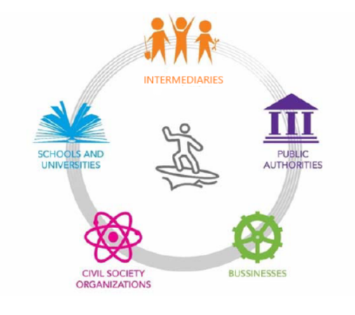For describing the systemic aspects of the ZEB societal eco-innovation, the Penta Helix model (figure 1) is utilized as described by Diepenmaat, Kemp, and Velter (2020). This model is preferred since the ZEB Centre is the intermediary actor not only because of the different activities it undertakes but also because of its structure.

Figure 1: The Penta Helix model

Specifically, it is a national organization equally supervised by the Norwegian University of Science and Technology (NTNU) and the SINTEF research institute (ZEB Centre, 2020d; SINTEF, n.d.). As an intermediary, the ZEB Centre encompasses 21 public and private actors representing the whole value chain of the Norwegian building and construction sector (ZEB Centre, 2020d; ZEB Centre, 2020e). Accurately, public authorities are represented by i) the Norwegian Building Authority (DiBK), ii) Enova SF, an organization owned by the Ministry of Climate and Environment for promoting the more efficient energy consumption, iii) Forsvarsbygg, the Norwegian Defence Estates Agency, iv) Husbanken, the Norwegian Housing Bank, v) Sør-Trøndelag Fylkeskommune, Trøndelag region County Council Authority, and vi) Statsbygg, a state company owned by the Ministry of Local Government and Modernization for implementing government's building policy (ZEB Centre, 2020e).

Furthermore, schools and universities are represented by the NTNU and the SINTEF research institute (ZEB Centre, 2020d; SINTEF, n.d.). Lastly, businesses are represented by the Federation of Norwegian Construction Industries (BNL), and the following firms: i) Brødrene Dahl, Norway's leading heating, ventilation, and sanitation technology wholesaler, ii) ByBo, a real estate developer, iii) Caverion Norge, a technical installations contractor, iv) DuPont, a building products producer, v) Entra, a leading real estate company owned by the Ministry of Trade and Industry, vi) Glava, a producer of insulation materials, vii) Isola, a real estate developer, viii) Multiconsult, a consulting company, ix) NorDan, a building products producer, x) Protan, a manufacturer of building materials, xi) SAPA, a building system supplier, xii) Skanska, a building contractor and developer, xiii) Snøhetta, an architecture firm, and xiv) Weber, a building products producer/supplier (ZEB Centre, 2020e). Through the establishment of the ZEB Centre, the actors are able to interact and achieve their final goal, the transition to the zero-energy houses. However, there is a lack of civil society organizations that could promote public awareness and express the issues related to society's concerns.

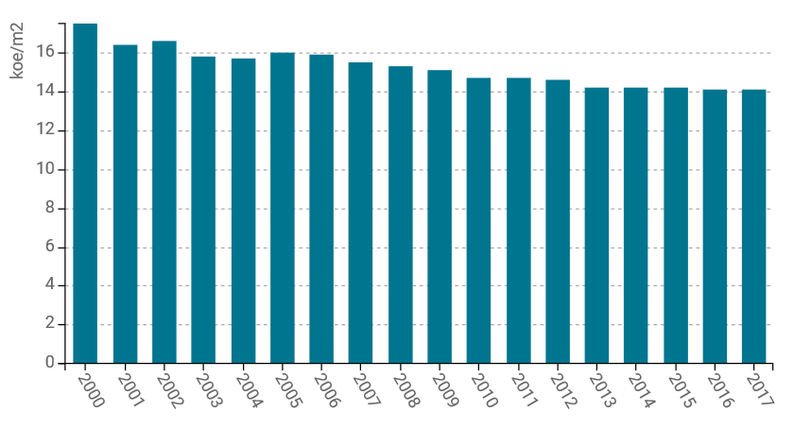The ZEB Centre encompasses all the different types of businesses that comprise the suppliers of the zero-energy houses and need to collaborate to meet the final goal. Specifically, the eco-innovation suppliers are developers, architectures, contractors, building product producers/suppliers, and wholesalers. On the other hand, the end-users of the eco-innovation are the buyers of homes that could be from individuals and companies to governmental and local authorities that own public buildings.

Figure 2: Energy residential consumption per m2 from 2000 to 2017 Source: ODYSSEE-MURE, n.d.

**The history of system building activities - actual policies**

Norway is a pioneer country in the field of greening the building industry. The country has developed various policies towards this direction starting from the year 2007 when the term of energy performance in buildings was introduced in the building codes, the “Planning and Building Act” regulation’s technical blueprint (Nykamp, 2020). Since 2007 the building codes have been regularly revised to gradually reduce the negative environmental impact of buildings in the country, a goal which has been achieved as depicted in figure 2 (Ruth & Marius, 2017; ODYSSEE-MURE, n.d.). An example of such a reduction is the initial imposition of an approximately 35 percent CO2 tax on mineral oil, used for heating, which led to the ban of its use for building heating from January 2020 (Norwegian Ministry of Climate and Environment, 2020). Moreover, since 2010 the European Union’s 2002/91/EC directive was fully implemented (Brekke, Isachsen, & Strand, 2016). The regulatory advancement continued in 2015 when the commitment of all new houses to conform to the “Passive House Level” standards was enacted (Ruth & Marius, 2017). Lastly, the 2012 and 2015 Norwegian Parliament agreements on climate issues stated that from December 2020 all new buildings would meet the Nearly Zero Emission Building (NZEB) levels (Brekke et al., 2016).

The ZEB Centre played a central role in the legislation advancement from 2009. The collaboration of all the stakeholders under the five pillars of the Centre’s work led to that progress (ZEB Centre, 2020b). Through a strong collaboration of all the stakeholders, an adequate policy mix was possible to be formulated according to the technological evolution. The greater the technological development, the more generous the policy mix introduced. An example of that progression is illustrated in figure 3, with the grants offered by Enova increasing year by year (Enova SF, 2020). A variety of system building activities were utilized in that effort, as introduced by Planko et al. (2016), which led to the current list of policy instruments as presented in table 1 (see ANNEX). Specifically, the system-building activities employed so far were mainly from the three out of the four key areas of strategy making, as displayed in table 2. Accurately, utilizing these system-building activities the technologies and materials required for the construction of the ZEBs have already been developed (Andresena et al, 2019). Moreover, the ZEB Centre has contributed to the coordination activities applied. Lastly, only Hurst, N. (2018). In Norway two out of the five market creation activities have been utilized until today, while some little progress has been achieved towards the socio-cultural pillar, with just some small-scale activities been implemented mainly related to the generation of a skilled pool of labor and altering user behavior. Although the progress Norway has achieved towards meeting the goal of energy-efficient buildings, there are many barriers to overcome by utilizing the appropriate system-building activities to reach the ultimate goal of zero-energy houses.

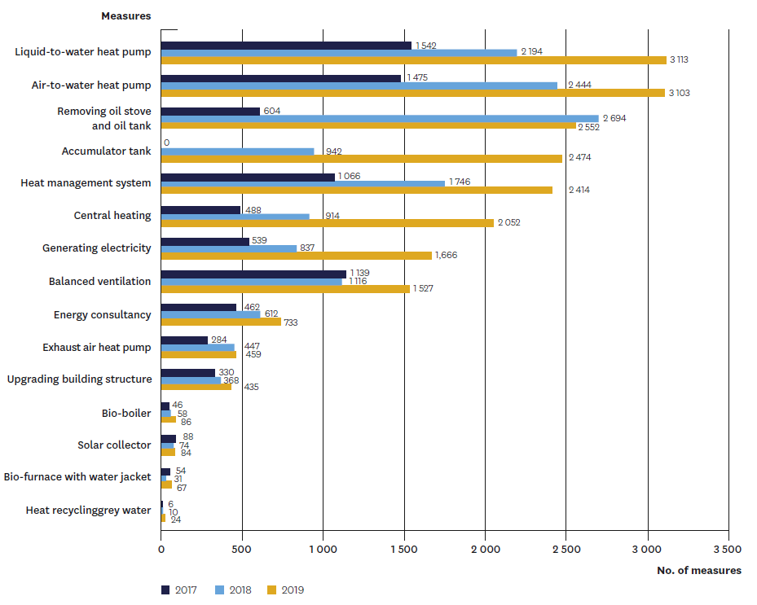

Figure 3: Number of grants provided within the Enova Subsidy scheme in years 2017, 2018, and 2019. Source: Enova SF, 2020

|  |  |  |  |  |
| --- | --- | --- | --- | --- |
| **Key Areas of Strategy Making** | **Technology development & optimization** | **Coordination** | **Socio-cultural changes** | **Market creation** |
| **System-Building Activities** | Testing new technologies, applications and markets | System orchestration | Generation of a skilled pool of labor (low-scale programs like the “Build Up Skills platform” and the “Bygg21”) | Creation of temporarily niche market |
| Knowledge development | Creating a shared vision | Change user behavior (low-scale programs like the “Futurebuilt”) | Collaboration with government for enabling legislation |
| Knowledge exchange | Defining a common goal | **-** | **-** |
| Co-creation of product and services | **-** | **-** | **-** |

Table 2: System-building activities employed until today in Norway towards the effort of meeting the goal of ZEBs.

**Barriers to diffusion**

As mentioned in the previous part, stakeholders actively participate and develop ZEB in four main areas: technological, organization and coordination, socio-cultural, and market. Based on empirical data from additional literature a number of barriers in these areas have been identified that affect the active implementation and dissemination of ZEB technology.

*Technologies, innovative solutions, and knowledge dissemination*

Even today, projects on ZEB are considered very ambitious and for the implementation of these projects, it is necessary to have certain technical knowledge as well as to distribute information in terms of technical aspects to improve and implement the experience gained. In Norway, there is an uneven distribution of knowledge, which is an obstacle in the decision-making process and a problem in the modernization process. Many stakeholders do not have sufficient knowledge and experience at both the construction and decision-making levels. Owners may not know how to start an energy renovation. In the public sector, there is also often a lack of understanding of the long-term picture of the energy supply system and therefore a lack of competence when considering major energy renovation projects. (Levin, 2014) Since some ZEB projects are seen as difficult, risky or unrealistic, many contractors develop and implement ZEB projects using simplified standards, or so-called "low ambition" which are less environmentally and energy-efficient (Lindkvist, Karlsson, Sørnes, Wyckmans, 2014).

Large organizations and private property owners have knowledge of technical solutions for major repairs, but this knowledge is not always extensive enough to make optimal cost decisions. However, residential repairs are made not only by large organisations but also by individuals. Individuals tend to have a limited degree of knowledge about general repairs and even less knowledge about the technical aspects of energy-efficient repairs. (Karlsson, Lindqvist, Wojtczak, Stachurska-Kadziak, Holm, Sornes, Schneuwly, Tellado, Rodriguez, 2013) Moreover, there are restrictions on technical solutions that can be installed in the house, as well as a number of standards that should be taken into account.

*Financial incentives*

Energy-efficiency goals are usually subordinated to the economic considerations and capabilities of the country. In Norway, there is a lack of financial incentives for modernization, developing and implementing the ZEB. The country has low energy costs and high construction costs that reduce the incentives to invest in low-energy construction, since there is a possibility to have little return and the payback period can be extremely long. Energy-efficient equipment is quite costly as such high prices are mentioned as the main barrier. The public and private sectors generally invest only in high-performance solutions. Moreover, the public sector usually requires that the return on investment is clearly spelled out, which often makes it difficult to find capital for expensive projects. It requires good documentation and reasoning to convince investors that an energy project can be a good commercial deal in the long term. (Karlsson, Lindqvist, Wojtczak, Stachurska-Kadziak, Holm, Sornes, Schneuwly, Tellado, Rodriguez, 2013)

At the same time, homeowners themselves are responsible for house reconstruction and invest either individual savings or apply to housing associations. However they are also reluctant to consider switching to energy-efficient equipment since the return on investment is low. Moreover, residents of Norway note that there is little market interest in energy-efficient technologies, as such, low bills can only cover high labor and equipment costs in the long term. (Lindkvist, Karlsson, Sørnes, Wyckmans, 2014)

*Socio-cultural*

Cultural and historical values have always played a significant role in the decision-making process. Moreover, in the conditions of technological development, they could play both a stimulating factor and an existing barrier. In Norway the modernization of cultural and historical buildings as well as the established values of construction is a barrier to the transition to nZEB. Moreover, most owners follow the "Do it yourself" principle in matters of construction or restoration, while a highly qualified specialist is required to make a decision on the creation of an nZEB. There is also a perceived risk of being an early adopter in nZEB, based on the fact that there is an individual approach by owners to the process of upgrading buildings and there is no single solution for the end user.(Lindkvist, Karlsson, Sørnes, Wyckmans, 2014)

“The biggest challenge might be to convince everyone of the need to make a building that was both high-tech and homey, and that the one without the other is not a good house,” Anne Cecilie Haug and Kristian Edwards, senior architects (Ferro, 2015)

*Organizational and legal*

The complexity of different stakeholders in the modernization and decision-making process is seen as an obstacle in Norway. Government plays a key role in promoting energy-efficient buildings, so legislation affects different players and competing interests. At the same time in Norway there are no specific requirements for energy distribution and ventilation which leads to uncertainty for the decision making process and also has an impact on the modernization process (Lindkvist, Karlsson, Sørnes, Wyckmans, 2014).

Currently, the ZEB market exists and develops doe to large companies that know that they may not get a high economic return, but want to develop the skills that will be required in the future, as well as receive positive advertising from efficient construction. However, small construction companies do not have the same enthusiasm and incentive to improve their skills, since the market does not require energy-efficient construction on a large scale (Karlsson, Lindqvist, Wojtczak, Stachurska-Kadziak, Holm, Sornes, Schneuwly, Tellado, Rodriguez, 2013). Therefore, there is a need for better regulation of zero energy construction in the market. Political decisions and social responsibility of the public sector play an important role in making investment decisions and can increase the profitability of ZEB and positive cash flow in the construction market (Levin, 2014).

**Policy proposals and necessary institutional changes**

In order for the ZEB industry to actively develop, a comprehensive approach to all four main areas of strategic development is necessary. For each of the areas, a number of actions were proposed that can contribute to the development and strengthening of ZEB in the country. Moreover, it is important to actively involve existing stakholders in the problem of spreading energy-efficiency projects, as well as to consider the possibility of attracting new institutions and stakeholders.

*Technologies, innovative solutions, and knowledge dissemination*

To achieve a breakthrough in the field of nZEB, it will be necessary to combine the knowledge of all the different levels of infrastructure work in order to find synergy. In this situation, the Norwegian government should develop more technical solutions along with the dissemination of knowledge in this area (Weiss, Meier, Knotzer, Höfler, 2019). At this approach, it is important to consider not only possible technological changes, but also to develop new strategies for using resources and technologies. Positive engagement can encourage ambitious and risky projects. At the same time, it is necessary to take into account the realism of projects. Commitment to high ambitions with an unknown technical environment can cause projects to fail. Less ambitious projects can still be energy-efficient.

It is necessary to promote the knowledge of service personnel, owners and project teams. First of all, it is necessary to determine the level of awareness about energy-efficient projects among these groups. A stimulating approach to the development of the eco-energy sector can be the creation of appropriate training programs for various stakeholders and key actors (Milovanović, Bagarić, Tzanev, Petran, 2019). This will allow the country to develop deeper knowledge in the field of energy and the environment, and will also contribute to the demand in society for energy-efficiency. In general, it is important to find a method to increase the level of motivation among various stakeholders.

*Financial incentives*

In the interests of financial institutions and the future sustainable development of the country, there is a need to develop various business models that take into account both short-term and long-term investments. The government can provide financial support to owners in carrying out energy repairs, paying for additional expenses necessary to achieve low energy levels. In addition, there is a need to develop funding schemes for specific types of measures and assessments. It is also important to consider subsidies for measuring, evaluating and documenting demonstration construction projects with high energy-efficiency ambitions. Financial support measures for property owners will help to show the advantages of participating in innovative projects compared to traditional ones. In addition, when a real estate owner sees the added value of these projects, for example, when the experience of one modernization project can also be applied in future projects, they have a higher motivation to invest in the modernization and energy reconstruction of the building. (Levin, 2014)

The government can also promote the ZEB industry by lowering the discount rate and raising energy taxes, which would make investment in long-term building improvements more attractive. In addition, the most honest and fair relationship between real estate owners and organizations in the financial sphere is also important. Owners should have a more complete overview and comparison of future operating costs with and without measures, such as when investments are not made and what the operating costs will be after reconstruction.

*Socio-cultural*

This aspect includes both individual perception and socio-economic perception. The development of a social institution should not only include raising awareness among residents but should take into account how the ZEB can address the broad social aspects of living. It is extremely important to raise public awareness about the benefits of energy-efficient buildings. The result can be achieved through educational channels and institutions, as well as through the involvement of the media and energy professionals.

To some extent, social barriers can also be avoided by involving residents in a building renovation project, thereby working with end users and increasing knowledge about how the heating and ventilation system will be used to ensure their comfortable use in the building. Or, upon completion of the reconstruction / construction of the building, residents may be issued manuals on the operation of the building in accordance with the project. In this case, they have access to information about the optimal way to live in their home.

*Organizational and legal*

Competent assessment at various stages of the nZEB project is one way to combine and use the perspectives of various stakeholders to make future decisions. Moreover, it is necessary to develop certain standards for regulating the renovation of old or historical buildings. (Weiss, Meier, Knotzer, Höfler, 2019)

At the stage of project formation, it is very important to ensure a good level of communication between all the necessary participants in the construction industry: architects, engineers, clients, contractors, etc. Pre-project seminars can provide a clear and understandable statement of project goals, building performance targets, as well as solving a number of problems at an early stage. (Karlsson, Lindqvist, Wojtczak, Stachurska-Kadziak, Holm, Sornes, Schneuwly, Tellado, Rodriguez, 2013)

*6.5. New social relations*

In many cases, it is also important to develop new social interactions for the successful development of technology. For example, there is an IEE project that aims to improve the energy performance of existing non-residential buildings on a large scale. This project also aims to demonstrate that energy-efficient buildings can also meet the profitability requirements set by the building owner/investor. The project is aimed at five countries: Sweden, Norway, Denmark, Finland, and Estonia. (Levin, 2014) Since these countries are already linked by the goal of a single project, it can be assumed that the development of the relationship between them can help to strengthen the ZEB approach in construction, as well as increase knowledge diffusion and lead to the growth of awareness among the population: users, investors, specialists in various fields etc.

*Limitations of the analysis*

It is valuable to start by enhancing that isolated policy initiatives don’t have enough capacity and, to be able to understand the specific policy initiatives, it’s crucial to learn about the entire energy system involving ZEBs. (Drysdale, Mathiesen & Paardekooper, 2019).Through our work a limitation comes from the number of ZEBs running being small and, even though the data collected about them is good, this is still not sufficient for a bigger scale installation of ZEBs. Moreover, there was not enough information about public funding schemes to stimulate investment in ZEBs besides the construction of those buildings connected to the ZEB Centre. This also applies to house refurbishment in order to achieve a better energy-efficiency.

**Conclusions**

Barriers in the decision-making process to adopt ZEB are related to problems in the modernization process. In Norway, there is insufficient dissemination of technical knowledge in the field of ZEB reconstruction within the framework of the processes considered. The results also indicate that decisions to renovate building owners are influenced by factors such as a lack of social understanding of what energy-efficiency means, financial constraints, and the lack of clear rules for zero-energy construction. Based on the detected barriers, a number of interventions in various key areas were proposed in this paper.

Overall, Norway has come a long way in the field of ZEB, and decision makers are carefully considering how their ZEB will develop in the future and are clearly concerned about future progress. Although technical, financial, social, and organizational issues were discussed separately, it is important to understand that each of them overlaps with the other. Existing barriers and solutions cannot be considered mutually exclusive when setting new tasks and solutions. The final result of this study indicates that the ZEB field is developing in Norway and these projects are appearing more often. This work may also raise a question for future research: How effectively is knowledge transferred to other ZEB projects? And is it true that Norway's energy goals are becoming higher than economic considerations?

**References**

Amoruso, G., Donevska, N., & Skomedal, G. (2018). German and Norwegian policy approach to residential buildings’ energy efficiency—a comparative assessment. *Energy Efficiency*, *11*(6), 1375–1395.<https://doi.org/10.1007/s12053-018-9637-5>

Andresen, I. (2017). Towards Zero Energy and Zero Emission Buildings-Definitions, Concepts, and Strategies. *Curr Sustainable Renewable Energy Rep (2017) 4:63-71.*  <https://doi.org/10.1007/s40518-017-0066-4>

Andresena, I., Wiikb, K. M., Fufab, S. M., & Gustavsena, A. (2019). *The Norwegian ZEB definition and lessons learnt from nine pilot zero emission building projects*. IOP Publishing. <https://doi.org/10.1088/1755-1315/352/1/012026>

Berardi, U. (2013). Moving to Sustainable Buildings: Paths to adopt green innovations in developed countries. *Versita.*<https://doi.org/10.2478/9788376560113>

Brekke, T., Isachsen, K. O., & Strand, M. (2016). *EPBD implementation in Norway.* <https://www.epbd-ca.eu/wp-content/uploads/2018/08/CA-EPBD-IV-Norway-2018.pdf>

Chau, C. K., Tse, M. S., & Chung, K. Y. (2010). A choice experiment to estimate the effect of green experience on preferences and willingness-to-pay for green building attributes. *Building and Environment 45.*<https://doi.org/10.1016/j.buildenv.2010.05.017>

Diepenmaat, H., Kemp, R., & Velter, M. (2020). Why sustainable development requires societal innovation and cannot be achieved without this. Sustainability (Switzerland), 12(3). <https://doi.org/10.3390/su12031270>

Drysdale, D., Mathiesen, B. V., & Paardekooper, S. (2019). Transitioning to a 100% renewable energy system in Denmark by 2050: assessing the impact from expanding the building stock at the same time. *Energy Efficiency*, *12*(1), 37–55.<https://doi.org/10.1007/s12053-018-9649-1>

Enova SF. (2020). Annual Report 2019. <https://www.enova.no/om-enova/kampanjer/arsrapporten-2019/>

Ferro, S. (2015). In Norway, A New Model For Zero-Energy Housing. *Fastcompany.com*. Retrieved from: <https://www.fastcompany.com/3040202/in-norway-a-new-model-for-zero-energy-housing>

Fufa, S. M., Dahl, S. R., Sørnes, K., Inman, M., & Inger, A. (2016). *A Norwegian ZEB Definition Guideline* (ZEB Project report No. 29). SINTEF Academic Press and Norwegian University of Science and Technology. <https://www.sintefbok.no/book/index/1092>

Hurst, N. (2018). In Norway, an Ambitious New Standard for Green Building Is Catching On. *Smithsonianmag.com*. Retrieved from: <https://www.smithsonianmag.com/innovation/in-norway-ambitious-new-standard-green-building-is-catching-on-180968828/>

Karlsson, A., Lindqvist, C., Wojtczak, E., Stachurska-Kadziak, K., Holm, D., Sornes, K., Schneuwly, P., Tellado, N., & Rodriguez, F. (2013). Common Barriers and Challenges in Current nZEB Practice in Europe. *D1. 1 Report, FP7 ZenN*.

Levin, P. (2014). Energy Renovations of Non-residential Buildings in Northern European Countries-National non-technical barriers and methods to overcome them Report. *Report. TotalConcept*.

Li, D. H. W., Yang, L., & Lam, J. C. (2013). Zero energy buildings and sustainable development implications –A review. *Energy 54 (2013) 1-10.*<https://doi.org/10.1016/j.energy.2013.01.070>

Lindkvist, C., Karlsson, A., Sørnes, K., & Wyckmans, A. (2014). Barriers and challenges in nZEB Projects in Sweden and Norway. *Energy Procedia*, *58*, 199-206.

Milovanović, B., Bagarić, M., Tzanev, D., & Petran, H. (2019). Innovative Training Schemes for Retrofitting to nZEB-Levels. In *RILEM spring convention and sustainable materials, systems and structures conference-Energy Efficient Building Design and Legislation, France* (pp. 255-262).

Norwegian Ministry of Climate and Environment. (2020). *Norway’s Fourth Biennial Report. Under the Framework Convention on Climate Change.* <https://www4.unfccc.int/sites/SubmissionsStaging/NationalReports/Documents/58167_Norway-BR4-1-Norway_BR4%20(2).pdf>

Nykamp, H. (2020). Policy Mix for a Transition to Sustainability: Green Buildings in Norway. *Sustainability*, 12(2). <https://doi.org/10.3390/su12020446>

ODYSSEE-MURE. (n.d.). *NORWAY PROFILE*. <https://www.odyssee-mure.eu/publications/efficiency-trends-policies-profiles/norway.html#buildings>

OECD/ IEA. (2013). Transition to Sustainable Building. Strategies and opportunities to 2050. *International Energy Agency.* [https://www.oecd-ilibrary.org/energy/transition-to-sustainable-buildings_9789264202955-en](%20https://www.oecd-ilibrary.org/energy/transition-to-sustainable-buildings_9789264202955-en)

Peterson, K., Torcellini, P., & Grant, R. (September 2015). A common definition for Zero Energy Buildings. *U.S. Department of Energy.*<https://www.energy.gov/sites/prod/files/2015/09/f26/A%20Common%20Definition%20for%20Zero%20Energy%20Buildings.pdf>

Planko, J., Cramer, J. M., Chappin, M. M. H., & Hekkert, M. P. (2015). Strategic collective system building to commercialize sustainability innovations. *Journal of Cleaner Production 112 (2016) 2328-2341.*<https://doi.org/10.1016/j.jclepro.2015.09.108>

Ruth, W., & Marius, K. (2017). Between craft and regulations: experiences with the construction of two “super insulated” buildings in Norway. *Nordic Journal of Science and Technology Studies*, 5. <https://doi.org/10.5324/njsts.v5i2.2322>

Sebi, C., Nadel, S., Schlomann, B., & Steinbach, J. (2019). Policy strategies for achieving large long-term savings from retrofitting existing buildings. *Energy Efficiency*, (12), 89–105.<https://doi.org/10.1007/s12053-018-9661-5>

SINTEF. (n.d.). *Applied research, technology and innovation*. <https://www.sintef.no/en/this-is-sintef/>

ZEB Centre. (2020a). *Use, operation and implementation of zero emission buildings*. <https://www.zeb.no/index.php/en/use-operation-and-implementation-of-zero-emission-buildings>

ZEB Centre. (2020b). *About the ZEB Centre*. <https://www.zeb.no/index.php/en/about-zeb/about-the-zeb-centre>

ZEB Centre. (2020c). *Concepts and strategies for zero emission buildings*. <https://www.zeb.no/index.php/en/concepts-and-strategies-for-zero-emission-buildings>

ZEB Centre. (2020d). *Organisation.* <https://www.zeb.no/index.php/en/about-zeb/organisation>

ZEB Centre. (2020e). *Partners.* <https://www.zeb.no/index.php/en/partners>

Zhang, J., Zhou, N., Hinge, A., & Feng, W. (2015). Zero-energy buildings – an overview of terminology and policies in leading world regions. <https://www.eceee.org/library/conference_proceedings/eceee_Summer_Studies/2015/6-policies-and-programmes-towards-a-zero-energy-building-stock/zero-energy-buildings-an-overview-of-terminology-and-policies-in-leading-world-regions/>

**Appendix**

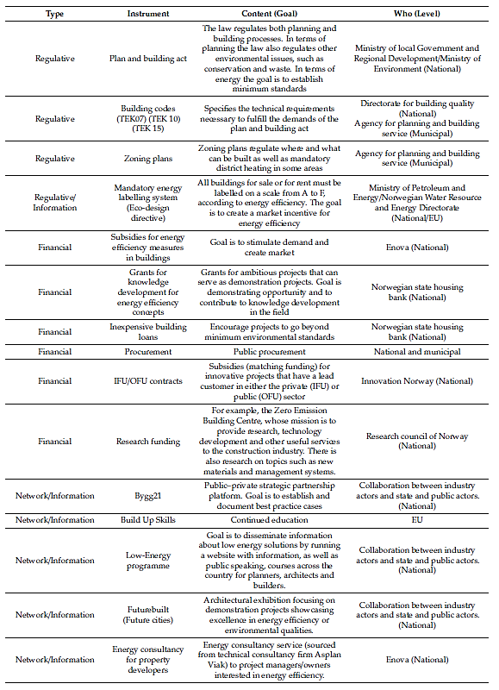

Table 1: List of policy instruments in Norway in 2020. Source: Nykamp, 2020



**Innovation for Sustainability**

Maastricht, the Netherlands

2020

1. Cited in (City of Copenhagen, Building and Construction Administration, Roads and Parks Department, July 2002)
2. (The City of Copenhagen, 2011, p. 21)